2012 | – 2020 | AFRO PC NTD progress report
“NTDs Elimination: NOW more than ever”
The Expanded Special Project for Elimination of NTDs

Introduction
The year 2020 is a milestone for the efforts to reduce the burden, control and elimination of NTDs. It is 8 years since the 2020 NTD Roadmap ‘Accelerating Work to Overcome the Global Impact of Neglected Tropical Diseases a Roadmap for Implementation’ and the ‘London Declaration on Neglected Tropical Diseases’ and 5 years since the global agreement on the Sustainable Development Goals (SDGs) framework. The year 2020 is a defining moment, when we report on the progress on the implementation of the 2013 African resolution on NTDs, the Regional NTD Programme supported activities and interventions, and discuss the gains that need to be sustained and gaps that need to be addressed by country NTD master plans that align with the NTD Roadmap 2021-2030.

Through the London declaration donors, pharmaceutical companies, governments and partners have provided unprecedented commitment and support to realize the achievements of the 2020 NTD Roadmap that we celebrate today.

The Expanded Special Project for Elimination of Neglected Tropical Diseases (ESPEN) launched in 2016, has become a critical partner in Africa. Over the first five years of its mandate, ESPEN has focused primarily on the five most prevalent neglected topical diseases (NTDs) in Africa and has provided operational assistance to countries to accelerate elimination of preventive chemotherapy (PC) NTDs, including mapping their burden of disease, delivering treatments efficiently, strengthening management of medicines, increasing transparency and using data for decision-making.
ESPEN mandate covers 52 countries: 47 countries in the AFRO WHO region: 45 requiring PC, 2 countries not requiring PC (Mauritius and Seychelles), 5 countries in the Eastern Mediterranean WHO region (EMRO): four in the African continent, Djibouti, Egypt, Somalia and Sudan, and 1 country outside Africa, Yemen. These five countries from the EMRO region were added to ESPEN mandate due to their special needs and required operational support in an unprecedented collaboration between WHO AFRO and EMRO Regional Directors.

ESPEN developed an online Portal aiming to strengthen accountability and promote an evidence-based approach, where NTD data can be accessed at subnational level. This helps provides full transparency and increases the availability of strong data for decision-making. It also enables health ministries and stakeholders to share and exchange subnational programme NTD data and use this quality data for smarter decision-making for NTD control and elimination. Almost 10,000 actions maps are available in the portal to help government implement the right NTD interventions and monitor progress at subnational level.

This short report provides progress in the five PC-NTDs during the implementation period of the 2020 Roadmap (2012-2020) in the African Region.

Major progress

- By 2018, 45 Member States in the African Region (except for Algeria and Cabo Verde) have developed and are implementing their NTD master plans.
- In total, all endemic countries (40 Member States) have achieved full mapping for three PC-NTDs, namely lymphatic filarial (LF), schistosomiasis and soil-transmitted helminthiasis. Through the AFRO mapping project from January 2014 through the end of 2016, mapping surveys for one or more PC-NTDs in at least 2,500 districts were conducted. The Global Trachoma mapping project (GTMP) produced a tremendous impact in the continent by accelerating the mapping on trachoma in 18 African countries.
- The geographical coverage of mass drug administration (MDA) for the five PC-NTDs: LF, onchocerciasis, schistosomiasis, STH and trachoma, has increased in all the endemic Member States. Thirty-eight countries have reached 100% geographical coverage for at least one PC-NTD for at least one year in the period 2014-2019, while all other endemic Member States have started MDA for at least one disease.
- From 2012 to 2020, 3.1 billion tablets were donated to countries in the WHO African Region facilitated by WHO.
- The number of people requiring preventive chemotherapy in the WHO African Region has been reduced from 603 million in 2015 to 588 million in 2019 as a result of stopping MDA and entering on post MDA surveillance.
- Progress was made in the elimination of targeted NTDs. Ghana was validated for elimination of trachoma as a public health problem in 2018. Togo and Malawi were validated for elimination of LF as a public health problem in 2017 and 2020 respectively, bringing the number of Member States in the region validated for elimination of PC-NTDs as a public health problem to three.

Lymphatic filariasis
- Mapping of LF in Africa has been completed in all countries except one district in Equatorial Guinea.
- In Africa, in 2012 there were 464 million requiring PC for LF. At the start of ESPEN in 2016, there were 371 million estimated people requiring PC for LF. By 2019 that number has declined to 339 million people in 32 countries.
- In 2019, of the 32 countries requiring MDA for LF in Africa 25 (78%) countries achieved 100% geographical coverage, an increase from 13(37%) countries in 2015. Between 2015 and 2019, the number of countries with 100% geographical coverage for LF MDA increased by 92%.
- The reported number of people treated for LF increased from 106 million in 2012 to 181 million in 2019 in the African region. Between 2012 and 2019, the number of people treated for LF increased by 70%.
- The proportion of implementation units achieving effective coverage (>65%) increased from 77.5% in 2016 to 90.1% in 2019.
- Madagascar, Sao Tome Principe and Kenya have conducted triple drug therapy (Ivermectin, Dietilcarbamazine and Albendazole) to accelerate LF elimination.
- The population requiring preventive chemotherapy for LF from 2013 to 2019 in Africa decreased by 150.4 million.
- In Africa Togo and Malawi were validated for elimination of LF as a public health problem in 2017 and in 2020 respectively.

Onchocerciasis
- The reported number of people treated for onchocerciasis increased from 132 million in 2016 to 152 million in 2019 in the African region. Between 2016 and 2019, the number of people treated for onchocerciasis increased by 15%.
- The proportion of implementation units achieving effective coverage (>65%) increased from 68.1% in 2016 to 89.9% in 2019.
- The regional coverage of onchocerciasis MDA in Africa increased from 67% in 2016 to 70% in 2019.
- In Africa 10.4 million people no longer requiring preventive chemotherapy for onchocerciasis in 2019.

Schistosomiasis
- The mapping of schistosomiasis in Africa is now complete as a result of the AFRO Mapping Project.
- The reported number of people treated for schistosomiasis increased from 36 million in 2012 to 102 million in 2019 in the African region. Between 2012 and 2019, the number of people treated for schistosomiasis increased by 183%.
- The regional coverage of schistosomiasis MDA in Africa increased from 13.6% in 2012 to 76.4% in 2019.
- The number of countries implemented PC for school age children in 2018 with >75% national coverage was 16 increased from six in 2012.
- The regional geographical coverage of schistosomiasis MDA in Africa increased from 31% in 2014 to 47% in 2019.

Soil-transmitted helminthiasis
- The mapping of soil-transmitted helminthiasis in Africa is complete as a result of the AFRO Mapping Project.
- The reported number of people treated for soil-transmitted helminthiasis increased from 76 million in 2012 to 244 million in 2019 in the African region. Between 2012 and 2019, the number of people treated for soil-transmitted helminthiasis increased by 221%.
- The regional coverage of soil-transmitted helminthiasis MDA in Africa increased from 25.3% in 2012 to 88.4% in 2019.
- The target coverage of 75% was reached by 14 countries in 2018 as compared to 11 countries in 2012.
- After conducting a high coverage mass drug administration consistently for 6 years, through ESPEN support, Zimbabwe conducted impact assessment survey for soil-transmitted helminthiasis. The results showed a significant reduction in the disease prevalence at district and national levels. The national prevalence of STH in school age children was estimated at 0.8%; infections of moderate and heavy intensity almost disappeared (0.1% prevalence). As a result, Zimbabwe can suspend deworming activities in 54 districts and reduce the frequency of PC in the remaining six districts. The total amount of albendazole tablets needed will be approximately 100 000 a year instead of an average of 2.6 million per year.

Trachoma
- The mapping of trachoma in the WHO African Region is at its final stages. Many of the countries in the Region have completed their mapping. However, currently there remain gaps only in 6 countries in districts that were either previously not thought to be endemic or in suspected endemic districts but where mapping could not be conducted due to insecurity.
- Population in areas that warranted treatment with antibiotics, facial cleanliness and environmental improvement for elimination of trachoma as a public health problem decreased from 175 million in 2012 to 117million as of May 2020. When ESPEN was established in 2016, there were an estimated 171 million people requiring interventions against trachoma.
- The reported number of people who received treatment with antibiotics for trachoma increased from 46 million in 2012 to 93 million in 2019 in the African region. Between 2012 and 2019, the number of people treated for trachoma increased by 102%.
- The number of people that required treatment with antibiotics for trachoma reduced by 58 million between 2012 and May 2020.
- As of May 2020, seven endemic countries in the African region no longer need MDA for trachoma and The Gambia and Togo are thought to not require interventions and have claimed to have eliminated trachoma and are pending validation.
- Ghana was validated for having eliminated trachoma as a public health problem in June 2018.

NTD response during the COVID-19 pandemic
- By May 2020, COVID-19 had spread to all NTD endemic countries in the African Region. By the end of November 2020, about 1.48 million cases and 24,000 deaths had been reported in the Region.
- The COVID-19 pandemic response related restrictions have caused disruption in essential NTD interventions.
- NTDs alone cause an estimated 200,000 deaths in Africa every year in the absence of the appropriate response.
- In May 2020, ESPEN conducted an online survey to evaluate the impact of the COVID-19 related measures on NTD activities in the Region. Of the 33 countries that responded to the survey, 26-reported postponement of NTD activities, only South Sudan confirmed implementation of MDA since the most recent case of COVID-19.
- NTD drugs and supplies were expiring in 12 countries, and disease-specific surveys were reported in 24 countries.
- WHO published technical guidance on how to safely maintain NTD interventions in the context of COVID-19 pandemic.
- Despite delays, 34 countries in the region restarted or planned to restart MDA in 2020 as of November 2020. Of the 34 countries, 23 have resumed MDA and the rest 11 countries planned to resume before the end of 2020.
- Eleven countries resumed or planned to resume pre-TAS and TAS surveys for lymphatic filariasis before the end of 2020.
- The NTD programme staff and the network of NTD community health workers contributed significantly to the COVID-19 response, while ensuring the integration of NTD interventions whenever possible.

Challenges and the way forward
- Inadequate domestic funding for country NTD programmes remains a programmatic challenge. To ensure programme sustainability it is critical to ensure a well-resourced national programme. Countries must increase domestic resources for a lasting change in addressing the challenges of NTDs.
- Integration of NTDs within the wider health system is a remaining challenge for the NTD community. Inclusion of NTDs within country essential health care packages, inclusion of NTD indicators with in the national health information system and service delivery approach embedded within the national health structure are all critical to achieve the NTD Roadmap 2030 goals.
- Sustainability planning should be incorporated within the early stages of programme development and enhanced in subsequent phases of the programme. Towards this end, the Global 2021 – 2030 Framework presents a conceptual approach that would be used to facilitate planning, generate further political and financial momentum to support the delivery of NTD services in a sustainable manner, promote collaboration between different programmes and sectors, without the need to modify institutional structures, promote working across sectors in a manner that ensures equity, inclusion and community engagement, and complement existing frameworks such as the WASH and NTDs strategy, and other initiatives towards achieving Universal Health Coverage and the Sustainable Development Goals.
- The COVID-19 pandemic has suspended or postponed implementation of NTD mass interventions, jeopardising the progress made so far. However, with the relaxation of country lockdowns and implementation of COVID-19 barriers measures, opportunities remain open for countries to carry out catch-up activities to achieve 2020 action plans in early 2021.
- Important gaps exist between disease control/elimination efforts and patient care programmes, between medical and environmental/behavioural interventions and between the core NTDs community and other important stakeholders, even within Ministries of Health that are not routinely or systematically engaged in technical and advocacy discussions for NTDs.
- Surveillance post MDA and post validation, diseases that will require long term interventions and may not always have donor support (SCH, STH), and facility based care morbidity (such as hydrocele, lymphedema) will require mobilization of domestic resources to achieve sustainability and long lasting impact. The overall national systems should incorporate all aspects of NTD programming.
- These gaps make NTD programmes less able to plan, fund and deliver their services with sustainable approaches that effectively target the population groups most in need, use programme resources effectively and mobilize further resources and efforts from other relevant sectors and programmes.
- Identified gaps in programme implementation and monitoring and evaluation will require a strong focus on operational research to generate evidence to support adaptation of existing strategies, adoption of new strategies and evolution toward integrated service delivery across health programmes.
- Development of research capacity at country level wil require expansion of partnerships with COR-NTD, ARNTD and similar research-focused organizations.
- In addition to developing new research capacity, a greater focus on laboratory capacity is needed to support the increased M&E demands of programmes reaching elimination endpoints..
- The AFRO NTD programme and ESPEN will use The NTD Sustainability Framework to support Member states in the region to identify pathways to support ambitious, measurable and sustainable actions, which will be outlined in 5-year NTD Master Plans, to achieve NTD targets and milestones, in line with the Global NTD Roadmap 2021-2030.
Table 1. Demographic and treatment data for Lymphatic filariasis in the African Region 2014-2019
Lymphatic filariasis | Indicators/AFRO region | 2014 | 2015 | 2016 | 2017 | 2018 | 2019¥
Demographics | Total Population | 872,955,626 | 841,462,940 | 910,051,267 | 924,826,079 | 972,661,520 | 1,006,455,052
 | PreSAC population | 127,691,726 | 134,584,303 | 141,718,072 | 144,304,367 | 154,843,808 | 157,264,746
 | SAC population | 235,951,005 | 238,518,954 | 246,670,121 | 262,860,949 | 275,953,434 | 288,294,553
 | Adult population | 436,834,257 | 444,410,982 | 463,157,127 | 510,346,127 | 531,100,418 | 556,140,881
 | Number of reported IU | 5,076 | 5,077 | 5,242 | 5,261 | 5,287 | 5,356
Endemicity | Endemic (MDA not delivered) | 732 | 619 | 405 | 301 | 392 | 489
 | Endemic (under MDA) | 1,183 | 1,235 | 1,329 | 1,530 | 1,365 | 1,072
 | Endemic (under post-intervention surveillance) | 139 | 259 | 285 | 471 | 587 | 648
 | Endemicity unknown | 23 | 12 | 21 | 12 | 21 | 12
 | Non-endemic | 2,528 | 2,575 | 2,698 | 2,733 | 2,804 | 2,841
 | Not reported | 471 | 377 | 504 | 214 | 118 | 294
Treatment | Population requiring treatment | 339,015,360 | 333,044,084 | 335,479,394 | 336,818,129 | 330,870,227 | 326,452,422
 | Population no longer requiring treatment | 30,547,076 | 51,703,685 | 54,693,718 | 94,083,023 | 129,022,667 | 150,419,985
 | Population targeted | 174,921,606 | 210,995,641 | 224,371,398 | 240,409,143 | 230,413,477 | 190,976,349
 | Population treated | 148,000,265 | 176,756,895 | 195,784,207 | 218,493,028 | 210,881,669 | 173,904,029
 | Number of IUs implementing MDA | 1,188 | 1,263 | 1,348 | 1,553 | 1,366 | 1,075
 | Number of IUs achieving effective coverage | 978 | 1,025 | 1,177 | 1,500 | 1,315 | 1,052
 | Geographical Coverage | 62% | 68% | 78% | 85% | 78% | 69%
 | Programme Coverage (AFRO region) | 85% | 84% | 87% | 91% | 92% | 91%
 | Regional Coverage (AFRO region) | 44% | 53% | 58% | 65% | 64% | 53%
 | No. IUs treated with ALB+DEC | 61 | 151 | 102 | 127 | 78 | 20
 | No. IUs treated with ALB+IVM | 1,127 | 1,112 | 1,246 | 1,392 | 1,229 | 985
 | No. IUs treated with ALBx2 | - | - | - | 34 | 59 | 63
 | No. IUs treated with IDA | - | - | - | - | - | 7
 | ¥The 2019 summaries have been extracted from 29 countries, which have successfully completed the submission and validation process of JAP reports. They are still provisional and updates on these figures are expected when review is completed for all the countries.

Table 2. Demographic and treatment data for onchocerciasis in the African Region 2014-2019
Onchocerciasis |  | Indicators/AFRO region |  | 2014 |  | 2015 |  | 2016 |  | 2017 |  | 2018 |  | 2019¥
Demographics |  | Total Population |  | 872,955,626 |  | 841,462,940 |  | 910,051,267 |  | 924,826,079 |  | 972,661,520 |  | 1,006,586,895
 |  | PreSAC population |  | 127,691,726 |  | 134,584,303 |  | 141,718,072 |  | 144,304,367 |  | 154,843,808 |  | 157,286,488
 |  | SAC population |  | 235,951,005 |  | 238,518,954 |  | 246,670,121 |  | 262,860,949 |  | 275,953,434 |  | 288,335,628
 |  | Adult population |  | 436,834,257 |  | 444,410,982 |  | 463,157,127 |  | 510,346,127 |  | 531,100,418 |  | 556,201,910
 |  | Number of reported IU |  | 5,076 |  | 5,077 |  | 5,242 |  | 5,261 |  | 5,287 |  | 5,356
Endemicity |  | Endemic (MDA not delivered) |  | 305 |  | 286 |  | 230 |  | 188 |  | 270 |  | 210
 |  | Endemic (under MDA) |  | 1,303 |  | 1,326 |  | 1,382 |  | 1,489 |  | 1,398 |  | 1,450
 |  | Endemic (under post-intervention surveillance) |  | 20 |  | 22 |  | 2 |  | 21 |  | 27 |  | 32
 |  | Unknown (consider Oncho Elimination Mapping) |  | 611 |  | 520 |  | 801 |  | 834 |  | 828 |  | 829
 |  | Unknown (under LF MDA) |  | 226 |  | 187 |  | 317 |  | 326 |  | 327 |  | 346
 |  | Non-endemic |  | 2,238 |  | 2,385 |  | 2,025 |  | 2,259 |  | 2,321 |  | 2,286
 |  | Not reported |  | 373 |  | 351 |  | 485 |  | 144 |  | 116 |  | 203
Treatment |  | Population requiring treatment |  | 225,156,565 |  | 181,640,862 |  | 194,952,506 |  | 206,119,496 |  | 211,738,086 |  | 225,537,151
 |  | Population no longer requiring treatment |  | 7,230,897 |  | 6,459,120 |  | 748,144 |  | 7,646,334 |  | 8,914,611 |  | 10,533,594
 |  | Population targeted |  | 153,507,065 |  | 173,204,708 |  | 176,107,293 |  | 205,319,931 |  | 207,566,489 |  | 209,819,177
 |  | Population treated |  | 120,424,830 |  | 142,779,660 |  | 158,549,139 |  | 182,448,863 |  | 187,122,934 |  | 189,417,026
 |  | Number of IUs implementing MDA |  | 1,306 |  | 1,330 |  | 1,382 |  | 1,491 |  | 1,400 |  | 1,452
 |  | Number of IUs achieving effective coverage |  | 1,047 |  | 1,108 |  | 1,278 |  | 1,389 |  | 1,292 |  | 1,363
 |  | Geographical Coverage |  | 81% |  | 83% |  | 86% |  | 89% |  | 84% |  | 87%
 |  | Programme Coverage (AFRO region) |  | 78% |  | 82% |  | 90% |  | 89% |  | 90% |  | 90%
 |  | Regional Coverage (AFRO region) |  | 53% |  | 79% |  | 81% |  | 89% |  | 88% |  | 84%
 |  | No. IUs treated with ALB+IVM |  | 614 |  | 622 |  | 668 |  | 747 |  | 678 |  | 621
 |  | No. IUs treated with IVM |  | 692 |  | 708 |  | 714 |  | 744 |  | 722 |  | 832
 |  | ¥The 2019 summaries have been extracted from 29 countries, which have successfully completed the submission and validation process of JAP reports. They are still provisional and updates on these figures are expected when review is completed for all the countries.
Table 3. Demographic and treatment data for soil-transmitted helminthiasis in the African Region 2014-2019
STH | Indicators/AFRO region |  | 2014 |  | 2015 |  | 2016 |  | 2017 |  | 2018 |  | 2019¥
Demographics | Total Population |  | 872,955,626 |  | 841,462,940 |  | 910,051,267 |  | 924,826,079 |  | 972,661,520 |  | 1,006,455,052
 | PreSAC population |  | 127,691,726 |  | 134,584,303 |  | 141,718,072 |  | 144,304,367 |  | 154,843,808 |  | 157,264,746
 | SAC population |  | 235,951,005 |  | 238,518,954 |  | 246,670,121 |  | 262,860,949 |  | 275,953,434 |  | 288,294,553
 | Adult population |  | 436,834,257 |  | 444,410,982 |  | 463,157,127 |  | 510,346,127 |  | 531,100,418 |  | 556,140,881
 | Number of reported IU |  | 5,076 |  | 5,077 |  | 5,242 |  | 5,261 |  | 5,287 |  | 5,356
Endemicity | High prevalence (50% and above) |  | 964 |  | 1,052 |  | 1,012 |  | 1,178 |  | 1,240 |  | 1,133
 | Moderate prevalence (20%-49%) |  | 1,637 |  | 1,692 |  | 1,753 |  | 1,880 |  | 1,874 |  | 1,845
 | Low prevalence (less than 20%) |  | 1,268 |  | 1,223 |  | 1,196 |  | 1,341 |  | 1,391 |  | 1,356
 | Unknown |  | 38 |  | 31 |  | 39 |  | 25 |  | 41 |  | 30
 | Non-endemic |  | 319 |  | 324 |  | 432 |  | 463 |  | 479 |  | 504
 | Not reported |  | 850 |  | 755 |  | 810 |  | 374 |  | 262 |  | 488
Treatment | PreSAC population requiring PC |  | 65,078,189 |  | 69,114,011 |  | 74,650,872 |  | 85,865,891 |  | 93,215,174 |  | 94,497,431
 | SAC population requiring PC |  | 122,777,303 |  | 129,841,224 |  | 130,846,354 |  | 159,871,646 |  | 163,800,911 |  | 172,027,372
 | Total population requiring PC |  | 196,866,219 |  | 204,311,698 |  | 207,015,112 |  | 247,968,272 |  | 257,323,386 |  | 266,660,609
 | PreSAC population targeted for PC |  | 13,153,644 |  | 18,976,680 |  | 11,394,992 |  | 13,565,900 |  | 15,552,566 |  | 4,629,699
 | SAC population targeted for PC |  | 104,865,795 |  | 128,710,318 |  | 140,377,451 |  | 172,978,378 |  | 158,819,918 |  | 128,567,318
 | Total population targeted for PC |  | 227,782,740 |  | 282,572,163 |  | 298,632,858 |  | 337,118,004 |  | 316,870,604 |  | 250,250,517
 | PreSAC population treated |  | 9,019,492 |  | 9,901,232 |  | 8,278,688 |  | 11,423,679 |  | 11,751,157 |  | 4,705,536
 | SAC population treated |  | 91,518,663 |  | 103,993,619 |  | 124,995,528 |  | 150,337,587 |  | 147,742,059 |  | 117,739,408
 | Total population treated |  | 189,936,923 |  | 222,334,626 |  | 256,084,972 |  | 292,297,851 |  | 283,709,488 |  | 223,201,846
 | Number of IUs implementing PC |  | 2,078 |  | 2,372 |  | 2,745 |  | 3,016 |  | 2,834 |  | 2,140
 | Number of IUs achieving effective coverage |  | 1,505 |  | 1,501 |  | 2,150 |  | 2,529 |  | 2,459 |  | 1,854
 | Geographical Coverage |  | 79.9% |  | 86.4% |  | 99.3% |  | 98.6% |  | 91.0% |  | 71.9%
 | Programme Coverage (AFRO region) for SAC |  | 87.3% |  | 80.8% |  | 89.0% |  | 86.9% |  | 93.0% |  | 91.6%
 | Regional Coverage (AFRO region) for SAC |  | 74.5% |  | 80.1% |  | 95.5% |  | 94.0% |  | 90.2% |  | 68.4%
 | No. IUs treated with ALB/MBD |  | 635 |  | 859 |  | 828 |  | 1,070 |  | 1,181 |  | 651
 | No. IUs treated with ALB+DEC |  | 61 |  | 150 |  | 99 |  | 125 |  | 76 |  | 18
 | No. IUs treated with ALB+IVM |  | 1,082 |  | 994 |  | 1,143 |  | 1,301 |  | 1,159 |  | 928
 | No. IUs treated with PZQ+ALB/MBD |  | 300 |  | 369 |  | 676 |  | 522 |  | 418 |  | 543
 | ¥The 2019 summaries have been extracted from 29 countries, which have successfully completed the submission and validation process of JAP reports. They are still provisional and updates on these figures are expected when review is completed for all the countries.

Table 4. Demographic and treatment data for schistosomiasis in the African Region 2014-2019
SCH | Indicators/AFRO region | 2014 | 2015 | 2016 | 2017 | 2018 | 2019¥
Demographics | Total Population | 872,955,626 | 841,462,940 | 910,051,267 | 924,826,079 | 972,661,520 | 1,006,455,052
 | PreSAC population | 127,691,726 | 134,584,303 | 141,718,072 | 144,304,367 | 154,843,808 | 157,264,746
 | SAC population | 235,951,005 | 238,518,954 | 246,670,121 | 262,860,949 | 275,953,434 | 288,294,553
 | Adult population | 436,834,257 | 444,410,982 | 463,157,127 | 510,346,127 | 531,100,418 | 556,140,881
 | Number of reported IU | 5,076 | 5,077 | 5,242 | 5,261 | 5,287 | 5,356
Endemicity | High prevalence (50% and above) | 345 | 357 | 354 | 437 | 431 | 439
 | Moderate prevalence (10%-49%) | 1,499 | 1,638 | 1,795 | 1,990 | 1,713 | 1,674
 | Low prevalence (less than 10%) | 1,259 | 1,217 | 1,100 | 1,133 | 1,506 | 1,395
 | Non-endemic | 1,218 | 1,213 | 1,260 | 1,386 | 1,418 | 1,441
 | Not reported | 717 | 622 | 694 | 290 | 178 | 377
 | Unknown | 38 | 30 | 39 | 25 | 41 | 30
Treatment | SAC population requiring PC | 68,640,414 | 76,991,252 | 80,551,829 | 91,938,149 | 92,875,636 | 97,722,330
 | Adult population requiring PC | 53,251,235 | 63,153,284 | 66,605,589 | 77,123,211 | 74,953,817 | 80,919,924
 | Total population requiring PC | 121,748,145 | 134,445,293 | 146,437,234 | 168,560,682 | 165,872,805 | 176,693,752
 | SAC population targeted for PC | 40,020,505 | 60,016,392 | 72,177,905 | 78,292,914 | 77,765,705 | 81,184,246
 | Adult population targeted for PC | 6,305,150 | 25,254,534 | 18,111,733 | 21,064,437 | 20,403,121 | 18,846,303
 | Total population targeted for PC | 56,959,268 | 89,174,882 | 93,727,625 | 104,077,900 | 101,586,011 | 96,717,590
 | SAC population treated | 38,402,055 | 49,886,814 | 63,521,461 | 72,854,288 | 68,363,503 | 70,505,898
 | Adult population treated | 7,056,362 | 13,127,642 | 11,225,686 | 13,000,412 | 14,800,264 | 13,626,717
 | Total population treated | 45,620,124 | 63,204,211 | 74,769,185 | 85,815,880 | 83,163,121 | 82,746,354
 | Number of IUs implementing PC | 944 | 1,232 | 1,535 | 1,595 | 1,504 | 1,510
 | Number of IUs achieving effective coverage | 641 | 710 | 1,128 | 1,186 | 1,144 | 1,236
 | Geographical Coverage | 30.4% | 38.4% | 47.2% | 44.8% | 41.2% | 43.0%
 | Programme Coverage (AFRO region) for SAC | 96.0% | 83.1% | 88.0% | 93.1% | 87.9% | 86.8%
 | Regional Coverage (AFRO region) for SAC | 55.9% | 64.8% | 78.9% | 79.2% | 73.6% | 72.1%
 | No. IUs treated with PZQ | 371 | 700 | 698 | 899 | 1,004 | 920
 | No. IUs treated with PZQ+ALB/MBD | 573 | 532 | 837 | 697 | 500 | 590
 | ¥The 2019 summaries have been extracted from 29 countries, which have successfully completed the submission and validation process of JAP reports. They are still provisional and updates on these figures are expected when review is completed for all the countries.

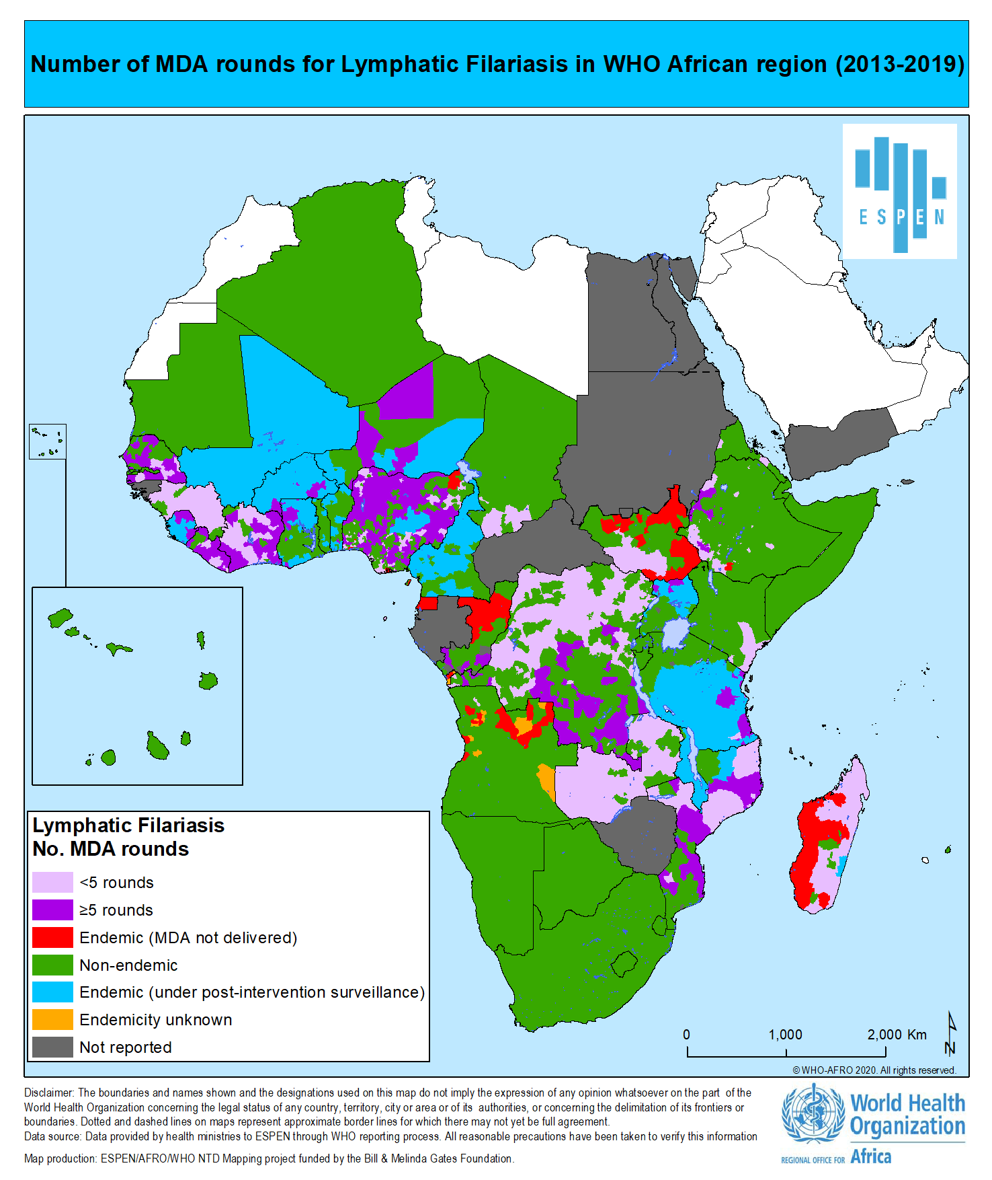

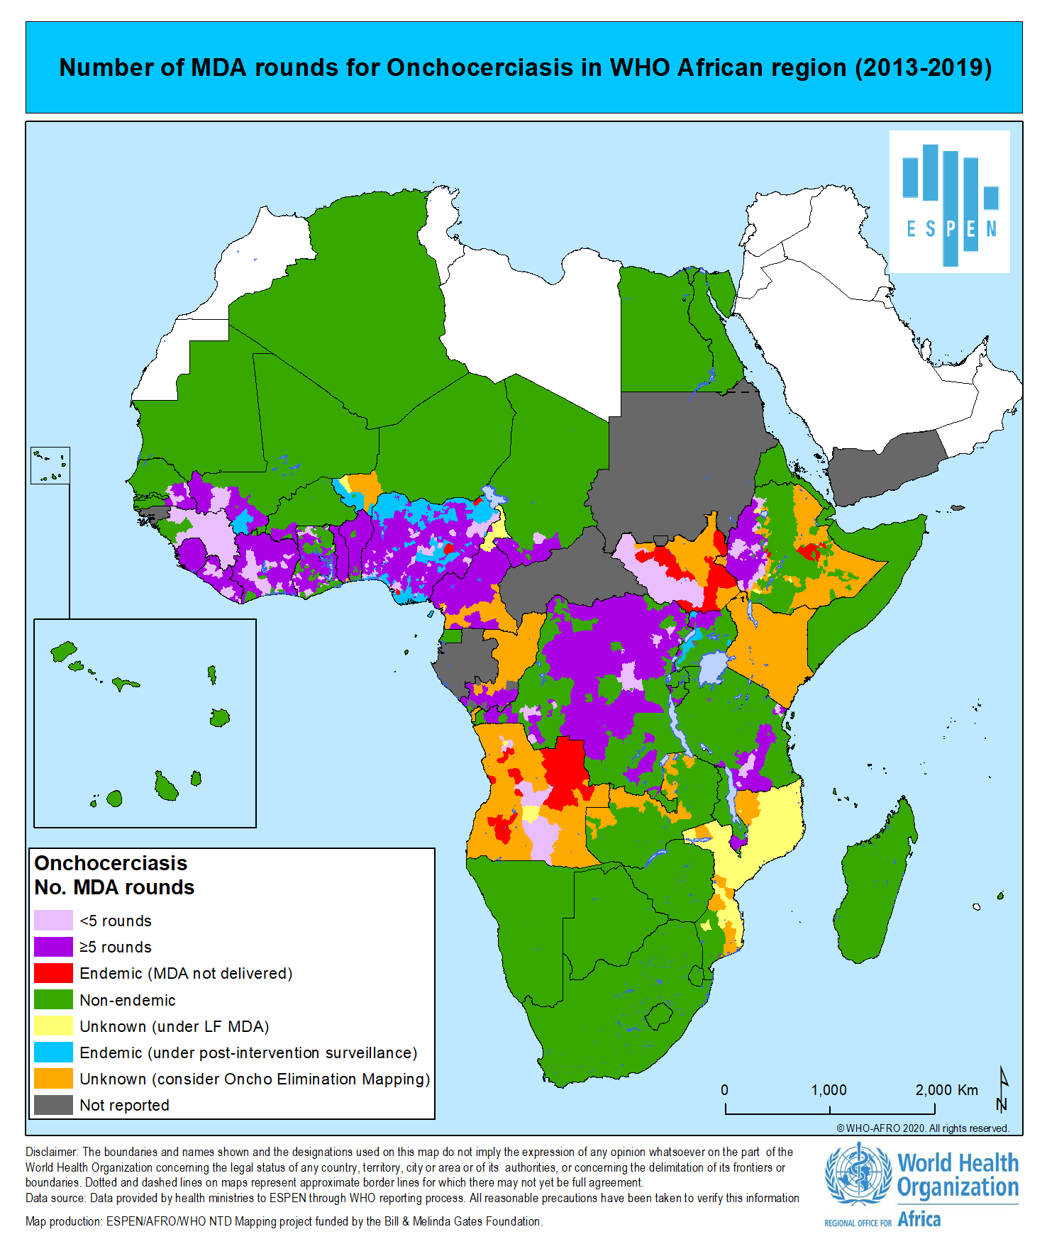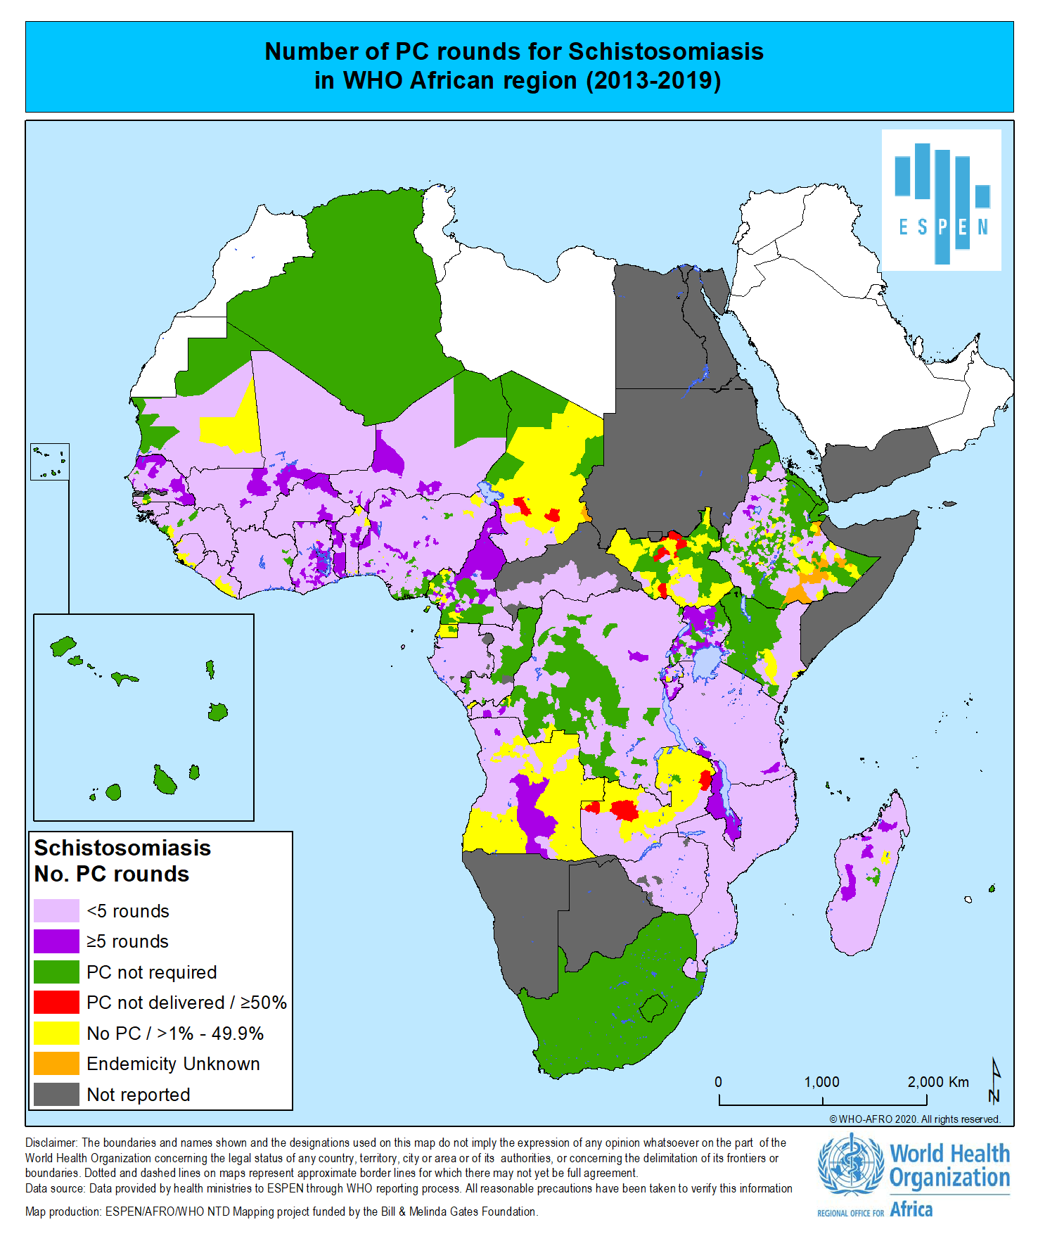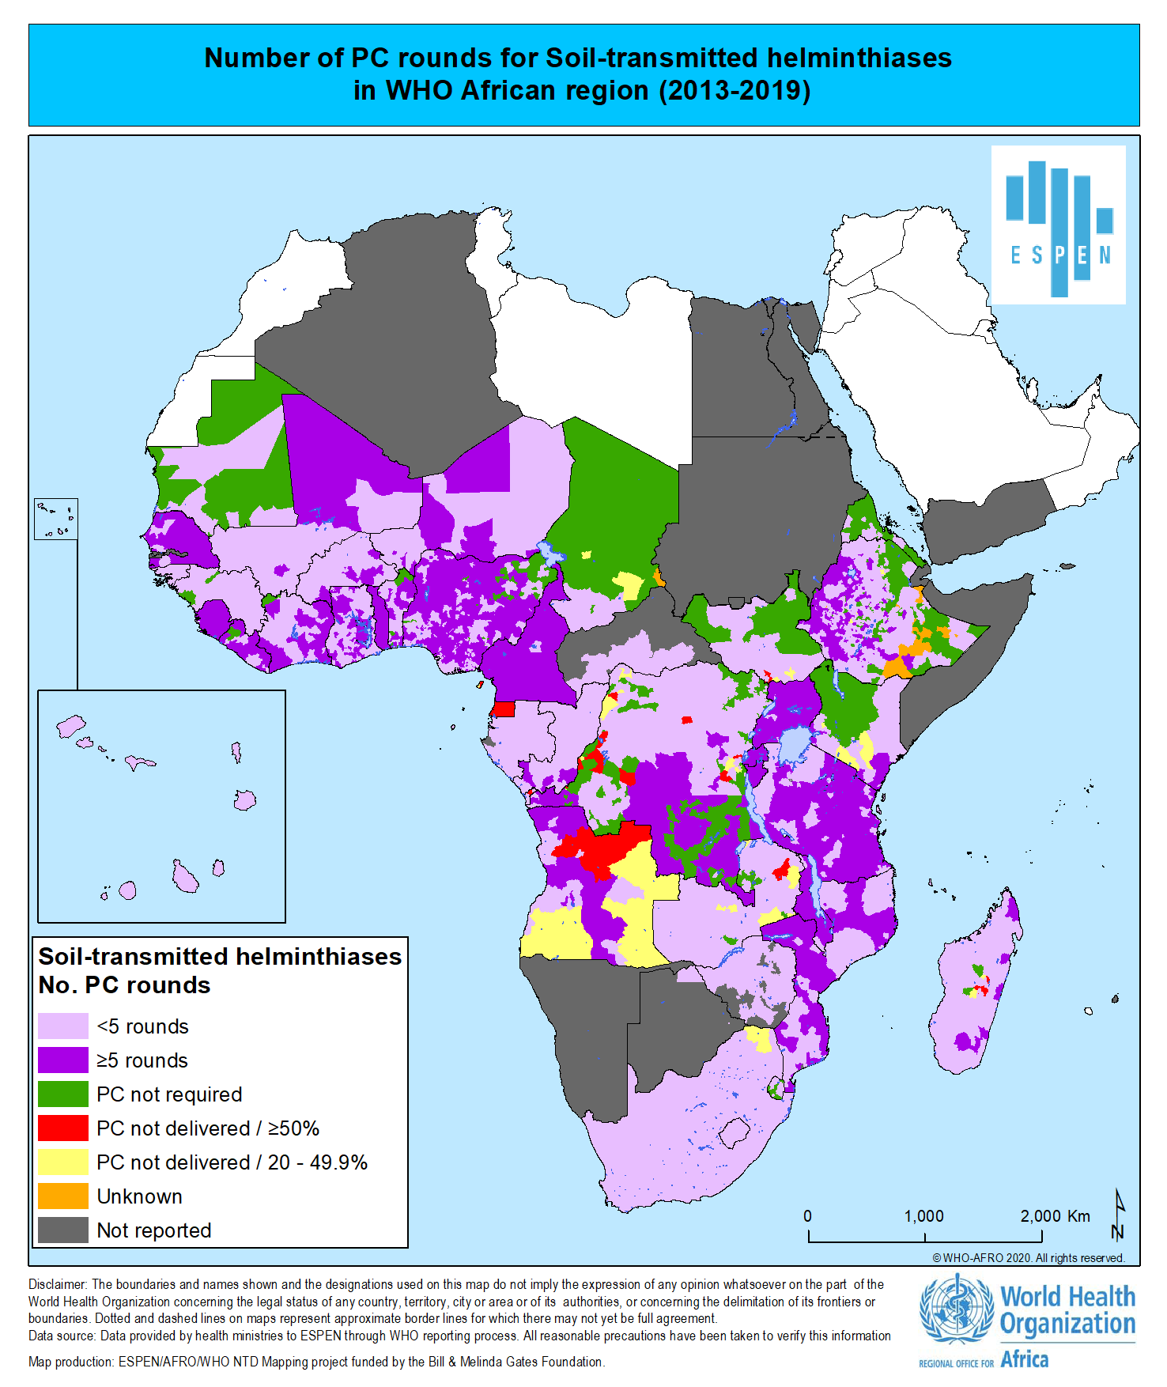

Angola, Benin Botswana, Burundi, Cameroon, CAR, Chad, Congo, Cote d’Ivoire, DRC, Eq. Guinea, Eritrea, Ethiopia, Gabon, Gambia, Guinea, Kenya, Lesotho, Liberia, Madagascar, Malawi, Mauritania, Mauritius, Mozambique, Namibia, Niger, Nigeria, Sao Tome & Principe, Senegal, Seychelles, South Africa, South-Sudan, Swaziland, Tanzania, The Gambia, Uganda, Zambia & Zimbabwe
Benin, Central African Republic, Chad, Congo, the Democratic Republic of Congo, Cote d’Ivoire, Egypt, Eritrea, Ethiopia, Guinea, Malawi, Mozambique, Nigeria, Senegal, Sudan, Tanzania, Uganda and Zimbabwe
Benin, Burkina Faso, Burundi, Cabo Verde, Cameroon, Central African Republic, Chad, Comoros, Congo, Côte d'Ivoire, Democratic Republic of the Congo, Eritrea, Eswatini, Ethiopia, Gabon, Ghana, Guinea, Guinea-Bissau, Kenya, Lesotho, Liberia, Madagascar, Malawi, Mali, Mauritania , Mozambique, Niger ,Nigeria, Rwanda, Sao Tome and Principe, Senegal, Sierra Leone, South Sudan ,Tanzania, Togo, Uganda, Zambia, Zimbabwe.
Benin, Burkina Faso, Cameroon, Chad, Comoros, Congo, Côte d’Ivoire, Democratic Republic of the Congo, Eritrea, Ethiopia, Ghana, Guinea, Guinea- Bissau, Kenya, Liberia, Mali, Mozambique, Niger, Senegal, Sao Tome and Principe, Sierra Leone, Uganda, United Republic of Tanzania, Zambia, Zimbabwe
Benin, Burkina Faso, Burundi, Côte d’Ivoire, Ethiopia, Gabon, Guinea, Guinea-Bissau, Liberia, Malawi, Mali, Mauritania, Niger, Sao Tome and Principe, Togo, United Republic of Tanzania
Burkina Faso, Burundi, Malawi, Togo, Liberia and Mali
Burundi, Cabo Verde, Côte d’Ivoire, Democratic Republic of the Congo, Ethiopia, Guinea, Malawi, Mozambique, Nigeria, Rwanda, Sao Tome and Principe, South Africa, Uganda and United Republic of Tanzania.
Burkina Faso, Burundi, Cameroon, Ghana, Malawi, Mali, Niger, Rwanda, Sierra Leone, Togo and Uganda
Midzi N, et al. Elimination of STH morbidity in Zimbabwe: Results of 6 years of deworming intervention for school-age children. PLoS Negl Trop Dis. 2020 Oct 23;14(10):e0008739.
Central African Republic, The Democratic Republic of Congo, Ethiopia, Kenya, Nigeria and South Sudan.
Benin, Burkina Faso, Burundi, Malawi, Mali, Mauritania & Senegal

