**The Republic of Liberia**

**Ministry of Health**

P10#yIS1

Master Plan for Neglected Tropical Diseases

**2023 -2027**

Contents

Abbreviations and Acronyms 7

Key Definitions 9

Foreword 11

Acknowledgements 12

Purpose of Document 16

The NTD Masterplan Development Process 16

Executive Summary 18

PART 1: NTD Situation Analysis 22

Section 1.1. Re-assess National Priorities and the national, regional, and global NTD Commitments 22

Section 1.2. National Context Analysis 23

1.2.1 Country Analysis 23

1.2.2. Health Systems Analysis 27

1.2.3 Analysis of the overall health system 29

Section 1.3. Gap Assessment 34

1.3.1 CouNTDown Research 34

1.3.2 FGS Research 36

1.3.3 REDRESS Research Project 38

1.3.4 Research findings on NTDs Interventions 42

Section 1.4 Disease Specific Analysis 44

1.4.1 Onchocerciasis 45

1.4.2 Lymphatic Filariasis (LF) 53

1.4.3 Soil Transmitted Helminths (STHs) 58

1.4.4 Schistosomiasis 62

1.4.5 Female Genital Schistosomiasis (FGS) 63

1.4.6 Leprosy 64

1.4.7 Buruli Ulcer 66

1.4.8 Yaws 68

1.4.9 Rabies 71

1.4.10 Unconfirmed or unmapped NTDs 72

Section 1.5. Program Context Analysis 72

1.5.1. Current NTD Program Organization and Status 73

1.5.2 Co-endemicity of NTDs in Liberia 74

1.5.3. NTD Program Performance (2017-2022)* and cross cutting issues 77

1.5.4 Performance of the other programs that are closely related to NTD Program 78

Section 1.6: Building on NTD Program Strengths 91

1.6.1. Strengths and Weaknesses 91

1.6.2. Opportunities and Threats 92

1.6.3. Gaps and priorities 92

PART 2 Strategic Agenda: 94

2.1 Purpose and Goals 94

Section 2.1: NTD Program Mission and Vision 94

Section 2.2: Milestones and Targets 95

2.2.1. Targets 95

2.2.2. Milestones 98

Section 2.3: Guiding Principles 102

Section 2.4: Strategic Pillars and Strategic Objectives 103

2.4.1. Program Strategic Pillars 103

2.4.2. Strategic Objectives 105

PART 3 Implementing the Strategy: NTD Operational Framework 107

Section 3.1: Strategic priorities and Key Activities 108

Section 3.2: Toward Program Sustainability: Intensifying Coordination and Partnerships 149

Section 3.3: Assumptions, Risks and Mitigations 156

Section 3.4. Performance and Accountability Framework 159

**List of Figures**

Figure 1 Participants at the opening ceremony of the Stakeholders Workshop 15

Figure 2 NTD Master Plan: Key Contents 20

Figure 3 NTD Master Plan: Process and Management Cycles 21

Figure 4 Geo-political map of Liberia (July, 2018) 23

Figure 5 Counties of Liberia within the Region 24

Figure 6 Endemicity of PC NTDs 2021 34

Figure 7 Map showing treatment coverage in 15/15 IUs 45

Figure 8 REMO map showing distribution of Onchocerciasis in Liberia 46

Figure 9 Map of counties surveyed 50

Figure 10 Antigenemia (ag) results from baseline and sentinel site surveys in 2012 and 2016 55

Figure 11 Microfilaria (MF) prevalence from baseline and sentinel site surveys 2012 and 2016 55

Figure 12 AG prevalence from sentinal site surveys in 2018 56

Figure 13 Mf prevalence from sentinel site surveys in 2018 56

Figure 14 STH treatment coverage 59

Figure 15 Prevalence of STH in Liberia, 2015 60

Figure 16 Trichuria prevalence and distribution 60

Figure 17 Ascaris prevalence and distribution 60

Figure 18 Hookworm prevalence and distribution 61

Figure 19 STH prevalence and distribution 61

Figure 20 Schistosomiasis Treatment Coverage 62

Figure 21 Map of Liberia showing location of survey 69

Figure 22 Routine data new case detection rate, Maryland, Jan - Dec 2017 70

Figure 23 Survey cases previously unknown to the health system, Maryland county 70

Figure 24 Map of Maryland county with positive yaws case during the survey 71

Figure 25 NTD endemicity by implentation unit 74

Figure 26 Map showing PCT-NTDs co-endemicity 75

Figure 27 CM-NTDs Co-endemicity Map 76

Figure 28 NTD mapping status 77

Figure 29 Map of access to improved water and schistosomiasis 85

Figure 30 Hierarchy of objectives for Liberia NTD Program 94

Figure 31 Program Strategic Pillars 103

Figure 32 Logic map summary diagram 104

Figure 33 Ministry of Health Organogram - NTD Program **Error! Bookmark not defined.**

**List of Tables**

Table 1 Liberia health system analysis using the six health systems building blocks 33

Table 2 Research findings on NTD interventions 44

Table 3 No. and % Ov16 RDT positive children per community 48

Table 4 County level Ov16 RDT positivity 49

Table 5 Summary of Ov16 sero-positivity in each of the five survey counties 49

Table 6 Summary of data from rivers in counties visited 53

Table 7 Results from MDA for LF in Liberia 54

Table 8 Results from sentinel sites 2012, 2017 and 2018 57

Table 9 Results of preTAS in selected counties 58

Table 10 Prevalence of Schistosomiasis Mansoni from Baseline to Follow up 3 62

Table 11 Prevalence of Schistosomiasis Haematobium from baseline to Follow up 3 63

Table 12 Situation of leprosy in Liberia at the end of 2021 **Error! Bookmark not defined.**

Table 13 Burden of leprosy in Liberia from 2016 - 2021 66

Table 14 Situation of Buruli ulcer in Liberia at end of 2021 form follow up of BU assessment (HMIS) 67

Table 15 Buruli ulcer case detection in Liberia 2016 - 2021 68

Table 16 Suspected and confirmed yaws cases from 2018-2021 71

Table 17 National population data, schools and health facilities at county level 73

Table 18 Known NTD distribution in Liberia per county 74

Table 19 Vectors and associated NTDs 78

Table 20 WASH & NTDs Challenges 84

Table 21 Summary of intervention information on existing NTD Program 91

Table 22 Strengths and weaknesses 92

Table 23 Opportunities and threats 92

Table 24 Gaps and Priorities 94

Table 25 NTD Program Mission and Vision 95

Table 26 Liberia NTDs Targets 2027 95

Table 27 Cross-cutting Targets 96

Table 28 Disease specific targets 97

Table 29 Milestones for targeted NTDs (LF) 98

Table 30 Milestones for targeted NTDs (Onchocerciasis) 99

Table 31 Milestones for targeted NTDs (Schistosomiasis) 100

Table 32 Milestones for targeted CM NTDs 102

Table 33 Guiding Principles 103

Table 34 Strategic Objectives for the Elimination of Neglected Tropical Diseases 106

Table 35 Strategic pillars with activities 148

Table 36 Membership and Terms of Reference - Program Coordination Mechanism 152

Table 37 Partnership Matrix 155

Table 38 Performance Indicators for Pillar 1 160

Table 39 Performance Indicators for Pillar 2 162

Table 40 Performance Indicators for Pillar 3 164

Table 41 Performance Indicators for Pillar 4 165

# Abbreviations and Acronyms

|  |  |
| --- | --- |
| ALB | Albendazole |
| AFRO | Africa Region of the World Health Organization |
| APOC  BU | African Program for Onchocerciasis Control  Buruli Ulcer |
| CDD | Community Drug Distributor |
| CDTI | Community Directed Treatment with Ivermectin |
| CHANGES | Community Health and Nutrition, Gender and Education Support |
| CHDs | Child Health Days |
| CM | Case Management (NTDs) |
| CMCHWs  CHW | Community Maternal Child Health Workers  Community Health Worker |
| ComDT | Community Directed Treatment |
| DALYs | Disability Adjusted Life Years |
| DEC | Diethyl carbamazine Citrate, an anti-filarial drug |
| DFMO | DL - alpha-difluoro-methyl-ornithine (Eflornithine), a trypanocidal drug |
| DHT | District Health Team |
| EIA  GDP | Environmental Impact Assessment  Gross Domestic Product |
| GNP | Gross National Product |
| GPELF | Global Program for Elimination of Lymphatic Filariasis |
| GWE | Guinea Worm Eradication |
| HAT | Human African Trypanosomiasis |
| HIV | Human Immunodeficiency Virus |
| HSSP | Health Sector Strategic Plan |
| IDSR | Integrated Diseases Surveillance and Response |
| IEC | Information Education and Communication |
| IRS | Indoor Residual Spraying |
| ITNs | Insecticide Treated Nets |
| IVM | Ivermectin |
| IU | Implementation Unit |
| LF | Lymphatic Filariasis |
| LFE | Lymphatic Filariasis Elimination |
| MADP | Mectizan Albendazole Donation Program |
| MBD | Mebendazole |
| MDA | Mass Drug Administration |
| MP | Master Plan |
| NGDO | Non-Governmental Development Organization |
| NGO | Non-governmental Organization |
| NTD | Neglected Tropical Disease |
| ONCHO | Onchocerciasis |
| PATTE | Pan African Tsetse and Trypanosomiasis Eradication Campaign |
| PCT  PEST | Preventive Chemotherapy  Politicial, Economic, Social and Technological Analysis |
| PELF | Program for Elimination of Lymphatic Filariasis |
| PHC | Primary Health Care |
| PZQ | Praziquantel |
| SAC | School age children |
| SAEs | Severe Adverse Events |
| SBCC  SBE | Social and Behavior Change  Snake bite envenoming |
| SCH | Schistosomiasis |
| SSTH | Schistosomiasis and Soil Transmitted Helminthiasis |
| STH | Soil Transmitted Helminthiasis |
| SWOT | Strengths, weaknesses, opportunities, and threats |
| TRA | Trachoma |
| TDR | Special Program for Tropical Diseases Research |
| UNDP | United Nations Development Program |
| UNICEF | United Nations International Children’s Emergency Fund |
| USAID | United States Agency for International Development |
| VL  WASH | Visceral Leishmaniasis  Water, Sanitation and Hygiene |
| WFP | World Food Program |
| WHA | World Health Assembly |
| WHO/AFRO | World Health Organization Regional Office for Africa |
| WHO | World Health Organization |

# Key Definitions

**Active case detection:** Deliberate efforts to identify cases through screening for a disease or diseases in at-risk populations. Active case detection is usually implemented outside of health facilities.

**Control:** Reduction of disease incidence, prevalence, morbidity, and/or mortality to a locally acceptable level as a result of deliberate efforts; continued interventions are required to maintain the reduction. Control may or may not be related to global targets set by WHO.

**Disability:** Inability to perform routine daily activities adequately or independently; the negative aspects of the interaction between a person with a health condition and his or her context (environmental and personal factors)

**Disability-adjusted** life year (DALY): A measure of overall disease burden. One DALY represents the loss of the equivalent of one year of full health

**Elimination (interruption of transmission):** Reduction to zero of the incidences of infection caused by a specific pathogen in a defined geographical area, with minimal risk of reintroduction, as a result of deliberate efforts; continued action to prevent re-establishment of transmission may be required. Documentation of elimination of transmission is called verification.

**Elimination as a public health problem:** A term related to both infection and disease, defined by achievement of measurable targets set by WHO in relation to a specific disease. When reached, continued action is required to maintain the targets and/or to advance interruption of transmission. Documentation of elimination as a public health problem is called validation.

**Eradication:** Permanent reduction to zero of the worldwide incidences of infection caused by a specific pathogen, as a result of deliberate efforts, with no risk of reintroduction.

**Hygiene:** Conditions or practices conducive to maintaining health and preventing disability.

**Integration:** the process by which disease control activities are functionally merged or coordinated within multifunctional health-care delivery

**Integrated vector management:** A rational decision-making process to optimize the use of resources for vector control.

**Mass Drug Administration:** Distribution of medicines to the entire population of a given administrative setting (for instance, region, county, district, sub district or village), irrespective of the presence of symptoms or infection; however, exclusion criteria may apply. (In this document, the terms mass drug administration and preventive chemotherapy are used interchangeably.)

**Morbidity:** Detectable, measurable clinical consequences of infections and disease that adversely affect the health of individuals. Evidence of morbidity may be overt (such as the presence of blood in the urine, anemia, chronic pain or fatigue) or subtle (such as stunted growth, impeded school or work performance or increased susceptibility to other diseases).

**Monitoring and Evaluation:** Processes for improving performance and measuring results in order to improve management of outputs, outcomes and impact.

**Platform:** Structure through which public health programs or interventions are delivered.

**Preventive chemotherapy:** Large-scale use of medicines, either alone or in combination, in public health interventions. Mass drug administration is one form of preventive chemotherapy; other forms could be limited to specific population groups such as school-aged children and women of childbearing age. In this document, the terms preventive chemotherapy and mass drug administration are used interchangeably.

**Rehabilitation:** A set of interventions designed to optimize functioning and reduce disability in individuals with health conditions in interaction with their environment

**Skin Neglected Tropical Diseases (Skin NTDs):** A subset of neglected tropical diseases with skin manifestations that impair, disable and disfigure and may lead to stigmatization, discrimination and socioeconomic problems

**Stigma:** A negative stereotype or perception that can lead someone to unfairly judge another person and falsely attribute negative characteristics to them. Stigma can result in prejudice (negative attitudes) and discrimination (negative behavior) towards persons affected by skin NTDs and/or mental health conditions and their families

# Foreword

Globally, one in seven persons suffer from Neglected Tropical Diseases (NTDs), the burden of NTDs in Liberia is an impediment to socio-economic development and leads to destitution of those that are affected and at risk of these disabling diseases. There is no doubt that NTDs constitute a challenge to the attainment of Universal Health Coverage (UHC), the Sustainable Development Goals (SDGs), the African development agenda of 2063 - “the Africa we want” and the Pro-poor Agenda for Prosperity and Development (PAPD).

In recognition of the danger posed by NTDs in the fight against poverty and the growth and development of Liberia, the Ministry of Health included the control and eradication of NTDs (e.g.; Onchocerciasis, Lymphatic Filariasis, Soil-transmitted Helminths, Schistosomiasis, Buruli Ulcer, Rabies and Leprosy) among the priority diseases to be addressed in the National Health Plan of 2023-2027.

The Ministry of Health collaborated with partners to develop this National NTDs Master Plan based on evidence gathered on the burden, prevalence and co-endemicity from nationwide epidemiological mapping of the NTDs in the country and intervention evaluation. This Master Plan provides the framework for resource mobilization and the acceleration of interventions that will prevent, control and eradicate priority NTDs in Liberia. It has a monitoring framework to track the performance of the program towards improving NTDs services and interventions in Liberia. The objectives of the Master Plan are to strengthen ownership at the national and sub-national levels, advocacy for sustained resource mobilization, coordination partnership and monitoring of the program performance. The core strategies identified to accelerate interventions towards elimination include, leadership and governance, awareness creation, evidence generation, expansion and improvement of services, coordination and partnership for sustained resource mobilization.

It is my ardent hope and prayer that this Master Plan will guide the implementation of NTDs interventions in Liberia and that development partners will align their resources and commit to its implementation

Dr. Wilhelmina Jallah,

Minister of Health

Acknowledgements

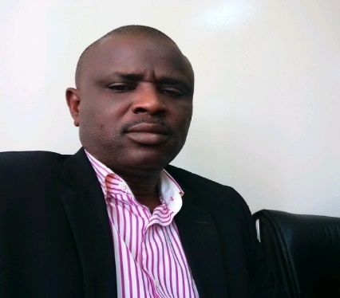The 2023-2027 NTDs Master Plan development was undertaken by the Ministry of Health, the World Health Organization, alongside other development partners with the aim of reducing the burden of NTDs in Liberia and accelerating actions for the elimination of priority NTDs.

Our gratitude goes to the World Health Organization, American Leprosy Mission, Effect Hope, Sightsavers, Anesvad, Liverpool School of Tropical Medicine (LSTM) , Schistosomiasis Control Initiative UK, Action Transforming Lives, German Leprosy Relief Association, , and other partners for providing technical and financial support for the successful completion of this NTDs Master Plan. We want to thank Professor Sammy Sam-Wobo, Dr. Helene Kwamba and Dr. Fred Maloba, the ESPEN consultants who guided the process along with WHO Dr. Moses Jeuronlon and our partners Mrs. Tiawanlyn G. Godwin-Akpan from American Mission, Mr. Alex Bedell from SightSavers, and Liberia NTD Ambassador, Dr. Evelyn D. Kandakai whose work contributed immensely to the successful completion of this Plan.

I want to extend sincere thanks to the National NTDs Program team led by Mr. Karsor K. Kollie; Dr. Lorrine Cooper, Director of County Services; Dr. Ngombu Ballah, the Director of Quality Management Unit (QMU), and the Assistant Minister for Curative Services, Dr. Gorbee G. Logan for their meaningful contribution.

Special thanks and appreciation is extended to the Ministry of Health Policy and Planning team led by George P. Jacobs; Assistant Minister for Policy and Planning, Martin Dumoe; Director of Policy and Planning, Chea Sanford Wesseh; Assistant Minister for Vital Statistics, Carlton Kpan; Dorcas Wonnah of the M&E Unit and Justin Korvanyan, Director of Decentralization, for their invaluable contribution towards the planning and development of this Plan.

In addition, the successful completion of the 2023-2027 NTDs Master Plan has been made possible by the many institutions and individuals that contributed immensely at all levels of the Plan development process. I wish to extend my sincere thanks and appreciation to them for their tireless and valuable support.

This Master Plan builds on the foundation and progress made in implementing previous strategic plans and tries to address some of the inherent challenges identified previously. In alignment with the Global Roadmap for the elimination of NTDs, this Plan reflects three fundamental shifts from previous plans in the approach to tackling NTDs:

Increase accountability for impact by using impact indicators instead of process indicators.

Move away from siloed, disease-specific programs by mainstreaming programs into national health systems and intensifying cross-cutting approaches centered on the needs of people and communities in the context of Universal Health Coverage.

Appreciations are extended to the following for their contribution to the development and validation of this NTD Master Plan:

|  |  |
| --- | --- |
| **Name** | **Organization/Designation** |
| G. Martin Dumoe | MOH/Director, Planning |
| Karsor Kollie | MOH/Director NTDs |
| Peter Flomo | MOH/NTD Program Administrator |
| Prof. Sammy Sam-Wobo | WHO ESPEN Consultant |
| Dr. Moses K. Jeuronlon | WCO NTD FP |
| Dr. Hélène Kwamba | WHO ESPEN Consultant |
| Dr Fred Maloba | WHO ESPEN Consultant |
| Dr. Alex Bedell | Country Director, SightSavers |
| Mulbah Howard | NTD Manager, SightSavers |
| Alexlyn S. Monluo | MOH/Deputy Director NTDs |
| Tiawanlyn G. Godwin-Akpan | American Leprosy Mission |
| Patrick Konwloh | MOH/Director Health Information |
| Darwosu Borbor | MOH/NTD Program |
| Emerson Rogers | MOH/CM NTD Coordinator |
| Dorcas Wonnah | MOH/NTD M&E Officer |
| Joseph S. Quoi | MOH/Mental Health Division |
| Magdalene W. Barcoon | ACTS |
| Dr. Lorrane C. Cooper | MOH/CHS Director |
| Gifty Clarke | MOH/NHPU |
| Victor Kiatamba | MOH/HR |
| John B. Mattia | Bomi-NTDs FP |
| Augustione B. Flomo | Margibi-NTDs FP |
| Anthony Kerkula Bettee | MOH/NTDs Schisto/STH Coordinator |
| Abednego S. Wrights | Nimba-NTDs FP |
| Anthony W. Sali | Lofa-NTDs FP |
| Gar Mondyu Gargannah | Sightsavers |
| Derry Saye-weh Duokie | MOH/CHSD |
| Josephine T. Saul | Bong-NTDs FP |
| Jeremiah Davis | G. Gedeh-NTD FP |
| T. Henry Kohar | NDD |
| Gorbee Logan | MOH-AM/CS |
| Dr. Cynthia Blapool | Bong-CHO |
| Tarlo K. Beyan-Bakai | MOH/NTDs |
| Dr. Netty N. Joe | Nimba-CHO |
| Garmai M. Kennedy | Montserrado-NTDs FP |
| Life Kolako | MOH/NTDs |
| F. Zeela Zaizay | REDRESS |
| Georgina V. K. Zawolo | REDRESS |
| Ngormbu Jusu Ballah | MOH/QMU-Director |
| Estella G. Dandy | Sinoe-NTDs FP |
| Carlton G. Kpahn | MOH/Planning |
| Dorcas Y. Wonnah | MOH/M&E |
| Dr. Cecelia Woods Cheneyon | GCM-CHO |
| Quita M. Kollie | Client |
| Wuo Paye | Client |
| Gboilee M. Mulbah | MOH/Central |
| A. Vaifee Tulay | MOH/DMPPR |
| George P. Jacobs | MOH/Asst. Minister PPR |
| Dr. Aaron Y. Kollie | MOH/NTDs |
| Mike Mulbah | MoH/M&E Director |
| Sonnie Ziama Gbewo | MOH/NTDs Oncho Coordinator |
| Abraham W. Nyenswah | MOH/NTDs LF Coordinator |
| Anna Wickenden | Effect Hope/REDRESS |

Finally, I wish to extend my sincere thanks and appreciation to everyone who took off time from their busy schedule to participate in the development and validation of this Master Plan, as well as others whose names have not been mentioned herein, but made tremendous contributions.

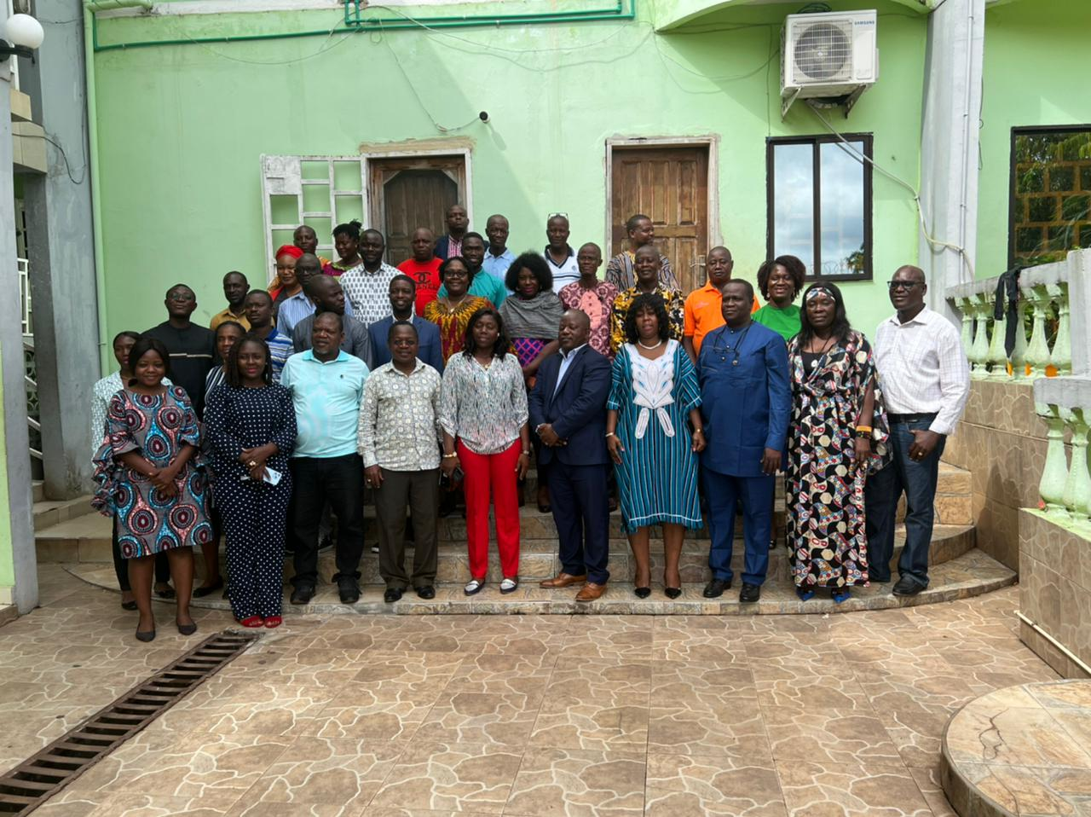

Figure 1 Participants at the opening ceremony of the Stakeholders Workshop

A. Varfee Tulay

Deputy Minister for Policy, Planning and M&E

# Purpose of Document

|  |
| --- |
| This integrated NTD Masterplan is intended to guide the Ministry of Health and its partners to design and implement interventions to control NTDs in the country, towards the control and elimination of selected NTDs in Liberia for the period 2023-2027 and in alignment with the WHO NTD Roadmap 2021-2030. This document can also be used for resource mobilization for NTD interventions to achieve the national vision for NTD elimination in the country and to guide the contribution of donors and partners to the national response to NTDs in Liberia.  In the spirit of integration and health system strengthening for Universal Health Coverage, this NTD Masterplan can be used to guide other national programs of the Ministry of Health and relevant government sectors and bilateral and multilateral partners to set priorities, design programs, and allocate resources to leverage investments for NTDs.  The NTD Masterplan can play a significant role in planning and undertaking comprehensive national health reviews, particularly when evaluating the National Health Plan, including the One Health Platform, and assessing progress toward achieving the Sustainable Development Goals. |
|  |
| The NTD Masterplan Development Process |
| Following the expiration of the 2016-2020 NTD Master Plan, there was a need to develop an updated version for the period 2023-2027. A team comprising of national and international experts and MOH partners conducted desk reviews, identified gaps, and ensured alignment with national priorities and global targets to generate the first draft of this NTD Masterplan. Following this was a national stakeholder workshop to review and develop a draft of the Masterplan, this draft was shared with international partners and technical experts. Following the consolidation of all comments the final draft was developed and shared prior to a validation meeting that took place in February 2023. The validation meeting focused on the key results and approaches outlined within the plan, and was followed by a small working group who have reviewed and instituted the recommended changes to the document following the workshop. The final version of the NTD Master Plan was completed on the 30th May 2023, and shared with all stakeholders.  This Master Plan is also in alignment with the framework and guide designed by the World Health Organization Regional Office for Africa for the development of NTD masterplans. The following strategic documents have informed this NTD Masterplan:   * The WHO Framework for Monitoring and Evaluating Progress of the Roadmap for Neglected Tropical Diseases 2021−2030. * The Global Leprosy (Hansen’s disease) Strategy 2021–2030. * The WHO Strategic Framework for Integrated Control and Management of Skin-Related Neglected Tropical Diseases 2021-2030.   The contribution of the following partners is acknowledged: WHO/AFRO, WHO Liberia, Effect Hope, Anesvad, Actions Transforming Lives, American Leprosy Missions, SightSavers, Schistosomiasis Control Initiative, REDRESS/Liverpool School of Tropical Medicine, German Leprosy ReliefAssociation, Ministry of Education, Ministry of Agriculture, and Italian Association Friends of Raoul Follereau. |

# Executive Summary

[Liberia](https://en.wikipedia.org/wiki/Liberia) is a [sub-Saharan](https://en.wikipedia.org/wiki/Sub-Saharan_Africa) nation in West Africa located at 6 °N, 9 °W. It borders the south Atlantic Ocean to the southwest and three other African nations on the other three sides, [Sierra Leone](https://en.wikipedia.org/wiki/Sierra_Leone) to the northwest, [Guinea](https://en.wikipedia.org/wiki/Guinea) to the northeast and [Ivory Coast](https://en.wikipedia.org/wiki/Ivory_Coast) (Côte d'Ivoire) to the east. In total, Liberia comprises 111,369 square kilometers (43,000 sq mi) of which 96,300 square kilometers (37,190 sq mi) is land and 15,000 square kilometers (5,810 sq mi) is water.

The country is divided into 15 Counties. The Liberian health system is organized into four levels: central, county, district, and community levels. The central level is responsible for policy development and guidance, the county level is responsible for providing policy guidance and oversight to its counties and the district level is responsible for overseeing service delivery. The priority diseases in Liberia include Malaria, Diarrhea, RTI/Pneumonia, STI, Typhoid, Malnutrition, Tuberculosis, HIV/AIDs. Neglected Tropical Diseases are generally coming into recognition as key public health issues within the health system. Based on available mapping data, historical information and data from published papers Liberia is affected by eight (8) Neglected Tropical Diseases, most of which are readily preventable and/or treatable. Some of these have been mapped and interventions commenced while a number, particularly case management NTDs are either yet to be mapped or fully mapped.

The strategic goal of the NTD Program is to reduce morbidity, disability and mortality via the control, elimination and eradication of targeted NTDs and contribute to poverty alleviation, increased productivity and better quality of life for the affected people in Liberia. Its focus is to progressively reduce morbidity, disability and mortality due to NTDs using integrated and cost-effective approaches with the view to eliminating NTDs in Liberia by the year 2030.

1. The Program’s Strategic Priorities are:Accelerating programmatic action.
2. Identify cross-cutting approaches.
3. Operating Models and culture to facilitate country ownership.
4. Strengthen resource mobilization, coordination and collaboration for the elimination of NTDs

The operational framework of this NTD master plan describes how Liberia will, in practice, implement the planned activities. It explains what the country’s capacity needs are, how resources will be mobilized, how potential risks will be mitigated, the scale-up strategy, assessment, and verification of disease elimination, and how the sustainability of the program achievements will be ensured. Mass drug administration, case management and transmission control are the main strategies that will be used to achieve the stated goals and objectives in the control of NTDs in Liberia.

The major activities that have been planned include procurement of medicines, conduct of NTD mapping and burden assessment surveys , capacity building of personnel at various levels, conduct of MDA, integrated surveillance, scaling up of the integration of case management (CM-NTDs), integrated vector management, and advocacy, sensitization and resource mobilization initiatives. Others include strengthening of NTD integration within county structures, development of tools and guidelines for NTD interventions, program reviews, supervision, monitoring, impact assessment, strengthening of the integrated data management system, as well as the capacity strengthening of NTD Focal Points at County and District Levels.

This Neglected Tropical Diseases (NTD) Master Plan (MP) 2023-2027, an updated version of the NTD MP (2016-2020), is aligned with the Liberia National Health Policy (NHPP 2022-2031) and the Essential Package of Health Services II. It aims to accelerate progress toward the elimination of priority NTDs in the framework of universal health coverage by improving access to integrated NTD services in Liberia

The NTD MP is an essential component for the effective planning and implementation of sustainable NTD programs. The Plan provides program goals and objectives, as well as a five-year detailed strategic plan based on extensive situation analyses and addresses all components of the NTD programs considered relevant to Liberia. Data from the mapping of NTDs in Liberia indicates medium-high prevalence and overlap of the following NTDs - Onchocerciasis, Lymphatic Filariasis, Schistosomiasis, Soil Transmitted Helminths, Buruli Ulcer, Leprosy, and Yaws. Therefore, the MP will enhance synergies among various NTD initiatives, provide the basis for integrated or linked NTD project plans, and includes costing and financing requirements for effective NTD program implementation and performance.

The NTD Master Plan forms the basis for harmonized and integrated implementation and performance monitoring of all NTD interventions in Liberia. The Plan aims to provide guidance to all partners and stakeholders working on NTDs in the country and to facilitate integration, partnership, coordination, and collaboration, and therefore, to effectively manage available resources to maximize investment outcomes. This Plan, which will also facilitate the achievements towards the 2030 NTDs elimination targets and goals, is focused on improving access to NTD-related interventions, enhancing planning for results, resource mobilization and financial sustainability of the National NTD Program, strengthening advocacy, coordination, and national ownership, and enhancing monitoring, evaluation, surveillance, and research on NTDs.

Progress in the implementation of planned activities, as well as the program performance and output, will be monitored regularly and evaluated at appropriate intervals. The strategic plan will be the framework for partner coordination, harmonization, and alignment. The contents are expected to enhance mutual commitment and accountability, transparency, and evidence-based and verifiable plans of all stakeholders to enhance effective and sustainable resource mobilization for NTD interventions in Liberia.

The preparation and updating of this NTD Master Plan was a process that included analysis of NTD programs, development process, and validation. The process included reviews, consultation meetings, workshops involving partners and stakeholders (in-country and outside), as well as consideration of outcomes of various monitoring and evaluation activities.

This Master plan comprises three main components:

1. Situation analysis
2. The NTD strategic agenda and
3. The Operational Framework

The situation analysis covers the NTDs, the health system, and the external profile of Liberia. The NTDs strategic agenda covers the mission, vision, strategic goals, program objectives, and focus, strategic milestones, priorities, and objectives. The operational framework covers the NTDs’ multiyear budget for strategic activities and sub-activities while addressing the strategic priorities and objectives (see figures 2 and 3).

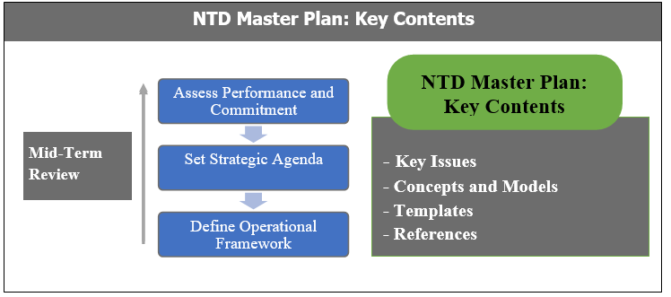

Figure 2 NTD Master Plan: Key Contents

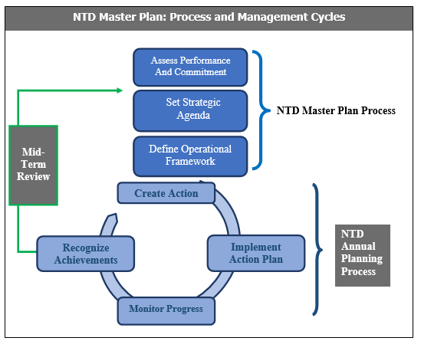

Figure 3 NTD Master Plan: Process and Management Cycles

PART 1: NTD Situation Analysis

## Section 1.1. Re-assess National Priorities and the national, regional, and global NTD Commitments

Neglected Tropical Diseases are a diverse group of more than 20 diseases affecting an estimated 1.7 billion people worldwide, predominantly impacting low-income populations in Africa, Asia, and the Americas. In recent years, NTDs have been included in global health priorities following the endorsement of the 2012 London Declaration on NTDs by a wide range of partners, research institutions, civil society organizations, and donors to support the delivery of the World Health Organization (WHO) NTD 2030 roadmaps.

NTDs are prioritized in the United Nations Agenda for Sustainable Development Goal 3 (SDG3) target, which states, “By 2030, end the epidemics of AIDS, tuberculosis, malaria and neglected tropical diseases and combat hepatitis, water-borne diseases and other communicable diseases.” Since Africa constitutes at least 40% of the global NTD burden, regional policymakers have also included NTDs in the list of priorities. NTDs are included in Aspiration One, Goal Three of Agenda 2063 for well-nourished and healthy citizens. Aligning with the WHO Roadmap for Neglected Tropical Diseases (2021-2030), another document, Kigali Declaration on NTDs, was launched to mobilize political will and secure commitments to end NTDs in the African Region and endorsed by governments from multiple counties within and outside Africa.

Liberia Ministry of Health's vision is a healthy and productive population living a dignified life. The health service delivery of Liberia is driven by the National Health Policy 2022 - 2031. The policy provides a clear framework upon which this Master Plan derives its implementation authority.

The priority diseases in Liberia include Malaria, HIV, TB, conditions of maternal deaths, and common childhood diseases (diarrheal diseases, measles, pneumonia, and malnutrition), which cause the highest morbidity among children under 5. NTDs are generally considered as key public health issues within the health system. Based on available mapping data, historical, information and data from published papers, Liberia is affected by eight (8) Neglected Tropical Diseases, most of which are readily preventable and/or treatable. The PCT-NTDs, have been mapped and interventions commenced while the majority of case management NTDs, are yet to be mapped although diagnosis and treatment has commenced due to confirmed presence of cases within the routine data management system.

The NTD Master Plan forms the basis for harmonized implementation and performance monitoring of all NTD interventions in Liberia. The Plan aims to provide all partners and stakeholders working on NTDs with harmonized tools that will facilitate integration, partnership, collaboration and therefore effectively manage available resources while considering value for money. The Plan will also facilitate the achievement towards the 2030 NTDs elimination targets and goals.

.

## Section 1.2. National Context Analysis

### 1.2.1 Country Analysis

**Political:**

There are three branches of the Government: The Executive, Legislative and Judiciary, with the government being headed by an elected president. Liberia is divided into five regions (North Central, North Western, South Central, South Eastern A, and South Eastern B), comprising 15 counties (figures 4 & 5), sub-divided into 93 health districts, which are further subdivided into clans.0F[1] Superintendents, appointed by the President, headeach of the 15 counties.

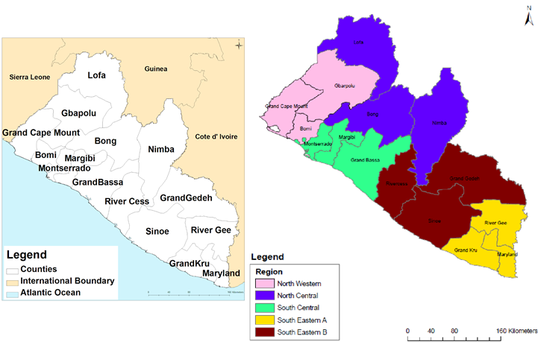

Figure 4 Geo-political map of Liberia (July, 2018)

P671#yIS1

Figure 5 Counties of Liberia within the Region

The country endured 14 years of civil crisis, which resulted in the loss of lives and the destruction of property. Since the end of the civil crisis in 2003, Liberia has held three peaceful general elections including a peaceful change of government in 2017. Despite the economic challenges faced, the country is gradually transitioning from short-term relief and recovery to long-term national development within the context of stability and economic growth under a legitimate government. The successful attainment of political stability in the country is also acting as a key enabler of social transformation and economic recovery. The Pro-poor Agenda for Prosperity and Development articulates the Government’s plans for medium-term development.1F[2]

The health sector, led by the Ministry of Health (MOH), operates in a decentralized manner in line with the overarching government decentralization policy. The MOH is divided into three departments, namely, Health Services; Policy, Planning, and M&E; and Administration. The National NTDs Program falls under the Bureau of Preventive Services within the Health Services Department. At the subnational level, health services are led by County Health Teams (CHTs) and District Health Teams (DHTs). The CHTs and DHTs provide supervision and other technical and programmatic supports to hospitals, health centers, clinics, and community services. Operationally, the County Health Officers (CHOs) head the health service delivery at the counties and District Health Officers (DHOs) supervise the districts while Medical Directors head the hospitals and comprehensive health centers, and Officers in Charge (OICs) head clinics.

#### Economic:

Ranked 176th on the UNDP Human Development Index of 2019,2F[3] Liberia’s socio-economic outlook presents a mixed scenario,is rapidly evolving with the changing context and previous and anticipated impact of the imminent elections. Over the years, slow economic performance, high rates of inflation, and a high unemployment rate are manifestations of an unprecedented level of poverty, which affects the health service delivery and care seeking options for the population.

The government’s institutional expenditure on health has increased over time: approximately US$49,364,031.00 in 2015/16, US$54,622,599.00 in 2016/17 and US$61,702,260.00 in 2017/18.3F[4] The Government of Liberia contributes 38% of the total resource envelope of approximately US$181,280,008.00 for public sector health financing in Liberia while donors make up the rest.4F[5]

Even though the government’s appropriation to the health sector within the national budget rose to 15.2% (80.3 million) in FY 2019/20, in line with the Abuja Declaration, it represents a 1.7% reduction in absolute value compared to FY2018/19 appropriation of $81.7 million (14.3%). This amount remains inadequate to deliver the required minimum health package.5F[6] The current per capita health expenditure of $15.33 is below the recommended per capita health expenditure of $86 to achieve Universal Health Coverage (UHC).6F[7] Similarly, the Government of Liberia’s spending on health is 2.26% of GDP, which is still below the WHO recommendation of at least 5% of GDP to achieve Universal Health Coverage.

The reliance on external funding creates an insecure and unsustainable health care system where a decrease or withdrawal of donor support could lead to interruption of essential health services to the population. Thus, the public health care system can be characterized as vulnerable to external shocks in terms of financing.

#### Social:

The major determinants of health that increase risk factors for NTDs include poverty, poor hygiene, residence in remote and marginalized communities, and certain cultural practices. As a result, NTDs are predominantly endemic in remote and poor communities.

NTDs also have significant social impact associated with stigma and discrimination which can adversely affect social inclusion and participation thereby creating a viscious cycle that drives and sustains certain NTDs in communities.

Analysis of the social factors which determine the interventions of NTDs are critical. The stigma and discrimination associated with NTDs can adversely affect the mental wellbeing of affected persons and their families and communities. Psychosocial interventions have not been integrated in the NTDs Program Liberia, although implementation research that has taken place during the REDRESS implementation research project has demonstrated the feasibility of integrating psychosocial support in NTD services.

#### Technological:

The mining industry of Liberia has witnessed a revival after the [civil war](https://en.wikipedia.org/wiki/Second_Liberian_Civil_War) which ended in 2003. Gold, diamonds, and iron ore form the core minerals of the mining sector with a new Mineral Development Policy and Mining Code in place to attract foreign investments. In 2013, the mineral sector accounted for 11% of GDP in the country and the [World Bank](https://en.wikipedia.org/wiki/World_Bank) projected a further increase in the sector by 2017. Apart from iron ore extractions, cement, diamond, gold, and petroleum resources have also been given due importance to enrich the economy of the country.

With regards to mass media and telecommunications, there are six major newspapers in Liberia, and 65% of the populations have mobile phone services provided by two GSM companies. With low rates of adult literacy and high poverty rates, television and newspaper use is limited, leaving radio as the predominant means of communicating with the public.

[Transport in Liberia](https://en.wikipedia.org/wiki/Transport_in_Liberia) consist of 266 miles of railways, 6,580 miles of highways (408 miles paved), 4 seaports, 29 airports (2 paved) and 2 miles of pipeline for oil transportation.  Busses and taxis are the main forms of ground transportation in and around Monrovia. Charter boats are also available.

Public electricity services are provided solely by the state-owned Liberia Electricity Corporation, which operates a small grid almost exclusively in [Monrovia.](https://en.wikipedia.org/wiki/Greater_Monrovia_District) The vast majority of electric energy services are provided by small privately owned [generators](https://en.wikipedia.org/wiki/Engine-generator). Additional power supply is provided by West Africa Power grid, which currently provides electricity to rural areas. Total capacity in 2013 was 20 MW, a sharp decline from a peak of 191 MW in 1989 before the war.

The repair and expansion of the [Mount Coffee Hydropower Project](https://en.wikipedia.org/wiki/Mount_Coffee_Hydropower_Project), with a maximum capacity of 80 MW, was completed in 2018. Construction of three new [heavy fuel oil](https://en.wikipedia.org/wiki/Heavy_fuel_oil) power plants is expected to boost electrical capacity by 38 MW.

Liberia has begun exploration for offshore oil; unproven oil reserves may be in excess of one billion barrels. The government divided its offshore waters into 17 blocks and began auctioning out exploration licenses for the blocks in 2004, with further auctions in 2007 and 2009. An additional 13 ultra-deep offshore blocks were demarcated in 2011 and planned for auction. Among the companies to have won licenses are [Repsol YPF](https://en.wikipedia.org/wiki/Repsol_YPF), [Chevron Corporation](https://en.wikipedia.org/wiki/Chevron_Corporation), and [Woodside Petroleum](https://en.wikipedia.org/wiki/Woodside_Petroleum).

The Political Economic Social and Technological (PEST) analysis is presented in figure 4. This analysis gives a picture of Liberia’s Political, Economic, Social and Technological situation which may have some influence of the implementation of the Master Plan bearing in mind the different NTDs in the country. It is assumed that with focused support, the Master Plan activities as enunciated in the document are achievable with support of Government of Liberia and partners.

### 1.2.2. Health Systems Analysis

#### Health system goals and priorities

The post-conflict and pre-Ebola period (MDG era) was characterized by enormous progress in the Health Sector in Liberia. Significant gains were made, including increased access to health services from 42% to 71% and improvement in selected health indicators, especially child health indicators, resulting in Liberia’s achievement of MDG 4 (reduction in under five mortality).7F[8] Notwithstanding this progress, overall health system challenges persisted and were exacerbated by the 2014-2015 Ebola Virus Disease (EVD) Outbreak.8F[9] Examples of poor health indicators in Liberia include: maternal mortality of 742 deaths/100,000 live births is still very high, ranking third in West Africa after Sierra Leone (1360/100,000 live births) and Nigeria (814/100,000 live births);9F[10] under five mortality is still high at 93/1,000 live births, with most of the deaths (63/1,000), occurring in the first year of life;10F[11] out-of-pocket expenditure of 54%11F[12] is very high and highly regressive; health sector financing is unsustainable due to heavy reliance on donor funding; healthcare is inaccessible for about 29% of largely rural population; bad road conditions limit access for poor rural communities; there are looming health threats due to diseases of epidemic potential (Ebola Virus Disease, Lassa Fever and now Covid-19); and there is a relatively large and yet insufficient health workforce that requires substantial investments, skills upgrading and motivation for optimum performance. For example, a 2019 capacity assessment12F[13] of all 15 counties placed 13 out of 15 counties in the ‘Limited Capacity’ category**,** meaning, although all basic organizational systems and processes are in place, selected domains (including human resources, supply chain, financial management, M&E etc.) have on-going weaknesses. Evidence from one county (Nimba County) attributed the weaknesses to a lack of maintenance of those health systems and processes when the supporting partners leave.13F[14]

Equity and efficiency issues are also evident in health resource allocation with inequitable distribution of resources across counties. For instance, per capita allocation ranges from a low of $32 in Margibi County to a high of $89 in River Gee County. There is also high percentage expenditure on curative care and secondary level care compared to preventive and primary care that are mostly used by the poor and rural communities.14F[15]

Access to health services remains a challenge, especially in rural communities and for patients with special needs including vulnerable or marginalized groups. Health facilities are still a considerable distance away from many communities, and with bad road conditions especially in rural areas, many patients walk several hours to get to the nearest health facility.15F[16]

A recent process evaluation16F[17] shows that adolescents, particularly pregnant girls, faced unique barriers including being frequently unable to access health facilities independently (health worker requiring the presence of an adult), shame related to their pregnancy, poor adherence and refusal to access resources often requiring extensive follow-up from healthcare workers, lack of social support due to absent fathers of their babies and language barriers at the health facility. There is now increasing evidence that poor, rural and marginalized women feel the gender-specific effects of NTDs most acutely, indicating that development, gender-equality and health outcomes are intrinsically linked.17F[18]

The implication of the above health system challenges and barriers to access is that there is a need to strengthen health systems in ways that will outlive donor support and sustain gains in disease control efforts, NTDs included. Inter-sectoral collaboration and targeted interventions are necessary to address these structural and social barriers to accessing health services.

Strengthening and managing health systems, especially those related to human resources, supply chain management, health management information system (HMIS), health financing, infrastructure, and coordination are key functions of the central MOH as stated in its Ten Year Policy and Plan, 2022-2031. A strengthened health system is key to NTDs control and towards that end, the NTDs Program will contribute to the health system strengthening efforts of the Ministry of Health.

### 1.2.3 Analysis of the overall health system

The analysis of the overall health system is summarized in Table 1 below:

|  |  |
| --- | --- |
| **Analysis of the country's health system using the Six Health System Building Blocks** | |
| **Service delivery** | The Department of Health Services is the technical arm and nucleus of the Ministry of Health. It is headed by the Deputy Minister for Health Services who is also the Chief Medical Officer of the Republic of Liberia. Additionally, the department has two Assistant Ministers: one for curative services and the other for preventive services. There are two divisions within the department: 1) Division of Curative Services is responsible for the supervision and coordination of health service delivery across the country and 2) Division of Prevention Services is responsible for the prevention and control of diseases. NTDs are supervised by the Division of Preventive Services.  Consistent with the national health policy, the national healthcare system of Liberia is based on three levels of care: Primary Care (the Community Health System linked to 780 health clinics), Secondary Care (District Health System with 63 health centers), and the Tertiary Care (National Health System with 39 hospitals).  The Counties translate policies and strategic plans into annual plans and provide supportive supervisions. Counties implement primary health care activities through the networks of health facilities in the districts and communities.  Some of the challenges facing health service delivery include inequitable distribution of health facilities, weaknesses in supply chain, staff attrition, logistical challenges due to poor road network, limited human and financial resources and technologies. |
| **Health workforce** | The 2015/2016 health workforce census conducted in Liberia for both public and private health sectors provided the number of healthcare workers. There are a total of 16,064 health workers captured with 98.3% of them interviewed and 1.7% absent during the census. Higher proportion of health workers were captured from Montserrado, Nimba, Lofa and Bong counties. However, these counties also have the highest number by population as well as by health facilities distribution in Liberia. Clinical health workforce (including Aids and health technicians) constituted over half 56.4% (9,065/16,064) of the overall workforce. However, this proportion could increase if clinicians who were recorded as administrators were added.  The census recorded 4,756 cadre mixed of Midwives, Nurses, Physicians and Physician Assistants across the fifteen counties of Liberia in both public and private facilities.  The disaggregation below shows that there are more registered nurses, constituting 64.7% (3,077/4,756) of the total core clinical cadre, followed by 19.5% midwives, 10.9% physician assistants and 4.9% physicians. Four counties namely: Montserrado, Nimba, Bong and Lofa have 68.2% of this group of cadre across the entire country with Montserrado alone obtaining 30.6% overall cadre. Considering the statistics above, Liberia’s health workforce falls below the recommended benchmark set forth by the World Health Organization (WHO). There are crucial need to train more health workers in addition to the existing one to include nurse anesthetics, laboratory Technologists, Radiographers, and other cadre of professionals to achieve the universal health coverage. |
| **Health information** | The Health Information System (HIS) Division coordinates the collection, processing and management of health and health-related data from health facilities, county health teams and other health institutions in the country. The National Health Information System Policy (2016-2021) mandates that HIS be strengthened to better collect, organize and maintain relevant data in a timely way. The system is expected to have the capacity to produce reports related to health sector development, including the analysis of trends, to understand the evolution of the health sector over time.  The integrated HIS covers the following areas: financial information, human resources, physical assets and equipment, health care service delivery statistics and surveillance. This system will be used to capture information on all NTDs from the counties to national level.  Some Case management NTDs (BU, leprosy, yaws, hydrocele and LF morbidities) have also been incorporated into the HMIS and the Integrated Disease Surveillance and Response (IDSR) guidelines for case detection, reporting and management. IDSR is the strategy adopted and used by the Ministry of Health for both passive and active epidemiological surveillance activities. Data on NTDs with the IDSR are captured on a weekly basis from all counties and sent to central office and then to NTDs office for verification. The data are also used by the NTDs Program to conduct data quality supervision. The data are used also for planning purpose. . |
| **Health**  **products** | The pharmaceutical and health commodities system in Liberia was severely affected by the 2014/2015 EVD outbreak and the COVID-19 pandemic. Attention was paid to this area during revision of the National Health Policy and Plan. The immediate objective is to use available resources to develop pharmaceutical services to meet Liberia’s requirements in the prevention, diagnosis and treatment of diseases by using efficacious, high quality, safe and cost-effective pharmaceutical products through strengthening mechanisms for drug and health products management, control, information systems, regulation and registration.  The Supply Chain Management Unit (SCMU) is responsible for overseeing all supply chain activities within the Liberian Public Health Supply Chain. The SCMU strives to maximize customer service based on the resources available by facilitating seamless linkages between organizations and functions within the supply chain. The SCMU functions include increasing the visibility of data up and down the system, facilitating greater coordination between stakeholders and ensuring alignment of demand with supply via data-based quantifications and the development of unified procurement plans. As a focal point for coordination, the SCMU is involved in virtually all supply chain activities and system strengthening interventions. It serves as the primary mechanism for institutionalizing good supply chain management practices and linking logistics activities throughout the supply chain. Given the critical role supply chain plays in ensuring that the MOH meets it mandate, the SCMU reports directly to the Deputy Minister/Chief Medical Officer of Liberia.  The Central Medical Store (CMS) is an autonomous, publicly-owned agency, mandated to supply the health sectors with medicines and all health commodities.  The CMS manages inventory of drugs through a computerized system (mSupply). Upon arrival of a shipment, the name and quantity of the medication, the batch number, the price unit and expiry date are entered in the system. Supplies are sent to drug depots at county levels and are recorded in the system so that any delivery can be tracked by batch number. The CMS has designed updated software which protects data entries and records the supply levels of sub-storage areas, as well as the central warehouse. It also contains a feature that automatically notifies CMS of the identity and location of products that are close to expiry.  At the county levels, specifically at the drug depots, there is eLMIS data management tool to manage the system. The information is computerized and managed with an organized system of records keeping.  Custom clearance and delivery are the final steps for receiving NTD drugs in the country which are outlined in the SOP. Delivery is the second process, moving the NTD drugs from the port (after its release) to the Central Medical Store (CMS).  The Liberia Medicine and Health Products Regulatory Authority (LMHRA) is responsible for quality assurance and pharmacovigilance of all medicines and health products in Liberia. Considering the challenging operating environment prevailing in Liberia, there are limitations in the regulatory functions of LMHRA. This is mainly manifested in the private sector; private sector dealers freely import, distribute, and sell medicines, some of them without being duly cleared by LMHRA. However, the circulation of counterfeit, sub-standard and expired medicines remain a major challenge to the LMHRA. |
| **Health financing** | There has been an almost fourfold increase in the total health expenditure from $100m in 2007/08 to $392.8m in 2018/19. This increase is still much less than the estimated cost per capita in terms of requirements for implementation of the previous National Health Sector Policy and Plan, which was costed to be US$1,250,126,322 or $296 per person, and benchmark estimates for delivering an essential package for UHC (US$112).  Despite government spending on health (> 10% of its total budget), about 80% of this goes to human resources and remunerations. There has also been a declining pattern of donor resources post-2015, which threatens sustainability for some programs and seems to have led to an increase in direct household out-of-pocket payments for health services.  As NTDs and other conditions are being prioritized and included in the new National Health Policy and Plan, it is envisaged that partners will continue to support the NTDs Program to achieve its targets. |
| **Leadership and governance** | The Department of Health Services, through the Division of Preventive Health Services, is responsible to coordinate the affairs of the disease prevention and control programs. There are 15 programs under the Division of Preventive Services. The Program Director for NTDs is responsible for the strategic direction of the program, and to provide regular programmatic reports to the Deputy Chief Medical Officer for Preventative Health Services (DCMO-PS) or the Chief Medical Officer (CMO) on the program activities. Program management at county levels is the sole responsibility of the County Health Teams, where direct implementation of technical activities begin and are rolled down to the community levels.  Liberia developed a National Health Policy and Plan in 2011 to run for 10 years until 2021. Following the Ebola virus epidemic that hit the country in 2014 and 2015, an Investment Plan for Building a Resilient Health System in Liberia for the period 2015 – 2021 was developed. In both plans, the Neglected Tropical Diseases were prioritized, having been considered for assessment in the first 3 years of implementation of the Plans.  The national health policy and the investment plans were in line with the Sustainable Development Goals (SDGs)18F[19] especially in its goal No 3.3 as far as tackling the NTDs is concerned. The NTDs Master Plan will therefore implement strategies that will strive to contribute towards achieving the objectives of the national health plans and the SDGs  Decentralization of management of the health services has been a major reform instituted in Liberia. The county health team structure is being strengthened to ensure that decisions for health are made at their level. Partnership has been strengthened with regular coordination meetings and joint supportive supervision (JISS).. The national level organizes the strategic planning, but each county also develops its own county work plan which feeds into the bigger plan. Micro planning for NTDs is included in the county planning process.  There are several coordinating mechanisms organized at the central level. The Department of Health services coordinates all disease programs. However, technical working groups are also formed to coordinate different disease conditions. The NTDs Program will constitute a National Steering Committee, and a secretariat in addition to the technical working group. They will together provide oversight in the following areas: Policy formulation, advocacy, coordination at inter-sectorial and inter-agency levels, review of progress and evaluation of reports and mobilization of resources for program activities.  Currently, there is weak coordination between the national NTDs Program, National Public Health Institute of Liberia (NPHIL) and the One Health Platform. The lack of an integrated plan is further hindering coordinated response to zoonotic diseases including rabies and Human African Trypanosomiasis (HAT). There is urgent need to address this gap moving forward into implementation of this NTDs Master Plan |

Table 1 Liberia health system analysis using the six health systems building blocks

## Section 1.3. Gap Assessment

Liberia is affected by a high burden of Neglected Tropical Diseases, most of which are readily preventable and/or treatable. Some of these have been mapped and interventions commenced while a number, particularly case management NTDs are either yet to be mapped or fully mapped these include yaws, Buruli ulcer, Lymphatic Filariasis (morbidity) and leprosy. The research findings below show gaps in the area of PC and CM NTDs.

**Endemicity of endemic PC NTDs in 2021**

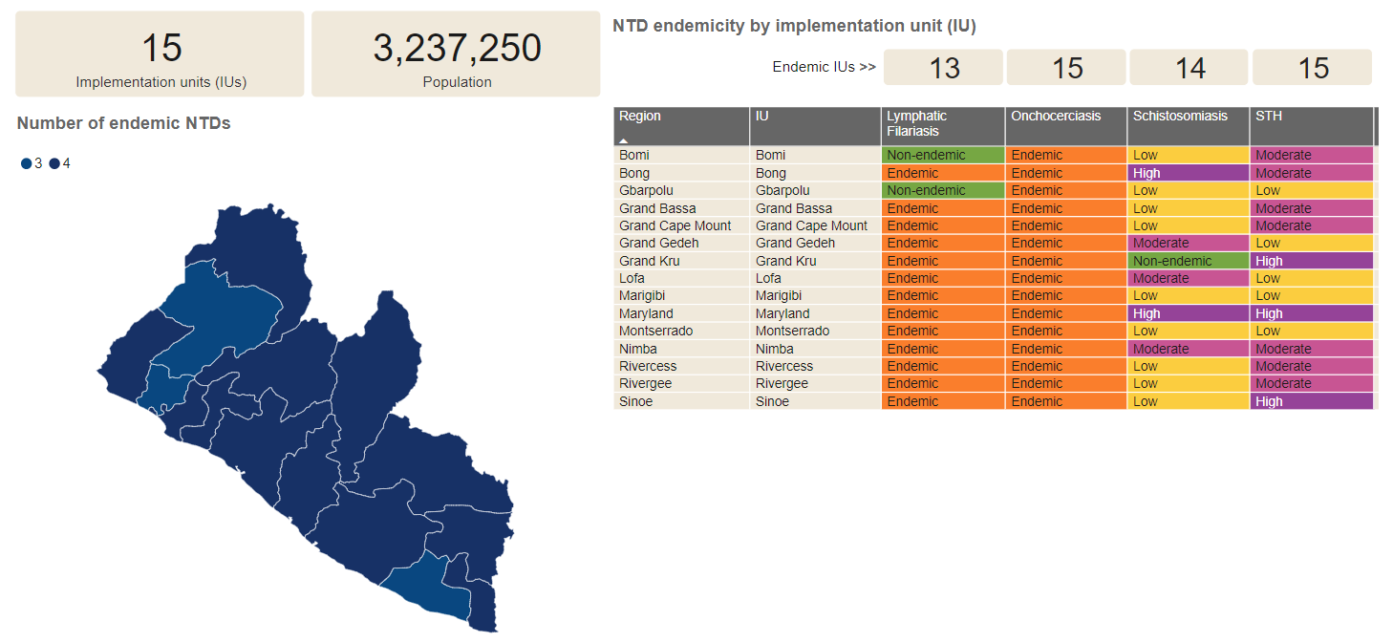

Figure 6 Endemicity of PC NTDs 2021

### 1.3.1 CouNTDown Research

In 2015, the COUNTDOWN consortium, funded through the UK Department for International Development (now FCDO), was established with an overall goal of reducing mortality, morbidity and poverty associated with NTDs. The focus countries were Ghana, Cameroon, Liberia and Nigeria to conduct implementation research to address current NTD program bottlenecks with a view to accelerating progress toward control and elimination of PC NTDs. This research was designed to address and explore key challenges in ensuring equitable NTD program delivery in Liberia.

#### Awareness

Most of the community members interviewed through CouNTDown had limited awareness of the drug distribution program or the neglected tropical diseases asked about (lymphatic filariasis, onchocerciasis, schistosomiasis or soil transmitted helminths). Limited awareness of diseases and associated interventions shaped the demand for and acceptance of mass drugs administration (MDA) in communities. For example, strong traditional belief systems shaped perceptions about the origin of disease and guided community members demand towards traditional medicine treatment seeking pathways. For parents, not understanding why their child should take a specific medicine often led to refusal. Furthermore, in some cases poor awareness mechanisms led to children swallowing medicines without parental consent.

#### Disease Knowledge

Perception and beliefs of some community members shaped the demand for and acceptance of MDA. Traditional beliefs shift the interpretation of diseases due to low knowledge; some people believe that African signs and witchcraft cause these diseases.

#### Accessibility

Rainy and dry season impacted the MDA process. Timing of both awareness activities and medicine distribution was a key factor in shaping program access. Community members were frequently outside of the community completing livelihood activities when distribution took place. Some men suggested that completing awareness and distribution over the weekend would mean more people would likely be present.

#### Availability

To ensure maximum inclusion of all community members during MDA both house to house and fixed-point distribution methods are required. Preferences for fixed point distribution locations varied, although clinics were highly favored. Due to variation by community and county, there is a need for CDDs to work with communities on a case by case basis to identify preferred distribution points.

#### Acceptability

Most community members accepted to swallow the medicines due to previous positive experiences and perceived benefit of curing sickness. In some instances, women particularly described accepting medicines due to the influence of community leaders. Where community members refused to swallow medicines, the main reason was due to observed or experienced side effects during previous MDA rounds. Strengthening awareness and referral around side effects would likely increase program acceptance.

#### 1.3.1.1 CouNTDown Recommendations

This research has highlighted several challenges in ensuring that communities are aware of NTDs and associated programs; that they can access medicines and information; and that when accessing medicines, they are encouraged to accept them. Strengthening program delivery based on community perceptions and opinions is likely to contribute in promoting equitable and effective person-centered service delivery. The following recommendations are designed to inform the pathway to enhancing NTD program delivery in Liberia:

1. To ensure maximum inclusion of all community members, both house to house and fixed- point distribution methods should be used during MDA. Proper awareness should also be completed in advance of distribution using these strategies,
2. Remaining drugs after distribution should be stored at the health facility for a period for those who missed out on MDA to have access to the medicine.
3. Multiple methods of communication will be essential in increasing the awareness of community members about NTDs and associated programs. Messaging should be simple, respond to traditional beliefs and be communicated in local languages to ensure it is understandable to everyone, especially women, who have lower literacy levels. Engagement of health facility staff and the county health team in message dissemination would support CDDs and enable more consistent messaging.
4. Men suggested completing awareness and distribution of drugs during the weekend, suggesting that more people could access MDA during rainy season, as they will be at home.

1. Establish health clubs in schools/communities, Use drama at strategic points such as market places

### 1.3.2 FGS Research

#### 1.3.2.1 Quantitative Findings for female genital schistosomiasis

Two hundred and sixty-four (264) women and girls were screened and diagnosed for FGS in both Bong and Nimba counties. Of these, 247 were treated and 17 were excluded from treatment because of being pregnant. Pregnant women were followed-up to be treated after delivery. The table below shows the results of women and girls screened diagnosed and treated

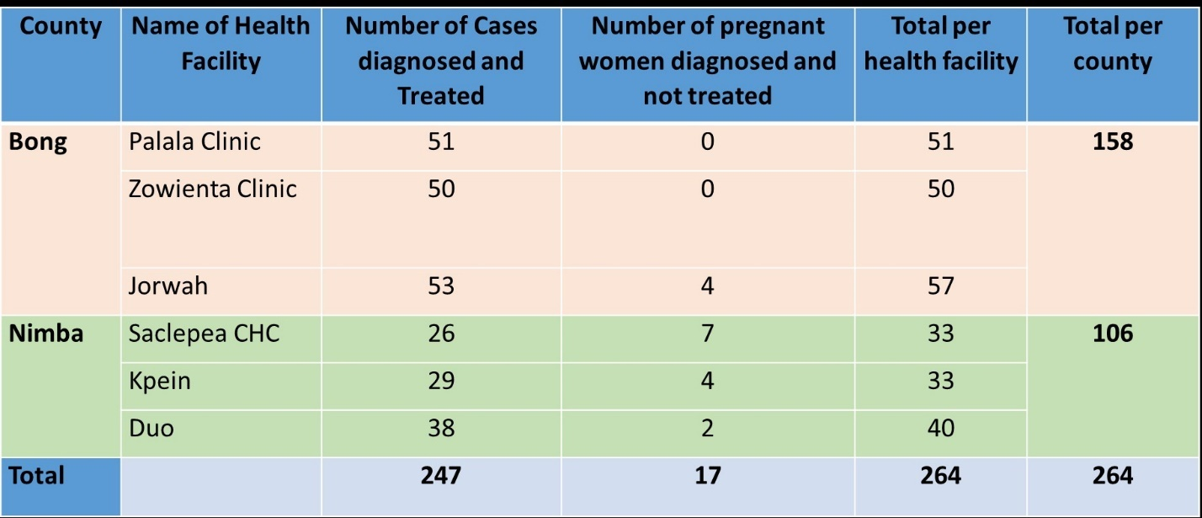

Table 3: Women and girls screened, diagnosed and treated for FGS

#### 1.3.2.2 FGS Qualitative findings:

Cases of sub- or infertility experienced by women with symptoms of FGS were described as Illness experience of women and girls Both midwives and TTMs. This was identified, in addition to urogenital symptoms, as a key presenting complaint and a key source of stigma as a consequence of underlying beliefs around childlessness and miscarriages. For example, one health worker described a women experiencing enacted stigma being referred to as ‘a witch who sold her stomach to the dark world’

#### Knowledge and skills gained

Health workers are able to diagnose FGS and communicate with women and girls experiencing symptoms (see table above). Health workers reported a marked difference on how women are managed at health facilities, for example, a significant attitudinal change towards women who were repeated visitors to health facilities; whereas previously, they were assumed to be nonadherent to treatment already provided for STIs and UTIs or to have multiple sexual partners.

#### Clinical diagnosis and communication tools

The symptom checklist and process surrounding speculum examination was described as the most useful tools in supporting clinical diagnosis. Pictorial guides surrounding FGS were described as particularly useful to health workers to communicate diagnosis to women.

#### Inclusion of trained traditional midwives in project intervention

The role of trained traditional midwives in identifying and referring women was described as central to success of intervention. Consequently, health workers felt it was their role to motivate TTMS and encourage them to frequent facilities.

#### 1.3.2.4 FGS Sustainability and enabling factors

* 1. Across health services, collaborative intervention design with primary healthcare workers, gynecology consultants, and program implementers and decision makers were engaged
  2. Locally driven (district level) intervention rollout and regular support of health workers by supervision structures embedded within routine services
  3. Establishing routine supply of Praziquantel is likely a key challenge to program sustainability.
  4. Extend FGS study to schistosomiasis endemic counties

### 1.3.3 REDRESS Research Project

#### 1.3.3.1 Background of REDRESS Project

Within two years of the implementation of the 2016 – 2021 Strategic Plan for the Integrated Management of NTDs requiring Case Management, the plan was noted to have significant gaps including the lack of mental health care for persons affected by NTDs. In 2019, a research collaboration of the Ministry of Health and six of its NTDs partners began the implementation of 4-year project called REDRESS, to address issues of equity and effectiveness previously neglected through fragmented approaches, whilst contributing to health systems strengthening. REDRESS uses a participatory action research framing to put persons affected by SSSDs at the center. REDRESS’ multi-disciplinary team has applied a systems approach to the evaluation of existing integrated approaches to the management of SSSDs through an expanded situational analysis or formative research phase (Phase One). Evidence generated from a systems perspective in phase one shaped the co-creation of new and existing SSSD interventions (phase two) for implementation, observation, and reflection within existing health systems structures.

#### 1.3.3.2 Summary Findings from the Formative Phase Research

Demand Side Factors: Demand side barriers to formal health seeking were identified as being attributed to awareness and health belief systems, geographic access to facilities, fear of stigma and discrimination, and costs related to health seeking.

Awareness:Health belief systems and lack of awareness of SSSDs within communities results in limited recognition amongst affected persons of the need to access formal health services. Consequently, many people use informal service providers and herbs. Informants highlighted three main avenues to promote greater awareness of SSSDs amongst communities, namely: Increase existing knowledge through radio campaigns; train existing trusted community members, such as community leaders, community health assistants (CHAs) and community health volunteers (CHVs) to increase awareness and promote care seeking as needed; and develop the role of patient advocates.

Structural Barriers***:*** Fear of experiencing stigma and discrimination if confirmed to have a SSSD; financial constraints to affording transportation/ costs of drugs and dressings prescribed; long distances to walk between home and health facility; and drug stock-outs at the health facility were all highlighted as structural barriers to health seeking for people affected by SSSDs. These barriers impacted initial health seeking as well as referral of patients through the system and the ability to attend facilities for follow up care.

Adherence:Where people had accessed services and been diagnosed with SSSDs, they were described by informants as defaulting from completing their treatment, due to several reasons: 1) Long duration of treatment required; 2) Irregular supply chain and stock-out of essential treatments, rendering medicines and resources inaccessible; 3) Costs associated with treatment.

#### Supply Side Factors

Supply side barriers to health seeking were also identified, frequently as a result of ongoing health system weaknesses. Specific barriers were described in relation to: surveillance and active case finding; clinical knowledge gaps and poor laboratory infrastructure hindering case identification; and weaknesses in the supply chain leading to drug stockouts causing significant treatment delays.

Surveillance and Active Case Finding:Challenges with surveillance include the lack of needed supplies for those involved, including: no transportation (bike/ fuel), no rain gear or phone. SSSDs are not included in the weekly bulletin (which is a report provided at county level each week), and as a result they are not prioritized for follow up in the same way conditions in the bulletin are. Monitoring and evaluation (M&E) weaknesses may undermine surveillance efforts due to lack of ledgers for record keeping, inadequately trained staff who may make an incorrect diagnosis, and not all SSSDs are captured within Health Management Information System (HMIS) (yaws, BU, lymphatic filariasis and leprosy only).

Diagnosis and Case Management***:*** Key gaps in knowledge of diagnosis and treatment practices were specifically identified in relation to onchocerciasis and yaws.

Confirming Cases and Laboratory Systems:Across all diseases, and in both counties, it was described that there are knowledge gaps in case identification and management at district and facility level. Majority of the knowledge and skill for case identification and management was described as sitting with the County NTD focal person. Consequently, participants described a delay in the patient pathway, as one person often held all the needed knowledge and skills to confirm a diagnosis within the county.

Supply Chain:Medicines and other goods are provided by the Central Medical Store (CMS) to the county health team, who are then responsible to deliver these to the facilities. There was, however, a lack of clear responsibility for supply chain functions, resulting in blame shifting when stock-outs occur.

Recruitment and Attrition:There were a few HR gaps described, with limited clarity surrounding planning for and recruitment processes. There were delays with recruitment to fill replacement positions, creating frustration for staff working voluntarily in these posts. Senior county level jobs were typically recruited for internally within the county and filled by staff already working at district level. The role of experience, qualifications or application of selection criteria was not clearly described by any participant.

#### 1.3.3.4 Demand Side Factors

Knowledge and Training:Knowledge gaps were described across participant groups and training in various aspects of SSSD identification, diagnosis, management and reporting, was frequently described as needed by almost all participant groups (most strongly expressed by surveillance, M&E and laboratory staff).The leading challenge to carrying out trainings for SSSDs included a lack of funding available, due to lack of donor priority for SSSD initial and refresher training. Where training has been conducted previously, it has been undermined by lack of the needed resources to put skills learned into practice.

Motivation:There were strong associations between motivation and money. Not receiving a salary (which was a frequent challenge) was a strong demotivator. Other demotivators include not having the needed drugs and supplies to be able to provide patients with quality care or to enable them to carry out their tasks. Clinical and community health workers described strong intrinsic motivation, being driven by love of the work, a desire to help their community and a commitment to fulfil the oath taken upon graduation from training.

Supervision:Supervision was infrequently discussed across all levels. Those in management positions spoke more about supervision, however, information was still sparse. Joint Integrated Supportive Supervision (JISS) was often the primary supervision method. Clinical supervision involved stock checks, review of staff duties against the job description, with mentoring performed if gaps were identified. Supervision of CHAs by the CHSS was an established supervision method. Supervision for SSSDs was hindered by lack of funding (available supervision funding from the donor prioritized maternal and child health). Other barriers also included a lack of resources to support the logistics of supervision e.g. motorbikes, and lack of training on supervision best practices. Any issues with poor performance are usually channeled through the nursing director and onwards to HR if necessary. The nursing director was often approached for guidance by the OIC and other staff supervisors when they had issues with managing staff performance. Some HR measures such as issuing written warning for staff with poor performance; pursuing staff to return to work; or removing poor performing staff to a non-clinical role were described.

Gender:Gender balance differed according to the type of position. Typically, management roles of participants interviewed at county and district levels were filled by men. Surveillance and M&E staff were also more frequently male. Clinical staff, including OICs were more balanced, with slightly more women than men in OIC roles.

Health Beliefs: Knowledge and awareness of SSSDs, particularly in Grand Gedeh County were identified as a key barrier shaping health access. Traditional belief systems were described as identifying witchcraft as one of the key causes of disease in both counties. These belief systems were described largely by county and facility level respondents as key in shaping health seeking, leading to a reliance on traditional forms of healing. This pattern in health seeking was also identified for mental health conditions. Faith-based providers tended to be preferred, whereas within Grand Gedeh county traditional healers and herbalists were more widely described. Some treatment practices, such as the chaining of patients by traditional healers could be perceived as harmful types of providers in SSSD case detection and or provision of psychological first aid could be of great benefit to people with SSSDs.

Stigma and Violence: People affected by SSSDs were described as experiencing multiple forms of violence including physical, verbal, emotional, and sexual. Participants also described neglect as common. Across levels of informant the most pervasive forms of violence described varied, however, sexual and gender-based violence was identified as critically important at community level, with both men and women being described as sufferers of such violence. Women were also identified as more likely to experience sexual and gender-based violence often triggered by an inability to fulfil gendered roles within the home. Violence was largely underpinned by stigma as a result of belief systems surrounding the causes of illness and a lack of education, particularly in rural areas, regarding possible other cause.

Mental Health***:***  People with chronic health conditions or disabilities, including SSSDs, must be supported physically and mentally. The welfare and education of the person must be taken into consideration, to reduce the viewpoint of other people who had the belief ‘*that in as much you have this chronic disease you are less important in the society’*. Councilors and mental health clinicians must be involved beforepeople accept their condition. Stigma amongst health workers, staffing shortages, limited training of staff and absent logistical support for patients were identified as key barriers to the provision of mental health services in Liberia. Mental health service provision was described as particularly week in Lofa County where the Carter Center was less active.

Collaboration with the Informal Health Sector: Current forms of collaboration between the formal and informal health sector varied across counties, but it was widely accepted that this is an area that could be strengthened and improved. Enhanced collaboration was largely discussed in relation to referral between services and informants gave key suggestions of how this could be achieved. For example; referral from informal to formal after one week if illness symptoms persisted; and allocation of faith and traditional healers to specific health facilities so they could collaborate to address spiritual and traditional (e.g. African signs) causes of ill-health.

#### Recommendations for Better Human Resource Management

A series of HR related recommendations were provided, including:

1. Improving case detection, diagnosis, and referral; enhancing the performance of a core management team for SSSDs and equitable approaches to psycho-social support and stigma reduction. These findings will be used as the basis for developing person-centered evidence-based interventions to improve the equitable and effective management of SSSDs, whilst seeking to contribute to health systems strengthening.
2. Training and refresher trainings for all relevant staff, including training vaccinators, OIC and midwives about SSSD case detection and referral. Include SSSDs in pre-service training for nurses.
3. Regional visits by clinicians to promote learning about best practices.
4. Provision of needed supplies following training, to put skills into practice.
5. Provide staff with required materials to carry out their role, e.g. rain gear, bag, flash light, personal protective equipment (PPE) for CHAs.

### 1.3.4 Research findings on NTDs Interventions

|  |  |  |
| --- | --- | --- |
| Thematic Area | Gaps Identified | Recommendation |
|  |  |  |
| Social Behavioral change | Limited awareness of MDA among community members  Poor awareness of NTDs transmission and treatment within the communities  Low acceptability of the drugs by some community members during MDA  Stigma and discrimination towards persons affected by NTDs | Awareness conducted before MDA should be simple and use multiple methods of communication  Establish school health clubs/communities to conduct awareness activities |
| Access | Timing and location of the MDA affects availability of community members to receive medicines  Inaccessible road conditions | Working with community members to identify most appropriate time to distribute drugs during MDA |
| Intersectoral/intra-sectoral collaboration | Lack of integrated mental health and NTD services  Poor WASH/NTDs collaboration for Schistosomiasis control  Limited collaboration between School Health and the NTDs program  Poor communication between One Health Platform and the NTDs program | *Include representatives from other relevant programs and sectors into NTDs planning and implementation for joint interventions* |
| Diagnosis and Management | Delays in the patient pathway  Long turn around time for laboratory testing  Low positive predictive value for clinical diagnosis (misdiagnosis by health workers)  Defaulting in treatment  Lack of clarity about the most effective model of case detection within an integrated approach to CM NTDs | Advocate for NTDs to be prioritized in the National Reference laboratory services  Ensure adequate supply of needed drugs for case management conditions.  To consider the optimal model for case detection in the design and implementation of case management initiatives |
| Monitoring and Evaluation | Low logistical support to NTDs Focal persons and community health workers for supervision and active surveillance activities  Lack of integrated NTDs ledgers at the health facilities | Strengthen active case search and referral  Provide logistics and motivation for active case search and supervision  Ensure availability of NTDs recording and reporting tools at the community and health facility levels |
| Human Resource Management | Gaps in knowledge for the diagnosis and management of NTD conditions  Knowledge gaps among community health workers for case identification  Limited trained health workers at primary healthcare facilities  Gender disparity amongst community health workers | Scaling up trainings and conducting refresher trainings at least every two years  Advocate with the community health division for gender balanced recruitment of community health workers |
| Supply Chain Management | Lack of clear responsibility for supply chain functions  Frequent stock-out of NTD drugs and commodities | Develop clear Standard Operating procedures (SOPs)  Improve drug requisition timing to avoid stock outs  Improving demand forecasting (quantification)  Integration of NTDs within the CMS (mSupply) and eLMIS |

Table 2 Research findings on NTD interventions

## Section 1.4 Disease Specific Analysis

### 1.4.1 Onchocerciasis

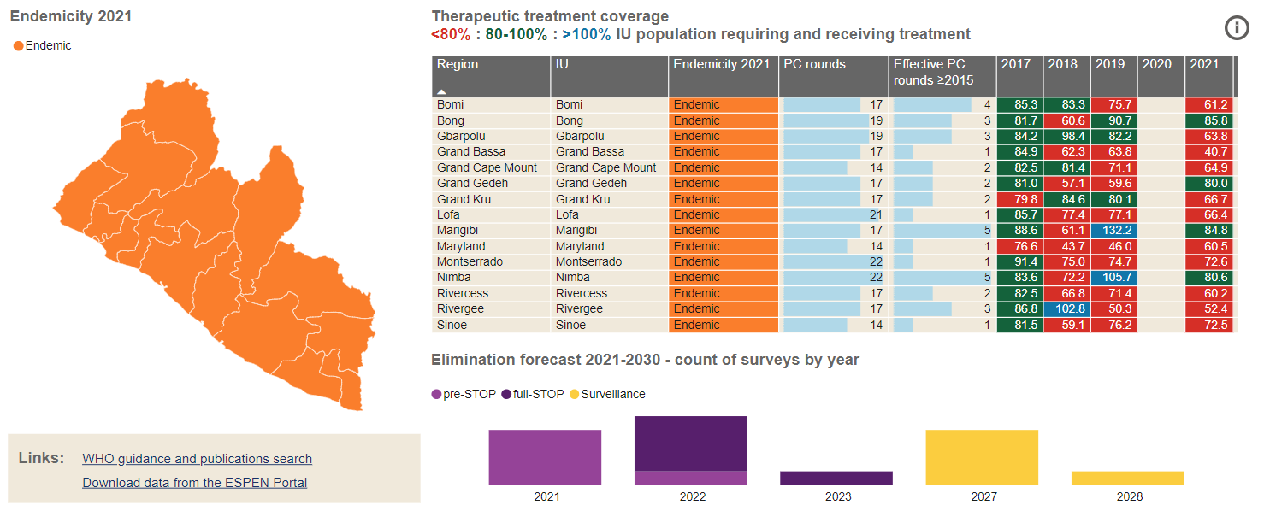

Figure 7 Map showing treatment coverage in 15/15 IUs

Onchocerciasis in Liberia was first diagnosed by the Harvard expedition to Africa in 1926 – 1927 and studies show that Onchocerciasis disease was found to be more prevalent in the interior than the coastal parts of Liberia. *Simulium yahense* was identified as the *Simulium* species responsible for the transmission of onchocerciasis in Harbel, Firestone rubber plantation, Liberia. According to a study conducted in the Rubber plantation, transmission of onchocerciasis in the area peaked in the dry season with a mean annual transmission potential estimated at 1,425 infective larvae per person.(NTDs Master Plan, 2012)

Though onchocerciasis in Liberia is believed to be the forest type, significant ocular onchocerciasis and blindness rate of 1.2% was reported from the Bong Range.Rapid Epidemiological Mapping of Onchocerciasis (REMO) conducted in 1999 estimated that the disease affects all 15 counties with an estimated 1,113,213 population at risk. Its results indicated hyper endemic and meso endemic areas with Nodules prevalence. The prevalence of the disease in the Southeast and Southwest counties were: Grand Gedeh 26%, River Gee 24%, Maryland 22%, Grand Kru 18% and Sinoe 22%, Grand Cape Mount 20%, Bomi 22%, Rivercess 2%, Grand Bassa 23%, and Margibi 28% (NTDs Master plan 2012).

|  |
| --- |
| P987C1T6#yIS1  Figure 8 REMO map showing distribution of Onchocerciasis in Liberia |
|  |

Following the 1999 Rapid Epidemiological Mapping of Onchocerciasis (REMO), the African Program for Onchocerciasis Control (APOC), in collaboration with Sightsavers, supported three Community Directed Treatment with Ivermectin (CDTI) projects in Liberia (the North West, South West and South East CDTI Projects). The North West project was approved for five-year funding by APOC from December 1999 to November 2004 for four counties (Lofa, Bong, Nimba and Montserrado), and two more projects (South West and South East CDTI Projects) were approved in 2002.

The civil war of 1990 – 2003 adversely affected the implementation of CDTI in Liberia. Over the years since 2006, it fluctuated between 65% and 70% therapeutic coverage. Since 2010, there has been a steady increase in the therapeutic coverage from 81.7% - 83% and geographic coverage from 97% - 99%. However, an epidemiological evaluation for the Northwest CDTI project was conducted in 2012 which results show a decrease in the prevalence rate of onchocerciasis from 22.58% to 6.85% after ten years of treatment in this project area (MOH 2012) .

In accordance with the WHO guidelines, during the National Onchocerciasis Elimination Expert Committee (NOEEC) meeting in May 2017 it was decided that Liberia conduct a verification of breeding sites, prospection for new sites including degree of productivity and delineation of transmission zones. It was also decided that the country conduct an impact assessment using *Onchocerca volvulus* -Specific Antigen (OV16) to enable the committee to assess the impact of treatment and review progress towards elimination of onchocerciasis. In March 2018, the breeding site survey was carried out completely in the southwest, incompletely done in the northwest and was not done in the southeast due to limited funding. By May 2018, the Ministry of Health along with its partner Sightsavers agreed to conduct an epidemiological impact assessment that will provide evidence on the status of transmission of onchocerciasis in the Southwest Region and to determine the village level sero-prevalence of onchocerciasis in children using OV16 rapid diagnostic test (RDT), allowing assessment of recent or ongoing transmission of *Onchocerca volvulus* parasite in Liberia using in children 5 to 9 years old. Out of 30 communities tested with RDT, 19 communities had positive case while 11 reported negatives. During the survey, 2,468 persons were tested and 91 were recorded positive and 2,377 negatives as shown below in table 3.

|  |  |  |  |  |  |  |  |  |
| --- | --- | --- | --- | --- | --- | --- | --- | --- |
| Number and percentage of Ov16 RDT positive children per community | | | | | | | | |
| **County** | **Community** | **RDT result** | | | | | | |
| **Positive** | **Negative** | **Invalid** | **Refused** | **(blank)** | **Successfully tested total** | **Percentage prevalence** |
| Bomi | Beajah Town | 5 | 93 | 0 | 0 | 0 | 98 | 5.4 |
| Fallah Town | 2 | 98 | 0 | 0 | 0 | 100 | 2.0 |
| Gongoo Town | 8 | 91 | 1 | 0 | 0 | 99 | 8.8 |
| Manori Camp | 3 | 97 | 0 | 0 | 0 | 100 | 3.1 |
| Suehn Town | 1 | 94 | 0 | 1 | 3 | 95 | 1.1 |
| Swawo Town | 2 | 98 | 0 | 0 | 0 | 100 | 2.0 |
| Grand Bassa | Bueh Town | 3 | 60 | 0 | 0 | 2 | 63 | 5.0 |
| Dirt hole Camp | 4 | 56 | 0 | 0 | 3 | 60 | 7.1 |
| Frazzier Town | 0 | 64 | 0 | 0 | 1 | 64 | 0 |
| German Camp | 3 | 83 | 0 | 0 | 0 | 86 | 3.6 |
| Weeboe Town | 0 | 51 | 0 | 0 | 1 | 51 | 0 |
| Grand Cape Mount | Bensonville | 1 | 96 | 0 | 0 | 4 | 97 | 1.0 |
| Gbah Foboi | 2 | 99 | 0 | 0 | 1 | 101 | 2.0 |
| Kiazolu Village | 0 | 101 | 0 | 0 | 2 | 101 | 0 |
| Kpeneji town | 0 | 100 | 0 | 0 | 0 | 100 | 0 |
| Mani Town | 0 | 99 | 0 | 0 | 2 | 99 | 0 |
| Siafa Keh | 0 | 100 | 0 | 0 | 3 | 100 | 0 |
| Margibi | Bondo Quarter Town | 0 | 18 | 0 | 0 | 2 | 18 | 0 |
| Division 14 | 1 | 90 | 0 | 0 | 2 | 91 | 1.1 |
| Division 23 | 0 | 91 | 0 | 0 | 1 | 91 | 0 |
| Division 36 | 0 | 38 | 0 | 0 | 4 | 38 | 0 |
| Gbege Town | 0 | 44 | 0 | 0 | 3 | 44 | 0 |
| Gbemenee Town | 0 | 69 | 0 | 0 | 2 | 69 | 0 |
| MAR other 1 | 1 | 58 | 0 | 0 | 1 | 59 | 1.7 |
| MAR other 2 | 1 | 47 | 0 | 0 | 1 | 48 | 2.1 |
| Rivercess | Gorzohn | 31 | 71 | 0 | 2 | 0 | 102 | 30.4 |
| Gbokon Gold Camp | 11 | 91 | 0 | 1 | 0 | 102 | 10.8 |
| Kola Tree | 4 | 80 | 0 | 2 | 0 | 84 | 4.8 |
| Sand Beach Junction | 5 | 103 | 0 | 1 | 0 | 108 | 4.9 |
| Solo Village | 3 | 97 | 0 | 1 | 0 | 100 | 3.0 |

Table 3 No. and % Ov16 RDT positive children per community

According to WHO, to proceed to a full stop MDA survey, the prevalence threshold is as follows: the survey prevalence for IUs should be <1% and not less than 3,000 children must be tested per transmission zone. Table 5 shows the percentage prevalence of Ov16 RDT reduction in Grand Cape Mount 0.5% and Margibi 0.7% counties respectively. Bomi and Grand Bassa counties also show a slight reduction in the prevalence rate and will require treatment and testing to obtain the required percentage. Rivercess County obtained the highest prevalence percentage which is alarming and will need further interventions and testing.

|  |  |  |  |  |  |  |  |  |
| --- | --- | --- | --- | --- | --- | --- | --- | --- |
| **County level Ov16 RDT positivity** | | | | | | | | |
| **County** | **Positive** | **Negative** | **Invalid** | **Refused** | **(blank)** | **Grand Total** | **Successfully tested** | **Percentage prevalence** |
| Bomi | 21 | 571 | 1 | 1 | 3 | 597 | 572 | 3.7 |
| Grand Bassa | 10 | 314 | 0 | 0 | 7 | 331 | 314 | 3.2 |
| Grand Cape Mount | 3 | 595 | 0 | 0 | 12 | 610 | 595 | 0.5 |
| Margibi | 3 | 455 | 0 | 0 | 16 | 474 | 455 | 0.7 |
| Rivercess | 54 | 442 | 0 | 7 | 0 | 503 | 496 | 10.9 |

Table 4 County level Ov16 RDT positivity

Dry Blood Spot (DBS) samples were correctly collected in three counties (Bomi, Grand Cape Mount and Rivercess). A random number generator was used to select samples from the total number of negative DBS samples available across all villages and counties. Grand Cape Mount had the lowest ELISA positivity in negative samples, with 2.4% of negative samples analyzed testing positive. Bomi and Rivercess both had 4.2% of positives testing negative, despite Rivercess having significantly more RDT positives than Bomi.

Since the ELISA tests were only done on negative samples, all positive ELISA tests are additional cases, to be added to the cumulative total of Ov16 positivity in each county. The combined total of RDT and ELISA positivity is given below in table 5.

|  |  |  |  |  |  |
| --- | --- | --- | --- | --- | --- |
| **Summary of Ov16 sero-positivity in each of the five survey counties** | | | | | |
| **County** | **Number RDT Positive** | **Number ELISA positive** | **Total number positives** | **Total number tested by any method** | **Percentage prevalence Ov16** |
| Bomi | 21 | 5 | 26 | 572 | 4.5 |
| Grand Bassa | 10 | NA | 10 | 314 | 3.2 |
| Grand Cape Mount | 3 | 3 | 6 | 595 | 1.0 |
| Margibi | 3 | NA | 3 | 455 | 0.7 |
| Rivercess | 54 | 5 | 59 | 496 | 11.9 |
| Counties Total | 91 | 13 | 104 | 2432 |  |

Table 5 Summary of Ov16 sero-positivity in each of the five survey counties

This indicates MDA has been successful in controlling the transmission of Onchocerciasis in Liberia and limiting exposure of children to the infection.

To further confirm the transmission potential for onchocerciasis, the NTDs program also conducted assessment of blackfly breeding sites in 10 of the 15 counties in 2020 and supported by Sightsavers (figure below).

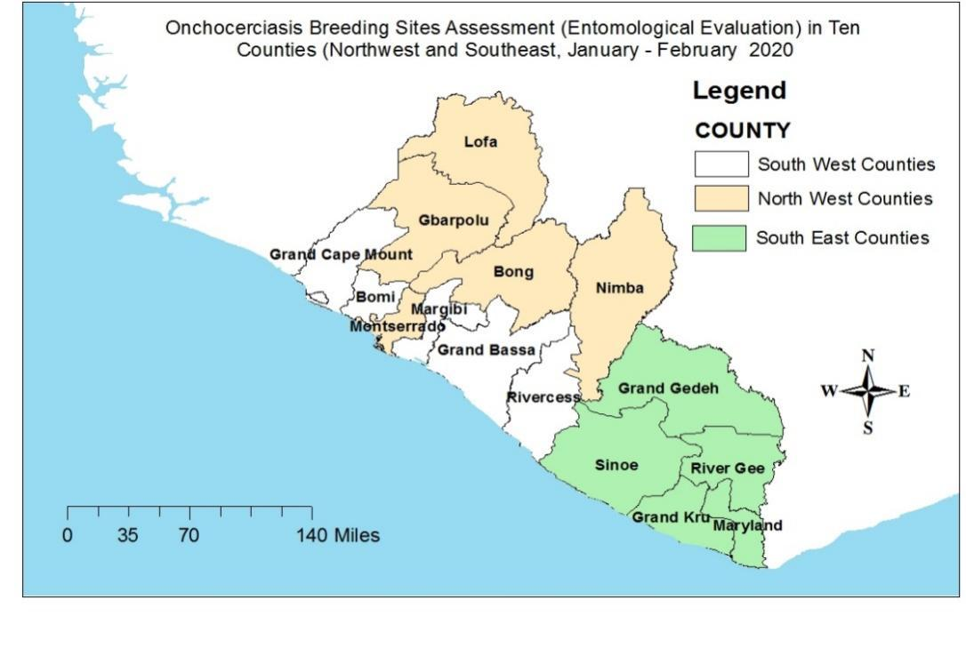

Figure 9 Map of counties surveyed

In both regions (northwest and southeast), 46 rivers were identified and visited in ten counties. In the northwest (Nimba, Gbarpolu, Montserrado, Bong, Lofa), 30 rivers were visited while in the southeast (Sinoe, Grand Kru, Maryland, River Gee, Grand Gedeh) 16 rivers were assessed.

| **Summary of data from rivers in counties visited** | | | | | | |
| --- | --- | --- | --- | --- | --- | --- |
| **County** | **District** | **River Name** | **Site**  **Suitable** | **Evidence of**  **Larvae** | **Larvae Rate** | **Breeding Site** |
| Bong | Kpaai | St. John River | Yes | Yes | 11 – 50 |  |
| Bong | Kokoyah | Boiro | Yes | No |  | Possible breeding site, dry water, no larva found |
| Bong | Jorquelleh | Behla | Yes | No |  | Possible breeding site, dry water, no larva found |
| Bong | Jorquelleh | Jorh | Yes | No |  |  |
| Bong | Suakoko | Kpatawe Waterfall | Yes | Yes | 11 – 50 | Very suitable breeding site |
| Bong | Suakoko | Yelee | Yes | Yes | 1 – 10 |  |
| Bong | Fuamah | St.Paul | Yes | Yes | 11 – 50 |  |
| Gbarpolu | Bokomu | Tulma | Yes | No |  | No larva was seen only flies |
| Gbarpolu | Bokomu | Mayama | Yes | No |  | Possible breeding site |
| Gbarpolu | Bopolu | Mafor | Yes | Yes | 11 – 50 |  |
| Gbarpolu | Bopolu | Marzer | Yes | Yes | 1 – 10 | Possible breeding site, larvae collected |
| Gbarpolu | Bopolu | Small Mahea | Yes | Yes | 11 – 50 |  |
| Gbarpolu | Gbarma | Lofa River | Yes | Yes | > 50 | Is a possible breeding site, larvae collected |
| Grand Gedeh | Putu District | Kunon | Yes | Yes | 1 – 10 |  |
| Grand Gedeh | Chien District | Dugbeh | No | No |  | Not suitable |
| Grand Gedeh | Cavalla District | Cavala | Yes | No |  | Possible site but no larvae found |
| Grand Kru | Bowa | Manu RIVER | Yes | Yes | 11 – 50 | Possible site |
| Grand Kru | Baclayville District | Dubo River | Yes | Yes | > 50 |  |
| Grand Kru | Baclayville District | Slaya River | Yes | Yes | 1 – 10 | Possible site but river drying |
| Grand Kru | Baclayville District | Gee RIVER | Yes | Yes | > 50 |  |
| Lofa | Kolahun | Bombia | Yes | No |  | Possible site, water dry |
| Lofa | Voinjama | Makona River | Yes | No |  | POSSIBLE site |
| Lofa | Voinjama | Zelebah | Yes | Yes | 1 – 10 | Suitable site, larvae present |
| Lofa | Quardu Gboni | Lofa River | Yes | No |  |  |
| Lofa | Voinjama | Lofa River | Yes | Yes | 1 – 10 |  |
| Lofa | Voinjama District | Lofa River | Yes | Yes | 11 – 50 |  |
| Lofa | Zorzor | Zeyea River | Yes | Yes | 11 – 50 |  |
| Lofa | Zorzor | Lawa | Yes | No |  |  |
| Lofa | Z0rz0r | Veyea | Yes | Yes | 1 – 10 |  |
| Lofa | Salayea | St. Paul | Yes | Yes | 11 – 50 |  |
| Maryland | Karluway 2 | Nye RIVER | Yes | No |  | Possible site, no larva found |
| Maryland | Karluway 2 | Hodo River | Yes | No |  |  |
| Maryland | Karluway 1 | Bolon River | Yes | No |  | Possible site, no larva found |
| Montserrado | Todee | Mehn | Yes | Yes | > 50 |  |
| Montserrado | Careburg | St Paul | Yes | No |  |  |
| Montserrado | Todee | St Paul | Yes | Yes | 1 – 10 |  |
| Nimba | Saniquillie Mah | St. John | No | No |  |  |
| Nimba | Gbehlay _ Geh | Yah | Yes | No |  |  |
| Nimba | Gbehlay Geh | Cestos | Yes | Yes | > 50 |  |
| Nimba | Saclepea Mahn | Yah | Yes | Yes | 11 – 50 |  |
| River Gee | Sarbo District | River Gbehah | Yes | No |  | Possible site, no larvae found |
| River Gee | Gbeapo District | River Gee | Yes | No |  | Possible site but no larvae found |
| Sinoe | Kpanyan | Planzon River | No | No |  | Not POSSIBLE |
| Sinoe | Kpanyan | Planzon River | Yes | No |  | Possible site, no larvae found |
| Sinoe | Dugbe District | Dugbe River | No | No |  | Not suitable due to mining activity |
| Sinoe | Tarsue District | Tarsue River | Yes | Yes | > 50 | Positive site but not on the list |

Table 6 Summary of data from rivers in counties visited

### 1.4.2 Lymphatic Filariasis (LF)

Lymphatic Filariasis (LF) is a mosquito-borne NTD that is primarily characterized by acute dermatolymphangioadenitis (ADLA), hydrocele and lymphedema. The non-fatal disease is caused by *Wuchereria bancrofti*, *Brugia malayi* and *Brugia timor*. LF in Africa, is caused by the *W. bancrofti* species. LF disabling consequences, hydrocele and lymphedema, subject millions of people in tropical and subtropical countries to physical, social, and economical challenges. Globally, 1.1 billion people living within 55 countries are at risk of contracting LF. Africa alone accounts for 34 countries, including Liberia (WB 2015).

Liberia completed LF Mapping in 2010 and result shows that the disease is endemic in 13 of the 15 counties. The result also shows microfilaria as the parasite which is transmitted by Anopheles Mosquito. The program began implementing the first integrated LF/Oncho MDA, using a community distribution method, in 2012 in all 13 endemic counties. The program subsequently treated in 2013, and 2015-2018 inclusive in all endemic counties (except for 3 counties in 2015 due to a drug supply issue). Moreover, MDA was also conducted in 2019 and 2021 as table 8 shows results from MDA coverage over the years.

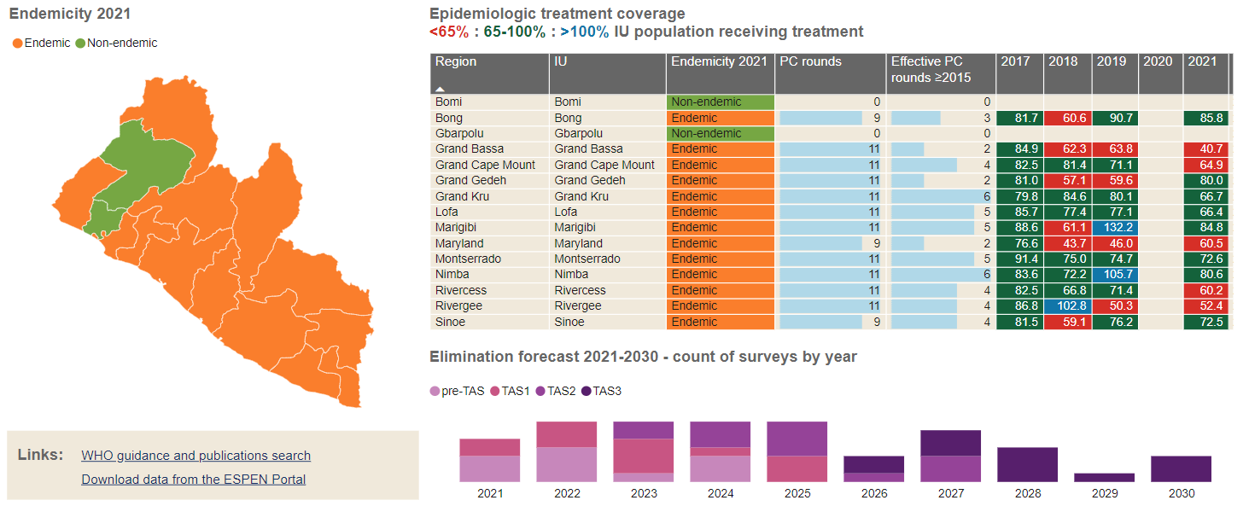

Figure 11 LF endemicity and treatment coverage

|  |  |  |  |  |
| --- | --- | --- | --- | --- |
| **Results from MDA for LF in Liberia** | | | | |
| **Year** | **Number of IUs** | **Target Population** | **Total Treated** | **Program Coverage** |
| **2012** | 13 | 2,728,403 | 2,213,340 | 81% |
| **2013** | 13 | 3,158,737 | 2,630,806 | 83% |
| **2014** | 13 | 3,938,313 | 0 | No coverage due to Ebola crisis |
| **2015** | 10 | 2,032,004 | 1,680,181 | 82.7% |
| **2016** | 13 | 2,379,739 | 2,168,022 | 84% |
| **2017** | 13 | 2,673,415 | 2,246,623 | 84% |
| **2018** | 13 | 2,642,082 | 2,148,214 | 81% |
| **2019** | 13 | 2,963,868 | 2,519,288 | 85% |
| **2021** | 13 | 2,715,552 | 2,297,650 | 81% |

Table 7 Results from MDA for LF in Liberia

The Neglected tropical diseases (NTDs) program has conducted three sentinel site surveys; the first, baseline, was conducted in 2012 in 11 sites and the second was conducted in 2016 in 11 sites across the same 11 counties. The second survey was conducted in 4 spot-check sites and 7 sentinel sites. The most recent survey was conducted in 2018 in 23 sites across 9 counties.

The sentinel site survey conducted in 11 counties in December 2016/January 2017 after the 3rd MDA (Sept. 2015 – Feb. 2016) showed that the microfilaria (mf) prevalence in Liberia had been reduced in all but one county (Figure 12 and 13). The county of River Gee had an increase from 0% to 0.99% mf. Maryland, the only county with a MF rate over 1% showed a reduction from 11.37% to 8.36%. The slow rate of reduction is likely attributed to receiving 2 rounds of MDA instead of 3 rounds due to drug supply issues in 2015/16 and the interruption of MDA due to the EVD outbreak resulting in 2 years without treatment. There is also the concern of cross-border transmission along the border with Cote d’Ivoire.

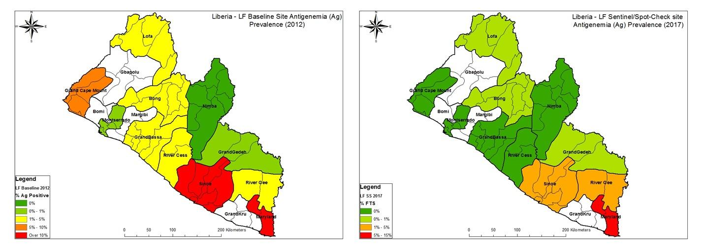

Figure 10 Antigenemia (ag) results from baseline and sentinel site surveys in 2012 and 2016

The prevalence of Ag decreased in all counties after 3 rounds of MDA. The ag prevalence was determined using ICTs in 2012 and FTS in 2016.

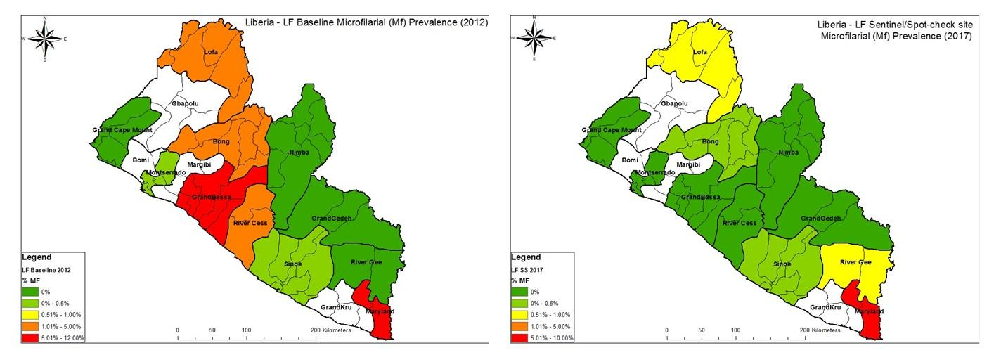

Figure 11 Microfilaria (MF) prevalence from baseline and sentinel site surveys 2012 and 2016

The prevalence of Mf decreased in all counties except for river gee after 3 rounds of MDA. the prevalence in river gee was determined to be 0.99%; this could be accounted for in the sample size as only 151 people were surveyed in 2012 and 302 in 2016

With all counties in the country receiving the 4th/5th round of MDA in 2017 an intensified sentinel site survey/pre – Transmission Assessment Survey (pre-TAS), was conducted in 2018 with 23 sites in 9 counties surveying 6878 participants using FTS cards. These included locations surveyed during the baseline (both sentinel and spot check site) with additional new sites in selected counties based on historical and program data. The results showed varied results across the 23 sites, with a summary of the results (both Ag and Mf) shown in Figure 3.

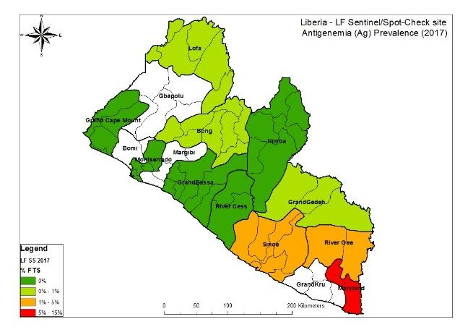

Figure 12 AG prevalence from sentinal site surveys in 2018

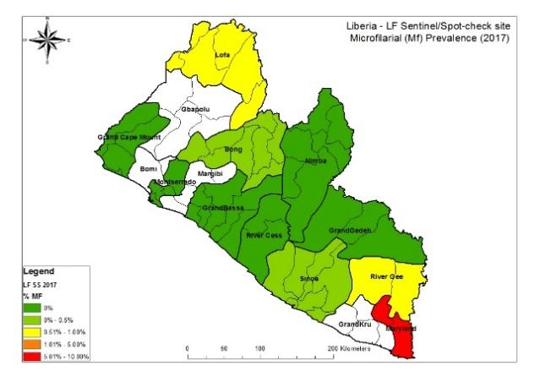

Figure 13 Mf prevalence from sentinel site surveys in 2018

The summary of results from the three sentinel site surveys are shown in Table 7. The results of the 2018 sentinel sites showed that three counties (Grand Gedeh, Lofa and River Gee) are eligible to proceed to Transmission Assessment Survey (TAS) with prevalence below the prevalence threshold in all sites in these counties. In two counties (Grand Cape Mount and Nimba), there were issues with data, therefore a recommendation was made to repeat the surveys the following year.

| **County** |  | **Baseline Survey 2012** | |  | **Sentinel Sites 2017** | |  | **Sentinel sites 2018** | |
| --- | --- | --- | --- | --- | --- | --- | --- | --- | --- |
|  | **Sample** | **% ICT Positive** | **% NB+** | **Sample** | **% FTS Positive** | **% NB+** | **Sample** | **% FTS Positive** | **% NB+** |
| **Grand Cape Mount** | 290 | 1.72% | 0.00% | 305 | 0.00% | 0.00% | 592 | 5.36% | 5.36% |
| **Grand Gedeh** | 298 | 0.34% | 0.00% | 301 | 0.66% | 0.00% | 586 | 0.00% | 0.00% |
| **Grand Kru** |  |  |  |  |  |  | 900 | 9.56% | 7.11% |
| **Lofa** | 300 | 4.67% | 1.33% | 303 | 0.99% | 0.66% | 899 | 0.67% | 0.00% |
| **Margibi** |  |  |  |  |  |  | 600 | 8.67% | 6.17% |
| **Maryland** | 299 |  |  |  |  |  | 914 | 2.74% |  |
| **Montserrado** | 300 | 0.33% | 0.33% | 306 | 0.00% | 0.00% | 595 | 1.69% | 0.84% |
| **Nimba** | 300 | 0.00% | 0.00% | 298 | 0.00% | 0.00% | 895 | 18.16% | 15.00% |
| **River Gee** | 151 | 1.99% | 0.00% | 302 | 1.66% | 0.99% | 897 | 0.11% | 0.11% |
| **Bong** | 300 | 3.00% | 1.33% | 302 | 0.33% | 0.33% | No Data | No Data | No Data |
| **Sinoe** | 294 | 20.07% | 0.34% | 302 | 2.98% | 0.33% | No Data | No Data | No Data |
| **Rivercess** | 300 | 5.00% | 2.67% | 306 | 0.00% | 0.00% | No Data | No Data | No Data |
| **Grand Bassa** | 300 | 8.00% | 8.00% | 305 | 0.00% | 0.00% | No Data | No Data | No Data |

Table 8 Results from sentinel sites 2012, 2017 and 2018

In 2020 preTAS survey was conducted in Bong, Grand Bassa, Grand Cape Mount, Nimba, Rivercess and Sinoe Counties. The survey was conducted in 6 counties through the ASCEND West Africa project and result shows that four counties were eligible for TAS as seen in the below result table 8.

**Results of preTAS in some counties**

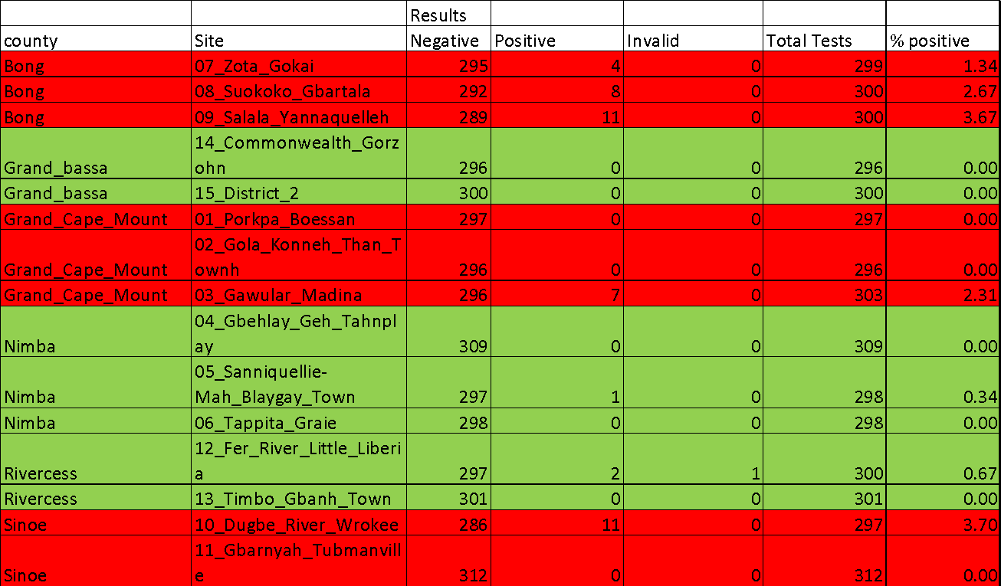

Table 9 Results of preTAS in selected counties

### 1.4.3 Soil Transmitted Helminths (STHs)

There are six 2030 global targets for soil-transmitted helminthiases:

* + - 1. Achieve and maintain elimination of STH morbidity in pre-school and school age children
      2. Reduce the number of tablets needed in preventive chemotherapy for STH
      3. Increase domestic financial support to preventive chemotherapy for STH
      4. Establish an efficient STH control program in adolescent, pregnant and lactating women
      5. Establish an efficient strongyloidiasis control program in school age children
      6. Ensure universal access to at least basic sanitation and hygiene by 2030 in STH-endemic areas

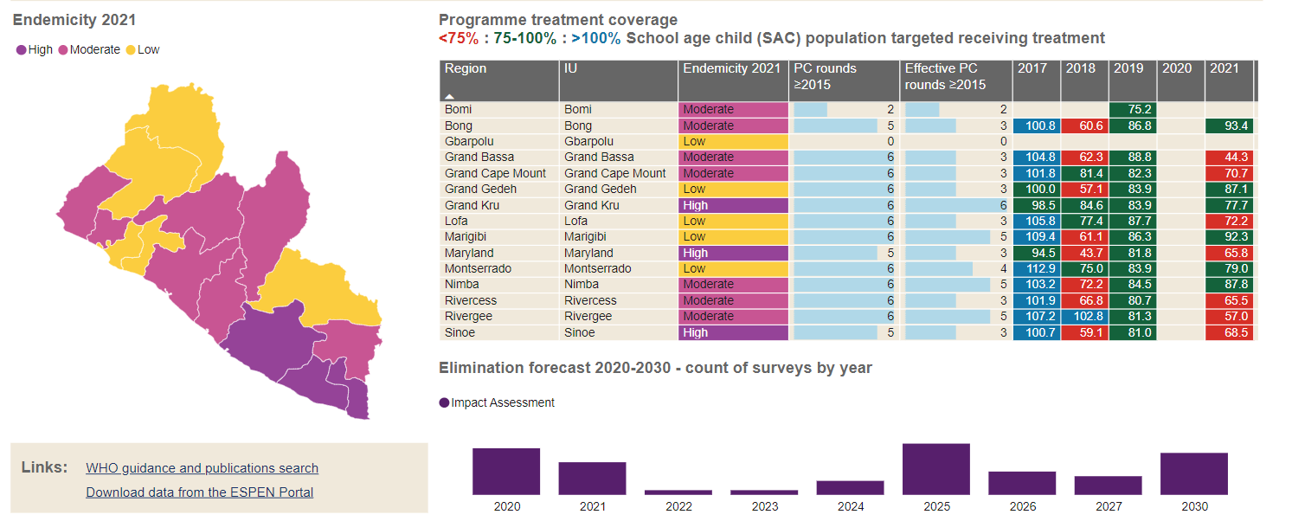

Figure 14 STH treatment coverage

Studies on the epidemiology mapping of Soil Transmitted Helminths and Schistosomiasis were conducted across the fifteen counties by the end of 2015 with support from Centre for Neglected Tropical Diseases (CNTD), Schistosomiasis Control Initiative (SCI), WHO, in collaboration with the Ministry of Health. The results of these studies indicated that Soil Transmitted Helminths (STH) are prevalent in all fifteen 15) counties of Bong (47.75%), Nimba (27.68), Lofa (15.51%%), Grand Bassa (36.88%), Rivercess (36.08%), Gbarpolu (18.13%), Grand Gedeh (17.02%), Bomi (28.5%), Margibi (10.38%%) and River Gee (41.91%). Grand Kru (89.2%, Maryland (66.25%), Sinoe (56.71%), Montserrado (17.88%), and Grand Cape Mount (20.41%).

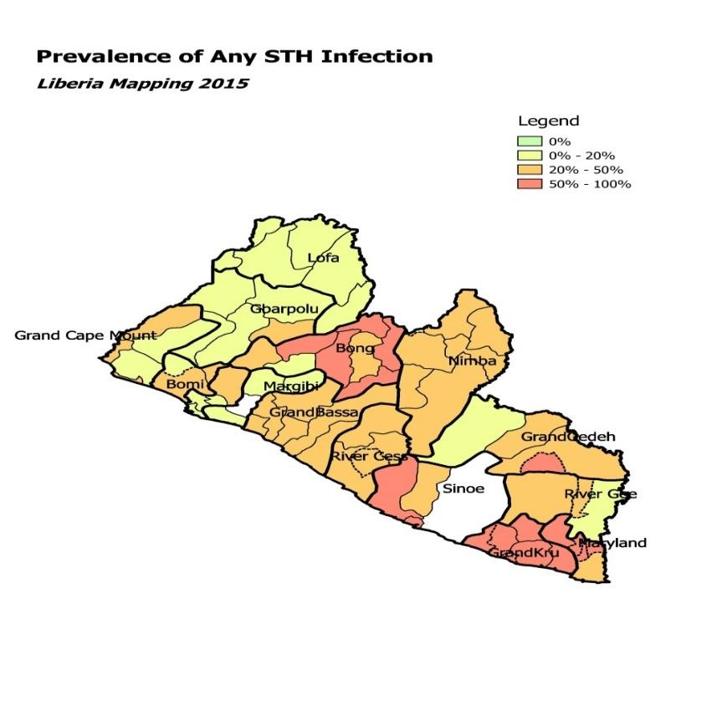

Figure 15 Prevalence of STH in Liberia, 2015

|  |  |
| --- | --- |
| **P2115C1T13#yIS1**  Figure 16 Trichuria prevalence and distribution | **P2117C2T13#yIS1**  Figure 17 Ascaris prevalence and distribution |
|  |  |
|  |  |
| **P2126C7T13#yIS1**  Figure 18 Hookworm prevalence and distribution | **P2128C8T13#yIS1**  Figure 19 STH prevalence and distribution |
|  |  |

The specific Soil Transmitted Helminths (STHs), namely *Ascaris lumbricoides*, *Trichuris trichiura* and hookworms are widely distributed in Liberia and prevalent in all the 15 counties. The highest prevalence of 50 – 100% is found in most of the southeastern counties (Maryland, Grand Kru, Sinoe and Rivercess); the counties in the central part of the country show moderate prevalence of 20 – 50%. The lowest prevalence of 0.1 – 20% is found in the northern counties including Lofa, Bong, Gbarpolu, Bomi, Montserrado, and Nimba.

From result of recent STH mapping surveys in 59 sampled schools in which a total of 3,144 children were examined, prevalence of *Ascaris* was 20%, Hookworm 9% and *Trichuris trichiura* 3%. STH mapping was conducted in all counties. . There is a need conduct reassessment mapping for Schistosomiasis and Soil Transmitted Helminthiasis in the 15 counties.

### 1.4.4 Schistosomiasis

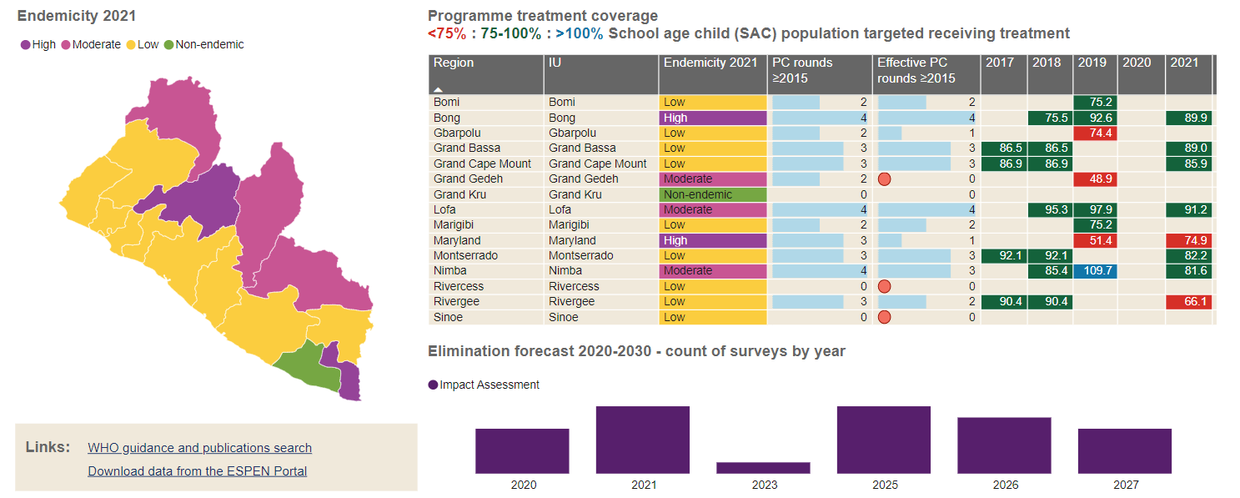

Figure 20 Schistosomiasis Treatment Coverage

Impact surveys have been undertaken in sentinel sites in Liberia to monitor the impact of preventive chemotherapy on the prevalence and intensity of SCH and STH infections, evaluating the effectiveness of mass drug administration in reducing baseline parasitological indicators of infection. The baseline impact survey took place in 2012 in sentinel sites in Bong, Lofa & Nimba. The first follow-up impact survey (FU1) took place in 2013, followed by FU2 in 2018 and FU3 in 2019/20.19F[20] The large gap between the first and second follow-up surveys was due to the pause in NTD activities as a result of the 2014-2015 Ebola outbreak.

Prevalence of Schistosomiasis Mansoni from Baseline to Follow up 3

|  |  |  |  |  |
| --- | --- | --- | --- | --- |
|  | 2012 | 2013 | 2018 | 2019 |
| Description | Baseline (BL) | Follow Up 1 (FU1) | Follow Up 2 (FU2) | Follow Up 3 (FU3) |
| Uninfected | 73.8% | 85.0% | 64.3% | 54.3% |
| Light Intensity | 22.0% | 10.7% | 14.4% | 22.5% |
| Moderate Intensity | 3.9% | 3.4% | 14.3% | 15.1% |
| Heavy Intensity | 0.2% | 1.0% | 7.0% | 8.1% |

Table 10 Prevalence of Schistosomiasis Mansoni from Baseline to Follow up 3

At the 38 schools visited in FU3, prevalence of S. Mansoni is higher than at FU2 and baseline. Compared to FU2, all positive infection categories have increased, although the biggest increase is in the light intensity category.

The proportion of light intensity infections at FU3 (22.5%) is roughly the same as at baseline (22.0%) however, the proportion of moderate and heavy intensity infections have both increase considerably. 3.9% and 0.2% respectively at baseline vs 15.1% and 8.1% respectively at FU3.

Prevalence of Schistosomiasis Haematobium from baseline to Follow up 3

|  |  |  |  |  |
| --- | --- | --- | --- | --- |
|  | 2012 | 2013 | 2018 | 2019 |
| Description | Baseline (BL) | Follow Up 1 (FU1) | Follow Up 2 (FU2) | Follow Up 3 (FU3) |
| Uninfected | 80.6% | 91.0% | 90.2% | 91.2% |
| Light Intensity | 10.6% | 6.5% | 6.8% | 7.2% |
| Heavy Intensity | 9.0% | 2.5% | 3.0% | 1.6% |

Table 11 Prevalence of Schistosomiasis Haematobium from baseline to Follow up 3

Prevalence of S. Haematobium more than halved from baseline to FU1 (20.2% to 9.0%) and has stayed largely stable since. Overall prevalence increased slightly in and FU2 and fell back in FU3.

The proportion of light intensity infections increased from FU2 to FU3 (6.8% vs 7.2%). This increase was offset by a fall in heavy intensity of infection cases (3.0% vs 1.6%).

### 1.4.5 Female Genital Schistosomiasis (FGS)

**Female Genital Schistosomiasis (FGS)**

Occurs when the female genital tissues become infected by eggs of Schistosome. Most common symptoms: Discharge, Pain, or bleeding during sexual intercourse and vaginal itching /burning. These symptoms may cause sub fertility, anemia, miscarriage, and increased risk of infection. Very limited information was available on the identification and management of FGS at health facilities. The NTD program was keen to develop a health systems approach to the identification, referral, and treatment of FGS.

In 2020-2021, Liberia conducted a study to develop and test an integrated package of care for the identification and management of FGS in highly endemic areas for schistosomiasis in Bong and Nimba counties. The districts are Bong county - Panta-Kpaai district: Palala, Zoweinta, Jorwah. In Nimba county, Sacleapea-Mah district, Kpein, Duo and Saclepea Comprehensive Health Center. At the end of the research, the remaining health facilities within Pantakpaai and Saclepea-Mah were trained on the identification and management of Female Genital Schistosomiasis. The figure below shows the study site.

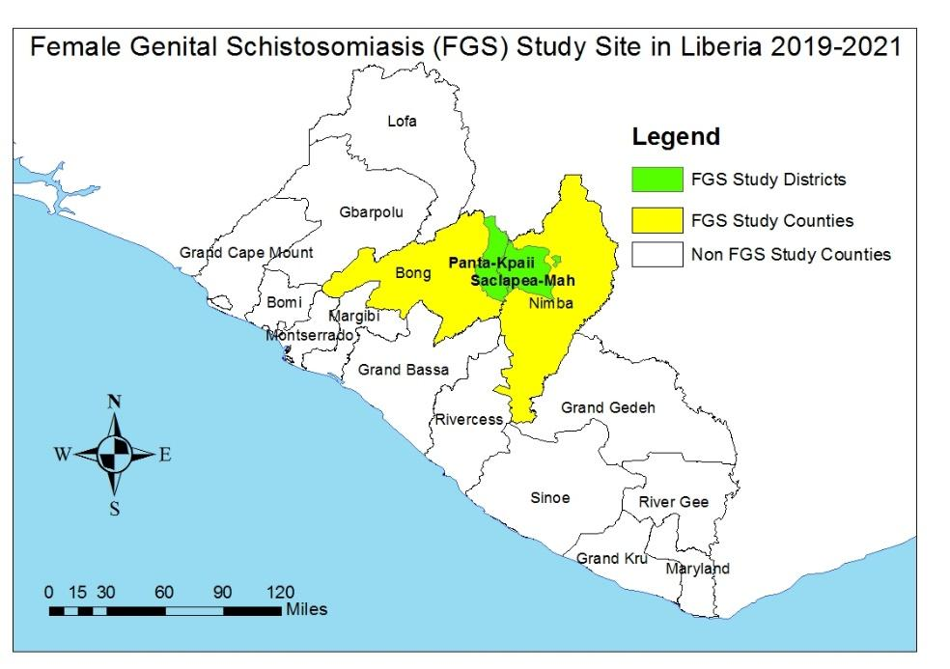

### 1.4.6 Leprosy

Leprosy, also known as Hansen’s disease, is a *Mycobacterium* causing disease that dominantly affects the skin, peripheral nerves, upper respiratory tracts, eyes, and nasal mucosa. This chronic infectious disease leads to social stigma and long -term suffering. For more than half a century, Leprosy has remained a major public health problem in Liberia.

Leprosy cases were reported in 6 of the 15 counties. The national prevalence was found to be <1 per 10,000 population.  Liberia cumulative leprosy prevalence is presented in Table 11 below.

|  |  |  |  |  |  |  |  |  |  |
| --- | --- | --- | --- | --- | --- | --- | --- | --- | --- |
| Situation of Leprosy in Liberia at the end of 2021 | | | | | | | | | |
| County | Population | Health Facility | Registered cases before ULR | Cured | Mis-diagnosed | Other withdrawal | New case during ULR | Registered cases after ULR | Prevalence rate per 10,000 |
| Bomi | 112,526 | 27 | 2 | 2 | 0 | 0 | 0 | 0 | 0.2 |
| Bong | 446,099 | 47 | 11 | 11 | 0 | 0 | 0 | 0 | 0.2 |
| Gbarpolu | 111,549 | 15 | 0 | 0 | 0 | 0 | 0 | 0 | 0.0 |
| Grand Bassa | 296,560 | 35 | 0 |  | 0 | 0 | 0 | 0 | 0.0 |
| Grand Cape Mount | 169,990 | 34 | 0 | 0 | 0 | 0 | 0 | 0 | 0.0 |
| Grand Gedeh | 167,558 | 24 | 5 | 5 | 0 | 0 | 0 | 0 | 0.3 |
| Grand Kru | 77,471 | 24 | 0 | 0 | 0 | 0 | 0 | 0 | 0.0 |
| Lofa | 370,361 | 60 | 5 | 5 | 0 | 0 | 0 | 0 | 0.1 |
| Margibi | 280,815 | 65 | 0 | 0 | 0 | 0 | 0 | 0 | 0.0 |
| Maryland | 181,845 | 25 | 6 | 6 | 0 | 0 | 0 | 0 | 0.3 |
| Montserrado | 1,495,877 | 369 | 0 | 0 | 0 | 0 | 0 | 0 | 0.0 |
| Nimba | 618,055 | 75 | 18 | 17 | 0 | 0 | 0 | 0 | 0.3 |
| Rivercess | 95,658 | 21 | 0 | 0 | 0 | 0 | 0 | 0 | 0.0 |
| River Gee | 89,344 | 21 | 0 | 0 | 0 | 0 | 0 | 0 | 0.0 |
| Sinoe | 136,969 | 39 | 0 | 0 | 0 | 0 | 0 | 0 | 0.0 |
| Total | 4,650,677 | 881 | 48 | 47 | 0 | 0 | 0 | 0 | 0.2 |

Table 11 Situation of leprosy in Liberia at the end of 2021 (DHIS2)

The Ministry of Health through the Case Management arm of the NTD Program has made significant progress in the control of Leprosy in Liberia as part of the global effort to eliminate leprosy as a public health concern. These achievements over the years have been credited to the substantial supports the NTD Program has received from its partners; the American Leprosy Mission, Effect Hope, German Leprosy Relief Association, REDRESS and the World Health Organization (WHO). Besides WHO support (provision of MDT), resources received from other partners have been used to train health workers, and CHAs using the integrated approach in 5 pilot counties in the identification, referral, and management of leprosy. As a result of these trainings, there have been significant efforts exerted in active case search and management as well as intensifying awareness. However, passive case search activities are ongoing in the remaining ten counties.

Liberia has only one Rehabilitation Center situated in Ganta, Nimba County that intercepts and manages severe cases of Leprosy. Since health facilities have limited capacity to manage severe cases, Ganta Rehab has the enhanced capacity to manage all severe cases including the production of prostheses.

Leprosy interventions are focused in all fifteen counties with case detection at community levels.

Records from 2016-2021 showed that Leprosy case detection started decreasing from 2019 but the disability grade II remain high especially in 2018 and 2019. Table 12 illustrates the trend of leprosy cases detection from 2016 to 2021

Table 12: Burden of Leprosy in Liberia from 2016- 2021 (DHIS2)

|  |  |  |  |  |  |
| --- | --- | --- | --- | --- | --- |
| YEAR | Total New Leprosy Cases | MB | PB | G2D | Under 15 |
| 2016 | 125 | 50 | 75 | 19 | 10 |
| 2017 | 114 | 33 | 81 | 12 | 14 |
| 2018 | 119 | 30 | 89 | 26 | 18 |
| 2019 | 78 | 17 | 61 | 39 | 14 |
| 2020 | 80 | 22 | 58 | 15 | 3 |
| 2021 | 48 | 38 | 10 | 5 | 2 |

Table 12 Burden of leprosy in Liberia from 2016 - 2021

### 1.4.7 Buruli Ulcer

Buruli Ulcer (BU) is a chronic debilitating infection of the skin and soft tissue that can lead to permanent disfigurement and disability. In some cases, it affects the bone, leading to osteomyelitis. Its causative agent is the *Mycobacterium ulcerans*. After tuberculosis and leprosy, BU is the third most common Mycobacterium disease of humans. Worldwide, BU exists in at least 33 countries with tropical and subtropical climates. Most cases occur in rural communities across sub-Saharan Africa and nearly half of the burden found in Africa is among children under the age of 15.

In Liberia, the first two cases of BU were reported in 1981 along the ManorRiver basin. Four other cases were reported in the same Mano river basin in 1984. In line with WHO resolution WHA57.1 and the Cotonou Declaration, the Ministry of Health along with its partners assessed three counties (Bong, Lofa, and Nimba) and confirmed 21 cases. Those counties were declared endemic for BU in February 2012.

Following the 2012 assessment, the Ministry began implementing a 3-year pilot project in three counties, which integrated BU response into the existing health systems.

In June and July 2013, MOH along with partners assessed the remaining 12 counties and declared them BU endemic. The assessment identified 13 cases while routine activities within the pilot counties identified and managed 36 cases. All counties of Liberia were therefore confirmed BU endemic by the end of 2013.

In 2014, the number of new BU cases identified and managed dropped to 35 cases, due to interruptions caused by the Ebola outbreak. In 2015, 105 cases were detected; 59 of them were diagnosed and treated through routine health services. In December 2015, the MOH along with its partners conducted a follow-up assessment of all 15 counties and confirmed an additional 46 cases, reconfirming that the disease is endemic in all 15 counties (table 13).

**Situation of Buruli ulcer in Liberia at end of 2021 from follow-up of BU assessment (HMIS)**

|  |  |  |  |  |  |  |
| --- | --- | --- | --- | --- | --- | --- |
| **County** | **No of Health Facilities visited** | **Cases of BU** | | | | |
| **2019** | **2020** | **2021 Reg. cases before the review** | **2021 New BU cases from the review** | **Total 2021** |
| Bomi | 26 | 25 | 5 | 2 | 2 | 2 |
| Bong | 48 | 41 | 66 | 31 | 31 | 31 |
| Gbarpolu | 14 | 0 | 0 | 1 | 1 | 1 |
| Grand Bassa | 36 | 0 | 0 | 9 | 9 | 9 |
| Cape Mount | 34 | 0 | 7 | 0 | 0 | 0 |
| Grand Gedeh | 24 | 0 | 20 | 0 | 0 | 0 |
| Grand Kru | 24 | 0 | 7 | 0 | 7 | 0 |
| Lofa | 60 | 21 | 8 | 6 | 6 | 6 |
| Margibi | 22 | 0 | 0 | 0 | 0 | 0 |
| Maryland | 25 | 10 | 0 | 3 | 4 | 4 |
| Montserrado | 216 | 0 | 0 | 0 | 0 | 0 |
| Nimba | 74 | 101 | 63 | 63 | 63 | 63 |
| RiverGee | 21 | 0 | 1 | 2 | 2 | 2 |
| RiverCess | 19 | 0 | 8 | 2 | 2 | 2 |
| Sinoe | 39 | 0 | 0 | 0 | 0 | 0 |
| **Total** | **682** | **198** | **185** | **119** | **127** | **127** |

Table 13 Situation of Buruli ulcer in Liberia at end of 2021 form follow up of BU assessment (HMIS)

Table 14 shows details of BU case detection in Liberia between 2016 and 2021. Patients with Category III lesions currently constitute more than 55% of all cases. Ulcerative forms are over 84%%, PCR positive results stands at 18%, and less than 11% of cases are below the age of 15 years.

**Table 14: Buruli Ulcer case detection in Liberia covering the 2016-2021**

|  |  |  |  |  |  |  |  |  |  |  |
| --- | --- | --- | --- | --- | --- | --- | --- | --- | --- | --- |
| **Year** | **Total New Cases** | **Cases <15yrs** | | **Category III Lesions** | | **Ulcerative Form at Diagnosis** | | **Specimen Tested by PCR** | | |
| **N** | **%** | **N** | **%** | **N** | **%** | **Total** | **PCR +** | **% PCR+** |
| **2016** | 93 | 12 | 13% | 49 | 53% | 91 | 98% | 32 | 6 | 6% |
| **2017** | 165 | 14 | 8% | 103 | 62% | 163 | 99% | 45 | 6 | 13% |
| **2018** | 341 | 17 | 5% | 184 | 54% | 303 | 89% | 76 | 23 | 30% |
| **2019** | 198 | *14* | 17% | 121 | 61% | 170 | 86% | 54 | 12 | 22% |
| **2020** | 174 | *21* | 12% | 73 | 42% | 104 | 60% | 61 | 10 | 16% |
| **2021** | 123 | *14* | 11% | 71 | 58% | 86 | 70% | 74 | 15 | 20% |

Table 14 Buruli ulcer case detection in Liberia 2016 - 2021

### 1.4.8 Yaws

Yaws is a chronic and usually ulcerative bacterial infection of the skin, caused by the bacterium *Treponema pallidum pertenue*, which is closely related to the causative agent of Syphilis, *Treponema pallidum*. The disease is transmitted through non-sexual human-to-human contact. It is found among people with poor personal hygiene and socio-economic conditions, and it is spread through skin to skin contact. Yaws can be found in tropical forest regions of Africa, Asia, Latin America, and the Pacific. Children below the age of 15 years account for about 75-80% of cases and they are the main reservoir of the organism (WHO, 2016b).

The resurgence of yaws in many countries of Africa and South East Asia20F[21] in recent years following eradication efforts in the 1970s,21F[22] has led the WHO to consider it in the WHO NTDs roadmap for eradication by 202022F[23]. In 2018, a survey was conducted in one of the Southeastern counties, Maryland County, aimed at rigorously estimating the burden of Skin NTDs with adequate population-level power precision. The objective of the survey was to develop a new burden estimation strategy using the community health infrastructure of Liberia. Maryland County is one of the rural southeast counties of Liberia with an estimated population of 165, 000 (where is the source?) inhabitants with challenging logistical transportation due to almost imposable road connectivity during the rainy season.

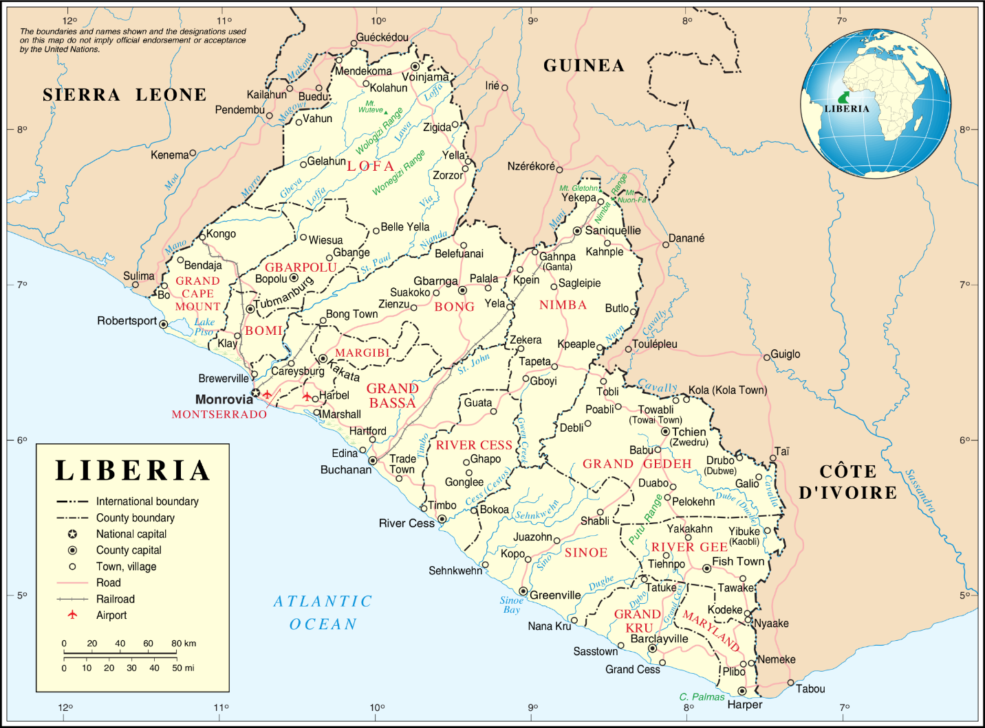

Figure 21 Map of Liberia showing location of survey

The survey lasted for four months with 56,825 persons enumerated and screened with 3,140 suspected cases referred for clinical confirmation. The graph below showed the comparison between the routine program data for 2017 and the survey data for 2018.

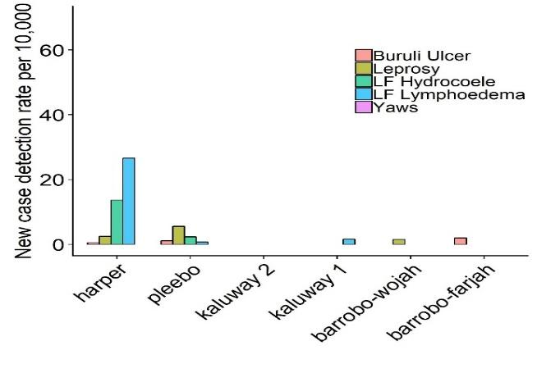

Figure 22 Routine data new case detection rate, Maryland, Jan - Dec 2017

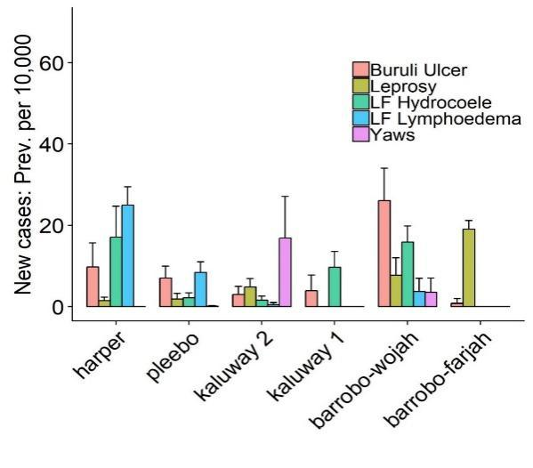

Figure 23 Survey cases previously unknown to the health system, Maryland county

The first case of Yaws was confirmed after screening close to 30,000 persons with different skin manifestations during the survey. There were 50 suspected cases of Yaws and 24 was serologically confirmed by the use of Rapid Diagnostic Test (RDT) and Dual Path Platform (DPP) (Table 16).

Suspected and confirmed cases from 2018-2021

|  |  |  |  |  |  |  |
| --- | --- | --- | --- | --- | --- | --- |
| **Year** | **Suspected cases** | **RDT Pos** | **RDT Neg.** | **DPP Pos.** | **DPP Neg.** | **PCR Pos.** |
| **2018** | 50 | 24 | 26 | 24 | 0 | 17 |
| **2019** | 23 | 0 | 23 | 0 | 0 | NA |
| **2020** | 0 | 0 | 0 | 0 | 0 | 0 |
| **2021** | 53 | 3 | 50 | 3 | 0 | NA |
| **Total** | **126** | **27** | **99** | **27** | **0** | **17** |

Table 15 Suspected and confirmed yaws cases from 2018-2021

The above table show that 27 of the 126 suspected cases were tested both for RDT and DPP positive. Seventeen (17) of the positive DPP were also PCR positive. No Mass Drug campaign with Azithromycin was conducted in the affected communities.

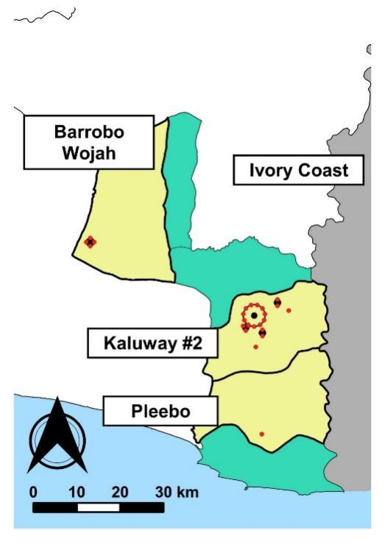 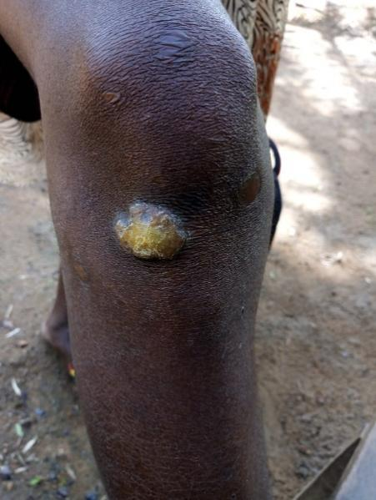

Figure 24 Map of Maryland county with positive yaws case during the survey

These findings triggered the interest of the Ministry of Health to determine the magnitude of yaws throughout Liberia, and then implement the yaws eradication strategy in endemic counties. The current NTDs Strategic plan will strive to attain the yaws eradication objective.

### 1.4.9 Rabies

Rabies elimination has been achieved in much of the western world but remains a huge challenge in resource limited countries. Despite being a preventable viral disease which can be controlled through effective vaccination and population management in the reservoir animal species, an estimated 59,000 people still die each year and roughly 3 million remain at risk. Of these deaths, the majority occur in children in rural communities in Asia (60%) and Africa (36%), where domestic dogs are the main reservoir species ([Hampson et al., 2015](https://www.sciencedirect.com/science/article/pii/S0001706X20317009#bib0025); [WHO, 2018a](https://www.sciencedirect.com/science/article/pii/S0001706X20317009#bib0065)).

Despite declaration as a national priority disease, dog rabies remains endemic in Liberia, with surveillance systems and disease control activities still developing. However, the actual burden of rabies in Liberia remainsunknown. Post Exposure Prophylaxis (PEP) in Liberia is based on wound washing and post-exposure vaccination of exposed persons, due to lack of rabies immunoglobulin (RIG). Rabies vaccine is limited to major cities, with remote and marginalized communities having no access to this life-saving treatment23F[24].

### 1.4.10 Unconfirmed or unmapped NTDs

The following diseases namely echonococosis, Taeniasis/cysticercosis, mycetoma, Food borne trematodes, Trachoma, Leishmaniasis and Snake bite envenoming prevalence is unknown in Liberia. With respect to Dracunculiasis, there is no ongoing transmission and Liberia is geared towards applying for eradication status. Therefore, the national NTDs program will integrate these remaining NTDs into existing surveillance platforms to determine the endemicity, geographic distribution and prevalence over the course of this masterplan.

Section 1.5. Program Context Analysis

### 1.5.1. Current NTD Program Organization and Status

The information on the country population, schools and the number of health facilities at county level, the disease distribution profile, the mapping status and the PC-NTD Co-endemicity map are presented in tables 16, 17, 18 and figure 15.

**National population data, schools, and health facilities at county level**

|  |  |  |  |  |  |  |  |  |
| --- | --- | --- | --- | --- | --- | --- | --- | --- |
| Counties | No. of Health Districts | Total population | Under- 5 (Pre-school) | 5–14years (School age) | No. of primary schools | No. of health facilities | | |
| **Hospitals** | **Health**  **Centers** | **Clinics** |
| Bomi | 4 | 112,526 | 19,129 | 31,507 | 51 | 1 | 0 | 26 |
| Bong | 9 | 446,099 | 75,838 | 124,909 | 103 | 3 | 0 | 44 |
| Gbarpolu | 5 | 111,549 | 18,963 | 31,234 | 26 | 1 | 0 | 14 |
| Grand Bassa | 8 | 296,560 | 50,415 | 83,037 | 83 | 3 | 1 | 31 |
| Grand Cape Mount | 5 | 169,990 | 28,898 | 47,597 | 71 | 1 | 4 | 29 |
| Grand Gedeh | 6 | 167,558 | 28,485 | 46,916 | 74 | 1 | 2 | 21 |
| Grand Kru | 5 | 77,471 | 13,170 | 21,692 | 67 | 1 | 4 | 19 |
| Lofa | 6 | 370,361 | 62,961 | 103,701 | 98 | 4 | 4 | 52 |
| Margibi | 4 | 280,815 | 47,739 | 78,628 | 109 | 3 | 15 | 47 |
| Maryland | $$6$$ | 181,845 | 30,914 | 50,917 | 79 | 1 | 3 | 22 |
| Montserrado | $$7$$ | 1,495,877 | 254,299 | 418,846 | 201 | 11 | 22 | 336 |
| Nimba | 6 | 618,055 | 105,069 | 173,055 | 63 | 6 | 5 | 64 |
| River Gee | 6 | 95,658 | 16,262 | 26,784 | 31 | 1 | 2 | 18 |
| Rivercess | $$6$$ | 89,344 | 15,188 | 25,016 | 27 | 1 | 1 | 19 |
| Sinoe | $$10$$ | 136,969 | 23,285 | 38,351 | 46 | 1 | 0 | 38 |
| Total | **93** | **4,650,677** | **790,615** | **1,302,190** | **1,129** | **39** | **63** | **780** |

Table 16 National population data, schools and health facilities at county level

**Known NTD distribution in Liberia per County**

|  |  |  |  |  |  |  |  |  |  |  |  |  |  |  |  |
| --- | --- | --- | --- | --- | --- | --- | --- | --- | --- | --- | --- | --- | --- | --- | --- |
| **Counties** | **Number of Endemic Districts** | | | | | | | | | | | | | | |
| Preventive Chemotherapy (PC-NTDs) | | | | | | | Case Management NTDs (CM-NTDs) | | | | | | | |
| LF | Oncho | SCH | STH | TRA | LOA | NS | HAT | Lep | BU | Lesh | GWD | Yaws | Rabies | Snake bites |
| Bomi | 0 | 4 | 4 | 4 | N/A | N/A | N/A | N/A | 4 | 4 | N/A | 0 | N/A | N/A | N/A |
| Bong | 9 | 9 | 9 | 9 | N/A | N/A | N/A | N/A | 9 | 9 | N/A | 0 | N/A | N/A | N/A |
| Gbarpolu | 0 | 5 | 5 | 5 | N/A | N/A | N/A | N/A | 5 | 5 | N/A | 0 | N/A | N/A | N/A |
| Grand Bassa | 8 | 8 | 8 | 8 | N/A | N/A | N/A | N/A | 8 | 0 | N/A | 0 | N/A | N/A | N/A |
| Cape Mount | 5 | 5 | 5 | 5 | N/A | N/A | N/A | N/A | 5 | 5 | N/A | 0 | N/A | N/A | N/A |
| Grand Gedeh | 6 | 6 | 6 | 6 | N/A | N/A | N/A | N/A | 6 | 6 | N/A | 0 | N/A | N/A | N/A |
| Grand Kru | 5 | 5 | 0 | 5 | N/A | N/A | N/A | N/A | 5 | 5 | N/A | 0 | N/A | N/A | N/A |
| Lofa | 6 | 6 | 6 | 6 | N/A | N/A | N/A | N/A | 6 | 6 | N/A | 0 | N/A | N/A | N/A |
| Margibi | 4 | 4 | 4 | 4 | N/A | N/A | N/A | N/A | 4 | 4 | N/A | 0 | 1 | N/A | N/A |
| Maryland | 6 | 6 | 6 | 6 | N/A | N/A | N/A | N/A | 6 | 6 | N/A | 0 | 6 | N/A | N/A |
| Montserrado | 4 | 4 | 4 | 4 | N/A | N/A | N/A | N/A | 7 | 7 | N/A | 0 | N/A | N/A | N/A |
| Nimba | 6 | 6 | 6 | 6 | N/A | N/A | N/A | N/A | 6 | 6 | N/A | 0 | N/A | N/A | N/A |
| River Gee | 6 | 6 | 6 | 6 | N/A | N/A | N/A | N/A | 6 | 6 | N/A | 0 | N/A | N/A | N/A |
| Rivercess | 6 | 6 | 0 | 6 | N/A | N/A | N/A | N/A | 6 | 6 | N/A | 0 | N/A | N/A | N/A |
| Sinoe | 10 | 10 | 10 | 10 | N/A | N/A | N/A | N/A | 10 | 10 | N/A | 0 | N/A | N/A | N/A |
| **Total** | **81** | **90** | **79** | **90** |  |  |  |  | **93** | **85** |  | **0** | **7** |  |  |

Table 17 Known NTD distribution in Liberia per county

**N/A – Data not available**

### 1.5.2 Co-endemicity of NTDs in Liberia

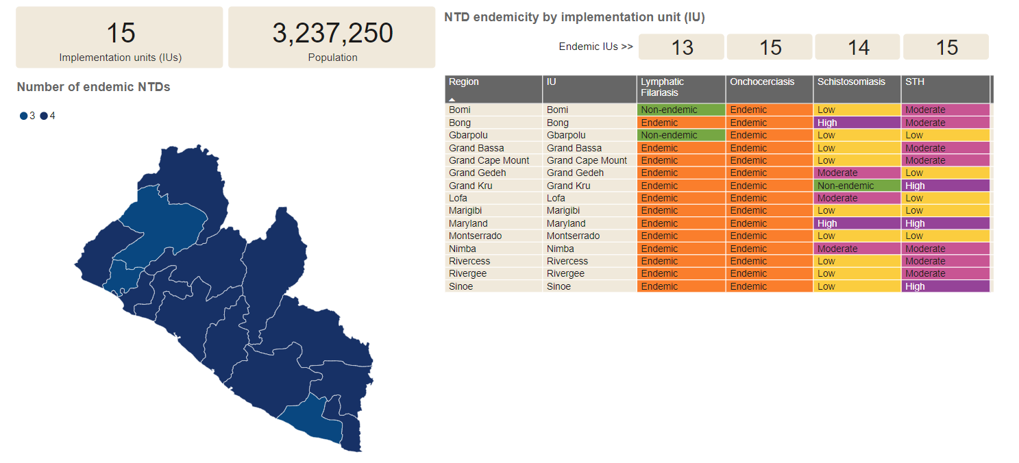

Figure 25 NTD endemicity by implentation unit

The service data (2017-2022) from the HIS revealed that four NTDs conditions are co-endemic in all the 15 counties: Soil Transmitted Helminthiasis (STH), Onchocerciasis, leprosy and Buruli ulcer. Lymphatic Filariasis (LF) is endemic in all counties except two, Gbarpolu and Bomi, which need to be re-mapped. Schistosomiasis was mapped in 15 counties and is endemic in 10/15 counties. It is not present in Montserrado, Maryland, Cape Mount, Sinoe and Grand Kru counties (new data is due for these counties following re-mapping.) For now (2018-2022), yaws is known to be endemic in two counties (Maryland and Margibi). However, the mapping of yaws and other case management NTDs conditions within the framework of this master plan will bring precision on the situation in the remaining 13 counties where there is currently no data.

|  |
| --- |
| P3348C1T23#yIS1  Figure 26 Map showing PCT-NTDs co-endemicity |
|  |

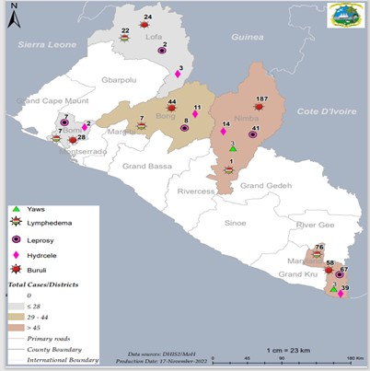

Figure 27 CM-NTDs Co-endemicity Map

### 1.5.3. NTD Program Performance (2017-2022)* and cross cutting issues

**NTD mapping status**

|  |  |  |  |  |
| --- | --- | --- | --- | --- |
| **Endemic NTD** | No. Counties in Liberia | No. of endemic Counties | No. of Counties mapped or known endemicity status | No. of counties remaining to be mapped or assessed for endemicity status |
| **Buruli Ulcer** | 15 | 14 | 14 | 1 |
| **Dengue\*** | 15 | N/A | N/A | 15 |
| **Dracunculiasis** | 15 | N/A | N/A | 15 |
| **Echinococcosis\*** | 15 | N/A | N/A | 15 |
| **HAT** | 15 | N/A | N/A | 15 |
| **Leishmaniasis (VL)** | 15 | N/A | N/A | 15 |
| **Leprosy** | 15 | 15 | 15 | 0 |
| **Loaisis\*** | 15 | N/A | N/A | 15 |
| **Lymphatic Filariasis** | 15 | 13 | 13 | 2 |
| **Mycetoma\*** | 15 | N/A | N/A | 15 |
| **Nodding Disease/ Syndrome** | 15 | N/A | N/A | 15 |
| **Onchocerciasis** | 15 | 15 | 15 | 0 |
| **Rabies\*** | 15 | N/A | N/A | 15 |
| **Snake bite envenoming\*** | 15 | N/A | N/A | 15 |
| **Scabies\*** | 15 | N/A | N/A | 15 |
| **Schistosomiasis** | 15 | 13 | 13 | 2 |
| **Soil Transmitted Helminthiasis** | 15 | 15 | 15 | 0 |
| **Trachoma** | 15 | N/A | N/A | 15 |
| **Yaws\*** | 15 | 2 | 2 | 13 |

Figure 28 NTD mapping status

**N/A – Data not available**

### 1.5.4 Performance of the other programs that are closely related to NTD Program

#### 1.5.4.1 Vector control

Table 19 describes the various vector management or control activities conducted in Liberia and how it impacts on NTDs and others targeted for vector control interventions.

Apart from the activities enumerated below in the table, there are no other integration activities, however the approval of this master plan will provide further impetus for collaboration with other line ministries and agencies.

**Vectors and Associated NTDs**

|  |  |  |  |  |  |  |  |  |  |
| --- | --- | --- | --- | --- | --- | --- | --- | --- | --- |
| **Intervention** | **Mosquitoes** | | | **Other Vectors** | | | | | |
| **Snails** | **Black fly** | **Sand fly** | **Tsetse fly** | | **Non Vector** |
| **LF** | **Dengue** | **Malaria** | **Schisto** | **Oncho** | **Leish** | | **HAT** | **GWD** |
| ITN | Yes | Yes | Yes | No | No | N/A | | N/A |  |
| IRS | No | No | No | No | No | N/A | | N/A |  |
| Space spraying | No | No | No | No | No | N/A | | N/A |  |
| Larviciding | No | No | No | No | No | N/A | | N/A | Yes |
| Traps | Yes | Yes | Yes | No |  | N/A | | N/A |  |
| Prevention and treatment of breeding sites | No | No | No | No | No | N/A | | N/A | No |

Table 18 Vectors and associated NTDs

#### 1.5.4.2 One-Health

The One Health Coordination Platform (OHCP) was launched in Liberia in 2017 with the purpose of productively facilitating cross-sectoral collaboration to address public health issues that cannot be solved by a single sector. It is recognized that investment in One Health will promote efficient alignment of limited human, financial and material resources. Importantly, a One Health platform provides the mechanism for building systems that enable early detection of emerging threats to human, animal and environmental health, and for mobilizing and deploying interventions to mitigate their potential emergence and spread.

The OHCP is organized to effectively achieve its mission with strong administrative and technical support. While the OHCP sits under the Office of the Vice President of Liberia, it is hosted by the National Public Health Institute of Liberia (NPHIL), from where the Secretariat functions. The Secretariat is responsible for the administration and operation of the OHCP. The One Health Technical Committee is headed by the NPHIL Director General and its Technical Working Groups are headed by technicians from line ministries and agencies.

The OHCP Governance Manual outlines the objectives of the platform and the structures and the processes and strategies intended for effectively achieve them. This manual provides guidance on roles and responsibilities of the multi-sectoral stakeholders engaged in the OHCP, either administratively or technically.

The vision of the OHCP is to prevent and prepare for events associated with human, animal, and ecosystem interface. The mission of the OHCP is to effectively coordinate the national “One Health” approach ensuring multi-sector participation, resource mobilization, mutual accountability, and transparency at all levels. All activities of the OHCP are conducted in accordance with the following values: partnership, integrity, transparency, rights, professionalism, quality, Accountability, and Cultural Sensitivity.

The overarching objective of the OHCP is to coordinate and facilitate discussions on issues concerning the health of humans, animals (including wildlife), and the environment that cut across multiple sectors in order to strengthen the institutionalization of a functional One Health approach in Liberia to address Public Health events including zoonotic diseases, and develop joint planning decisions and guidance for policy on prevention, detection, response, and recovery. The One Health Coordination Platform includes the Ministry of Health, Ministry of Agriculture, National Public Health Institute of Liberia, Environmental Protection Agency, and the Forest Development Authority that harmonize efforts across sectors, Create cross-sectoral linkages to share data, information, resources, and capacity building expertise, and leverage core capabilities of each agency to determine and direct interventions to address possible threats that relate to humans, animals, and the environment that cut across multiple sectors.

The country has identified zoonotic diseases of the greatest public health concern, which include Ebola, Yellow Fever, cutaneous anthrax, brucellosis, bovine TB, highly pathogenic avian influenza (HPAI), rabies, antimicrobial resistance, and Rift Valley Fever.

The key activities implemented are in the National Action Plan and Health Security (NAPHS) link below for the priority zoonotic disease control activities.

<https://www.afro.who.int/publications/national-action-plan-health-security>

The Integrated Disease Surveillance and Response (IDSR) platform is used to detect and report priority diseases of epidemic potential and public health concerns; NTDs, including Guinea worm, Buruli Ulcer, Yaws, and Rabies are integrated in the IDSR.

#### 1.5.5.3 Water, Sanitation and Hygiene (WASH)

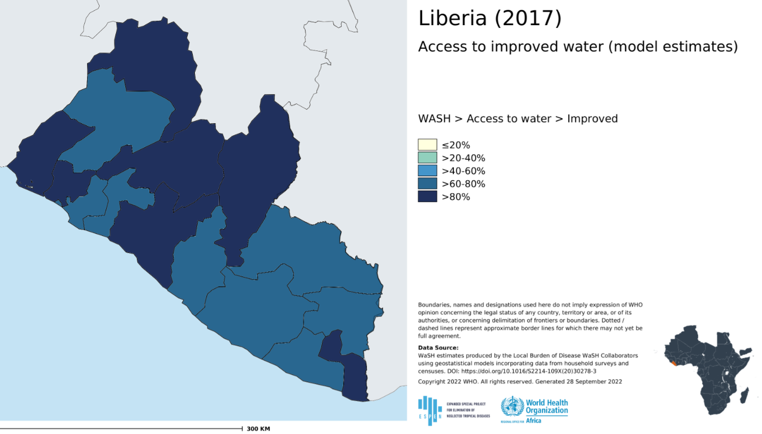

Access to WASH services is extremely low for most people in Liberia. According to the Joint Monitoring Program (JMP) 2019 report on Progress on Household Drinking Water, Sanitation and Hygiene, basic access to drinking water as of 2000 was 62%, which has risen to 73% in 2019. Access to basic sanitation was 14% in 2000 and rises to 17% in 2019. Over 2 million Liberians currently practice open defecation. The report also highlights that Liberia is amongst the 19 countries with data where more than half of the population had no hand washing facility at all, with 97% in Liberia. With this statistic, achieving the SDG 3 & 6 target of universal access to Health and Wellbeing, and Water and Sanitation for all will be especially challenging in Liberia.

| Theme | NTDs | Key problem/challenge to address |
| --- | --- | --- |
| **Behavior** | Soil Transmitted Helminthiasis | * The practice of children playing around barefoot on dirty floors or unhygienic surroundings in both rural and urban communities * Practice of people eating raw unwashed vegetables and fruits especially during the fruits season * The practice of mothers, caregivers not washing their hands at critical times (before feeding children and after changing their diapers, before eating and after using the toilet) * Inadequate or limited sensitization campaigns, not using existing school and community structures like School health clubs, community health workers or engagement in the use of social media on NTDs. |
|  | Schistosomiasis | * Because improved water sources are not enough for other purposes, bathing, washing of cooking utensils, and washing of clothes in infected fresh water sources has become a common practice of people in rural communities. * People also get in contact with infected water sources during fishing and swimming for recreation. * Infected sources like the streams are also used to irrigate farms during the dry season. * People also use open sources (streams, drainages and wetlands) for car washing activities to earning a living * Most infected males openly urinate in the rivers/streams or open spaces that contaminate the soil or water bodies. * The practice of using rivers and streams for defecation or building latrines over rivers and streams and running latrines pipes in the rivers. * The practice of using rivers and streams for disposal of waste. * The practice of using rivers and streams for drinking when safe water is not available. * Inability or unwillingness to pay for WASH services has resulted in breakdown of WASH services for long periods of time forcing people to turn to unsafe water sources. |
| Lymphatic Filariasis | * Most people have the notion that ITNs generate heat therefore they find it difficult to sleep under it. There has been mass distribution of ITNs, but usage is very poor. * The inappropriate use of the nets for fishing, protection of chicks from the hawks and decoration during wedding ceremony. * It is a practice for mosquito nets to be cut and sold in markets places and use as scrub for bathing |
| **Environment** | Soil Transmitted Helminthiasis | * The practice of open defecation and improper disposal of untreated sewage on land surface and in water bodies allows for infection of helminths. * Low access to CLTS program implementation has contributed to the increase in infection of helminthes in the population. * Limited accesses to improved safe water facilities in rural population (i.e. 250 pop to 1 water point) is not adequate and have resulted to people finding alternative water sources for drinking and other domestic choices. * Children less than five years are often left to play in unclean opened spaces leaving them exposed to helminthes infection as they move their hands from the soil to their mouths. |
| Schistosomiasis | * Most rural population rely on streams for domestic chores like washing of cloths, cooking utensils and bathing. Infected streams are pathways for transmission of schistosomiasis. * The practice of fishing by using local fishing nets or other traditional means, farming in swarms, which allow a person to stay in the stream for hours. * The youth also use open sources (streams, drainages, and wetlands) for car washing activities to earning a living. * The practice of open defecation and improper disposal of untreated sewage on land surface and in water bodies allows for infection of helminths. * Poor or lack of access roads to most rural communities has made the provision of safe water sources almost impossible. |
| Lymphatic Filariasis (LF) | * Poor environmental sanitation has increased the breeding of infectious mosquitoes that causes lymphatic filarial in rural and urban communities. * Some communities are endemic to lymphatic filariasis because of poor access to safe water supply. * Poor hygiene and sanitation practices, especially by persons living with chronic stage of LF, has increased the spread of the disease from persons living with the disease. * Poor access to healthcare facilities in country to promote treatment of lymphedema and hydrocele diseases and surgeries. |
| **Social inclusion** | Lymphatic Filariasis (LF) | * Stigmatization due to misunderstanding of the cause of the disease and the fear of it being contagious. * Traditional or cultural beliefs: most societies associate the later stage of the disease as a curse from God or witchcraft therefore infected people are not readily accepted in social functions or considered in decision making in the society. * Often infected people are excluded from accessing WASH services; prevented from using shared latrines, water points, use of bathrooms, etc. |
| **Treatment and care** | Soil Transmitted Helminthiasis | * Inadequate national program to target Individual/mass chemotherapy; even that most people cannot access it due to poor access roads or distance to treatment centers. * Existing national programs are not funded by government. * Mass chemotherapy is unfunded by fiscal budget. |
| Schistosomiasis | * Inadequate national program to target Individual/mass chemotherapy; even that most people cannot access it due to poor access roads or distance to treatment centers. * Existing national programs are not funded by government * Mass chemotherapy is unfunded by fiscal budget. |
| Lymphatic Filariasis | * Mass chemotherapy is unfunded by fiscal budget. * Limited access to water for hygienic wound care and safe home management of symptoms. * Those affected with LF are either not aware or do not have access to the appropriate footwear. * Limited access to infection prevention and control in health care facilities for lymphedema care and hydrocele surgery. * Existing national programs are not funded by government. * Limited supply of Home Based Self-care kits. * Providing hydrocele surgeries to patients remains a challenge. |
| Onchocerciasis | * Inadequate national program to target Individual/mass treatment with Ivermectin. * Existing national programs are not funded by government. * Limited access and training for individuals to manage of visual impairments. |

Table 19 WASH & NTDs Challenges

#### 1.5.6.4 WASH and NTDs Recommendations

The fragmentation, poor quality and irregular nature of both WASH and NTD data collection in Liberia is a significant barrier to improving the use of shared data for planning and delivery of WASH and NTD services. On this basis, the data recommendation is broken down into short and longer terms. In the short term, the focus is to bring together both sectors to share and review data to inform planning; in the longer term, the focus is on demonstrating opportunities and good practices to strengthen systems for WASH and NTD data collection. The WASH Commission, by government policy, is recommended to lead and coordinate sector activities and could play the vital role of organizing initial meetings that would set the agenda for future undertakings. However, the program can convene a joint planning workshop to initiate dialogue on coordination activities.

* Promote regular WASH and NTDs data collection, analysis and sharing
* Integrate NTDs and WASH data into a system (preferably DHIS2 or AKVO)
* Assess existing data and their quality and relevance to support decision making at national and subnational levels for WASH and NTDs
* Develop a costed plan of action to inform decisions on investment and strategic way forward.

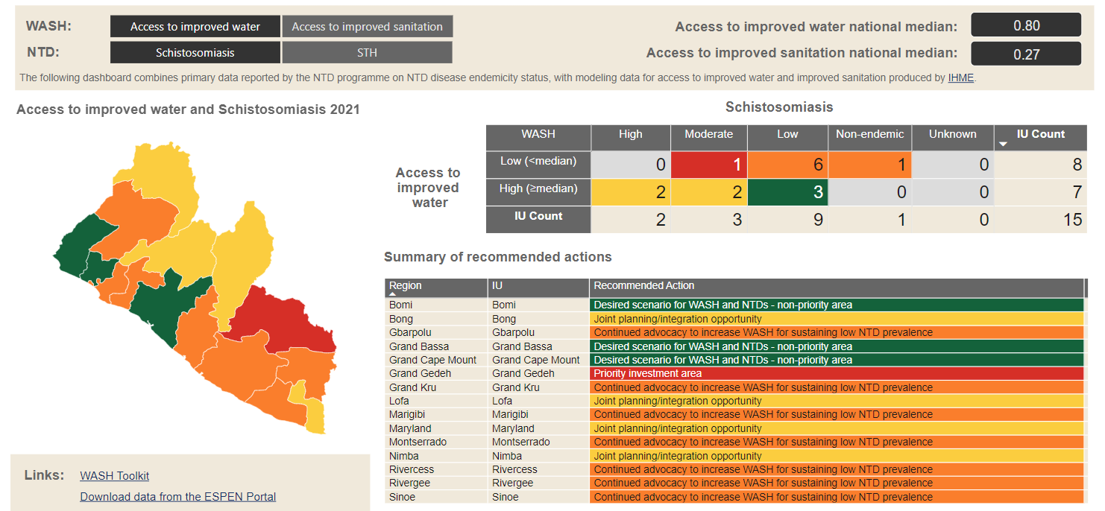

Figure 29 Map of access to improved water and schistosomiasis

#### 1.5.7.5 Short term recommendations

* Support meeting with the WASH commission executive director and the NTD Program Director to initiate engagement for collaboration of between the sectors.
* The WASH executive director communicates officially for the NTD Program Director to participate in the WASH sector meeting.
* WASH and NTDs Programs participate in collaborative meetings at the national level.
* WASH and NTDs Program participate in collaborative meetings at the county level.
* WASH, NTD Program, and NGO stakeholders should be given permission to access each other’s data platforms:
* For NTD stakeholders and WASH Commission staff, conduct a training for on use of WASH-liberia.org to access data collected through AKVO Flow or other software preferred by the sectors.
* Incorporate NTDs in the annual WASH Joint Sector Reviews (JSR)
* Invitation from WASH commission for NTDP and NTD Stakeholders to join a future JSR and to review 2018-2020 JSR findings
* Identify a task team to lead the process of incorporating NTD in the JSR: Review entry points for joint data collection and use
* Invite NTD stakeholders to contribute to the development of WASH sector performance monitoring tool and explore integration of NTD data for example using NTD endemicity as an indicator of need in terms of WASH provision) and NTD stakeholder involvement in, the process to finalize development of tool.
* Collaborate with partners to learn from best practice in other sectors and countries
* Participate in a country learning visit (for example to Ghana or Nigeria within West Africa region or Ethiopia or Kenya.
* Share learning through stakeholder engagement with other sectors that have experience of strengthening data platforms such as malaria, HIV/AIDS and immunization.
* Share WASH and NTDs landscape analysis and support their participation in joint WASH and NTDs workshop to ensure that actions to strengthen WASH and NTD data collection and use are aligned and complimentary to health system strengthening activities.
* Explore process to integrate an indicator on WASH into routine monitoring by surveys by county M&E officers - seek support for pilot/trial for this in 1-2 targeted Counties and strengthen AKVO data in one region funding and buy-in support. For example, by collaborating with SCI on SCH/STH surveys which can include WASH questions

#### 1.5.7.6 Long term recommendations

Train WASH Commission staff and WASH stakeholders on use of AKVO platform for WASH data and information management and sharing to better enable shared use of data by WASH and NTDs stakeholders.

Through joint WASH and NTD advocacy, build funding, political and technical support for integrating NTD and WASH data into DHIS2 for integrated planning and programming.

Increase advocacy actions through regular briefing and influencing meetings with policy makers at national and subnational levels to ensure WASH and NTDs are appropriated for in the fiscal space.

#### 1.5.7.7 Mental Health

Mental health is an integral part of general health and well-being and a basic human right; having good mental health means people are better able to connect, function, cope and thrive. Mental health exists on a complex continuum, with experiences ranging from an optimal state of well-being to debilitating states of great suffering and emotional trauma. People with mental health conditions are more likely to experience lower levels of mental well-being, and are consequently more vulnerable to the long term impacts of NTDs.

Neglected Tropical Diseases (NTDs) are diverse group of diseases that affects the physical, mental, and social well-being of people. While the mobilization and allocation of resources to combat these neglected health conditions is an important recognition of their effects on public health, unfortunately, less attention has been paid to addressing the needs of the people already affected by these conditions. In addition to the physical impairment and disability associated with NTDs, affected people often face social exclusion leading to high rates of mental ill health.

Recognizing the links between NTDs and mental health is important to ensure that health programs adequately meet the needs of those affected, to improve outcomes for beneficiaries. For example, the level of comorbidity between NTDs and mental health problems has not been adequately recognized in most estimates of illness burden to date. In Liberia, Mental Health and Psychosocial Support (MHPSS) services for people affected by NTDs is limited or non-existent in some facilities and communities.

Provision of comprehensive health care services will not only address the physical impairment and disability associated with NTDs, but will equally address stigma and discrimination, social exclusion, reduced access to health and social services, lack of educational opportunities, and restrictions in exercising civil and political rights faced by people affected with NTDs.

However, Neglected Tropical Diseases and Mental Health programs in collaboration with partners have integrated and upgraded the knowledge of mid-level health care workers to provide patient-centered care including mental health and psychosocial support in three counties (Lofa, Margibi, Grand Gedeh with support from REDRESS Project). However, the Carter Center has funding to scale up the training in Grand Bassa county. The master plan will address the scale up plan for the remaining 11 counties.

#### 1.5.7.8 Pharmacovigilance

Pharmacovigilance is a system of monitoring and evaluating suspected adverse effect(s) of a particular pharmaceutical product. It is the monitoring systems that identifies and investigates any report of Severe Adverse Effects (SAE) associated with the use of NTDs drugs. There exists a structure called the strong Logistic Management Information System (LMIS), which supports evidence-based procurement, quantification, supply planning, and financial decisions that are central to effective management of pharmaceuticals. The LMIS makes it easier for Liberia’s Ministry of Health (MOH) to collect, process, and report on medicine consumption at the national level. However, as a country emerging from decades of war, the LMIS remains weak.

The introduction of NTDs health products during implementation poses a number of challenges to health services due to need to recruit qualified personnel. Healthcare personnel will be required to ensure correct prescription through training, effective distribution channels and the fostering of compliance by patients and management of SAEs. There is a need to work with the Liberia Medicines and Health Products Regulatory Authority (LMHRA) to establish an appropriate Pharmacovigilance system to monitor the potential occurrence of unexpected adverse reactions. In order to achieve this, the NDTs program needs to be integrated into the national pharmacovigilance system at LMHRA which shall train program responsible person like the program pharmacist to handle all adverse drug related activities experienced by client as the result of the use of NTDs medicines.

The recipients of NTDs drugs will be informed likely on side effects and the procedure for reporting Severe Adverse Events following medication (SAEs) using the LMHRA standards. In over 12 years of experience with large scale Ivermectin treatment in Liberia, there have not been reports of serious or life threatening adverse reactions, however, there has not been a good experience with large scale treatment with other NTDs medicines. It is recognized that safety monitoring of all drugs is a necessity for public health. Thus, the proposed generic system aims to capture suspected adverse events associated with all drugs and it is not specific to NTDs drugs only. Coordination by the national Pharmacovigilance unit at LMHRA, as it is already for various disease control programs at national level will be required. The Expert Safety Review Panel will interpret safety issues associated with NTD drugs.

#### 1.5.7.9 Supply Chain

In addressing the Program supply chain challenges, the Master Plan will build capacity to support the availability of donated drugs at the sub-national level for mass drug administration (MDA) and NTDs requiring case management. This can be done by:

1. Improving demand forecasting (quantification) by developing the skills and capacity of national NTD team to provide accurate information to WHO and other partners and.
2. Improving standard procedures and training for the appropriate management of donated and procured medicines, thereby strengthening key elements of the national health supply chain.
3. Integration with LMIS to leverage their systems and personnel

A key objective of supply chain capacity building is to ensure that the correct volume of donated drugs required for MDA and case management activities are requested in the first place. Then, once delivered to each country, the donated or locally procured drugs maintain quality and integrity throughout distribution to the last mile and reverse logistics, to minimize loss, damage, or wastage.

Country review of NTD supply chain practices and operating procedures aligns with the intentions of the Nation Supply Chain Master Plan. This should also help to direct support to the national NTD program to complete the eleven draft SOPs which is key to product availability. The eleven draft SOPs are JAP Application, Shipping Notification Greenlight, Custom Clearance and Delivery, Transportation, Inventory Management, Storage, FEFO, Reverse Logistics, Removing Expiries, Wastage Management and Quantification. When these SOPs are completed, they will assist the program in the following ways, among others:

* Documenting of NTD supply chain practices and responsibilities.
* Raising the profile of supply chain risks and challenges that need to be addressed.
* Informing an implementation plan for the SOPs, including highlighting key considerations for training roll-out.
* Sharing of lessons learnt from other health program and supply chain projects.
* Discussions on a roadmap to integrate NTD supply chain into the national health system and others.

**1.5.8 Intervention information and Partners**

#### Summary of intervention information on existing NTD Program

|  |  |  |  |  |  |  |  |  |  |
| --- | --- | --- | --- | --- | --- | --- | --- | --- | --- |
| **Disease program** | **Date program started** | **Total Counties targeted** | **No. Counties covered**  **(Geographic**  **coverage*)** | **Total population in target counties** | **Proportion of population covered** | **Proportion of counties with required number of**  **effective treatment rounds completed** | **Proportion of counties that have stopped**  **MDA** | **Key strategies used** | **Key partners** |
| **LF** | 2012 | 15 | 13 | 3,280,790 | 84% | **85%** | TAS in 6 counties | MDA, Case detection, Self-Care, Surgery | LSTM, SightSavers,  ALM, effect hope,  GLRA |
| **Onchocerciasis** | 2000 | 15 | 15 | 3,811,656 | 84% | TBC  100% | MDA on-going | MDA, Breeding site survey | WHO, SightSavers |
| **SCH** | 2012 | 15 | 13 | 3,280,790 | 85% | 85% | MDA on-going | MDA, Impact Studies | WHO, SCIF, SightSavers, COUNTDOWN |
| **STH** | 2012 | 15 | 15 | 3,811,656 | 84% | 100% | MDA on-going | MDA, Impact Studies | WHO, SCIF, SightSavers,  COUNTDOWN |
| **TRA** | N/A | N/A | N/A | N/A | N/A | N/A | N/A | N/A | N/A |
| **HAT** | N/A | N/A | N/A | N/A | N/A | N/A | N/A | N/A | N/A |
| **Yaws** | 2018 | 2 | 2 | 434,696 | 9.35 | N/A | N/A | Case search | WHO, ALM, effect hope, LSTM |
| **Dracunculiasis** | N/A | N/A | N/A | N/A | N/A | N/A | N/A | N/A | N/A |
| **Leishmaniasis (VL)** | N/A | N/A | N/A | N/A | N/A | N/A | N/A | N/A | N/A |
| **Nodding Syndrome** | N/A | N/A | N/A | N/A | N/A | N/A | N/A | N/A | N/A |
| **Leprosy** | 2012 | 15 | 15 | 4,648,362 | NA | N/A | N/A | Case detection, Treatment | WHO  effect hope  ALM  GLRA  LSTM |

Table 20 Summary of intervention information on existing NTD Program

**\*Geographical coverage = No. of Counties covered by the program / Total no. of endemic counties in the country**

## Section 1.6: Building on NTD Program Strengths

### 1.6.1. Strengths and Weaknesses

|  |  |  |  |
| --- | --- | --- | --- |
| **Weakness** | **Strengths counteracting Weaknesses** | | **Opportunities counteracting Weaknesses** |
| * Lack of direct and sustainable funding for NTDs implementation * Over-stretched and limited financial resources * Lack of full ownership of existing programs at national and county levels * Poor Monitoring and evaluation of NTDs health products * Limited logistical support for staff at county and lower levels * Limited integration of mental health and NTDs * Inadequate supply of NTDs health drugs and commodities * Limited trained health professionals, especially at county and facility levels * Low awareness of NTDs within the general population * Stigma and discrimination against people affected by NTDs | * Committed Partners for NTDs implementation * Government ownership of the NTDs program * Increased visibility of NTDs into national health policy and plan * Appointment of an NTDs Ambassador for advocacy * Integrated NTDs program * Integration of NTDs services into the national health care system at all levels * Availability of NTDs data for evidence-based planning | * Existing and new partnerships for resource mobilzation * Political stability of country * High Community acceptance for NTD interventions * Availability of National NTD multi-year plan that can be used for resource mobilization * Government decentralization policy | |

Table 21 Strengths and weaknesses

### 1.6.2. Opportunities and Threats

|  |  |  |
| --- | --- | --- |
| **Threats that Need to be Prioritized** | **Strengths counteracting Threats** | **Opportunities counteracting Threats** |
| * Poverty * Use of external cash incentives by some programs to motivate volunteers at community level * Deplorable road conditions * Epidemics/pandemics * Reliance on donor support for NTDs activities * Security issues * Natural disaster | * Increased community participation in NTDs interventions * Standard community level human resource structure | * Opportunities at international level in funding CM NTDs * Inclusion of NTDs as priority diseases in the National Health Policy and Plan * The existence of Microfinance mechanisms |

Table 22 Opportunities and threats

### 1.6.3. Gaps and priorities

**Gaps and priorities**

|  |
| --- |
| **Gaps** |
| **Health Service Delivery** |
| Inadequate laboratory capacity for NTDs |
| no education carried out with women diagnosed and treated for FGS |
| Integration of Mental Health services with NTDs in the remaining 12 counties (training of mid-level health workers) |
| No MDA for Yaws affected communities in Maryland County since 2018 |
| No intervention in urban Montserrado for STH, SCH, LF and Onchocerciasis |
| FGS not embedded in routine health service delivery |
| **Health Workforce** |
| Inadequate technical and program staff at NTD, including staff for M&E and Supply Chain |
| Mid-level health workers are not trained in the integrated approach of CM NTDs outside of the initial pilot counties |
| Inadequate funding for NTDs at national and county level |
| Incomplete NTD SOPs for Supply Chain Activities |
| No training for health workers on FGS in Liberia |
| **Health financing** |
| Limited funding from government |
| Unsustainable financial support as most activities are supported by partners |
| **Health Information** |
| Burden of NTDs not well established – urgent need for mapping and surveillance |
| Limited research (including operations research) on NTDs |
| limited posters, brochures, and visual aids to be posted at the health facilities and in some communities |
| no community engagement leaders such as commissioners and paramount chiefs; and women’s group leaders to sensitize the communities on FGS |
| **Health Products** |
| Non availability of RDTs and DPPs to test for Yaws |
| Frequent stockout of NTDs drugs and commodities |
| **Leadership and governance** |
| Weak collaboration with WASH partners |
| Weak collaboration with the Malaria program |
| **Priorities** |
| Conduct smart advocacy for additional resources for NTDs at national and county level |
| Strengthen laboratory capacity and network for NTDs |
| Effective coordination of NTD management across different units of the MOH – ensure NTD Master Plan captures all NTDs of public health importance in Liberia |
| Advocate with counties to develop NTD plans and fund NTD activities |
| Integrate Mental Health services with NTDs in the remaining 12 counties (training of mid-level health workers) |
| Conduct mapping to establish the burden of CM NTDs |
| Conduct surgeries for back log of hydrocele patients |
| Scale up integrated NTDs services to the remaining counties |
| Urgently conduct mapping and surveillance of CM NTDs to establish a baseline for the current master plan |
| Conduct rigorous monitoring and supervision |
| Identify NTD research priorities in collaboration with both research and academic institutions |
| Development of NTD- WASH Framework to enhance collaboration, coordination and strengthen partnerships with the WASH sector |
| Strengthen technical knowledge of staff in both field and laboratory activities through focused training in key elements of Onchocerciasis, epidemiology and vectoral biology |

Table 23 Gaps and Priorities

# PART 2 Strategic Agenda:

## 2.1 Purpose and Goals

This section provides the strategic direction, overview of the targets and milestones for all NTDs that are endemic in Liberia. It includes the vision, mission, and goals of the NTD program. The strategic priorities and strategic objectives indicate the main ‘pillars of excellence as well as the continuous improvement objectives that the program seeks to achieve during the life cycle of the master plan (figure 35).

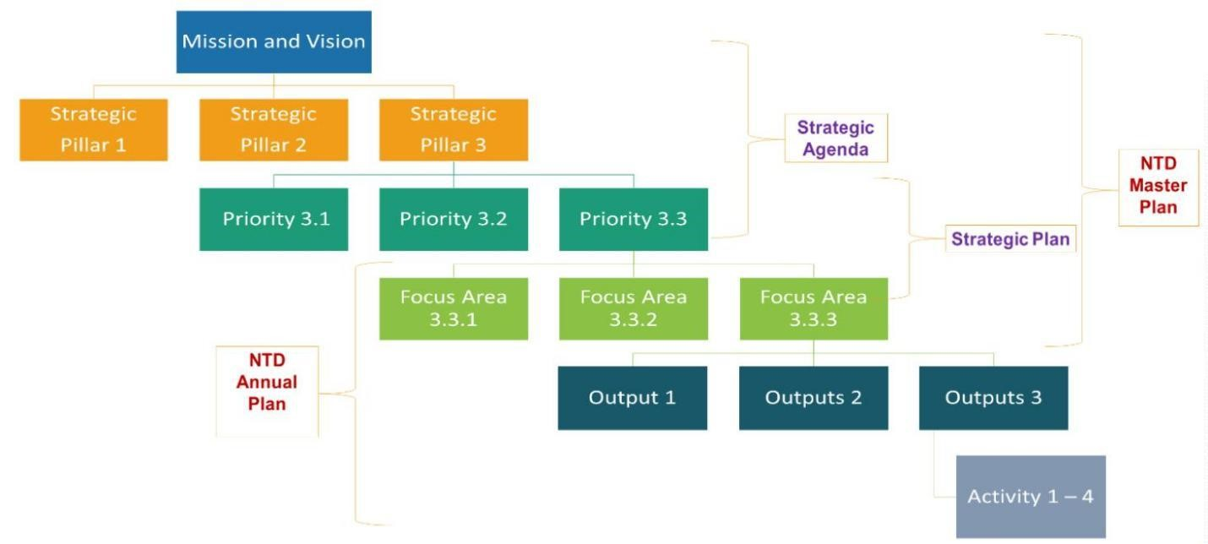

Figure 30 Hierarchy of objectives for Liberia NTD Program

## Section 2.1: NTD Program Mission and Vision

|  |  |
| --- | --- |
| **Mission and vision** | |
| **Mission**  *What we exist to do* | To strengthen the health system to deliver NTDs services effectively and efficiently on an equitable basis as an integral part of the health system |
| **Vision**  *Where we need to go* | A Liberia free of NTDs |

Table 24 NTD Program Mission and Vision

The Liberia NTD Master Plan, which is a five year strategic plan (2023-2027), includes Mission, Vision, Guiding principles, Programme Strategic Priorities and Pillars.

## Section 2.2: Milestones and Targets

The overarching and cross-cutting targets are derived from the NTD Global Roadmap 2021–2030. These targets provide opportunities for integration, coordination, and country ownership and equity

The development of this NTDs master plan includes targets for sectors such as WASH, safety, and vector control based on established targets. Disease-specific targets for 2025 and milestones for 2023 and 2027 are set for each of the endemic diseases for one of the following: eradication, elimination (interruption of transmission), elimination (as a public health problem), or control.

### 2.2.1. Targets

#### 2.2.1.1 Overarching targets

**Liberia NTD Targets 2027**

|  |  |  |  |
| --- | --- | --- | --- |
| Indicator | 2022 (Baseline) | 2025 (Midterm) | 2027 |
| Percentage reduction in people requiring interventions against neglected tropical diseases | 0 | 30% | 60% |
| Percentage reduction in people requiring interventions against CM neglected tropical diseases | 0 | 25 | **50** |
| Number of counties having eliminated at least one neglected tropical disease as a public health problem (LF, Schistosomiasis, STH, etc.) | 0 | 2 | 5 |
| Number of neglected tropical diseases eradicated or eliminated (countrywide) as a public health problem (GW). | 0 | 1 | 2 |

Table 25 Liberia NTDs Targets 2027

#### 2.2.1.2 Cross-cutting Targets

|  |  |  |  |  |
| --- | --- | --- | --- | --- |
| **Domain** | **Indicator** | **2022 (Baseline)** | **2025 (Midterm)** | **2027** |
| Integrated Approaches | Integrated treatment coverage index for preventive chemotherapy NTDs | 84.9% | 85% | **90%** |
| Percentage of counties that adopt and implement MMDP and other associated morbidity related interventions (i.e. OAE, TT surgeries, Leprosy, Buruli ulcer, etc.) for target NTDs. | 33% | 66% | **100%** |
| Multi-sectoral Collaboration | Proportion of population in endemic counties with access to safe water for SCH, and STH | 73% | 80% | **90%** |
| Proportion and number of endemic counties with adequate sanitation manipulation for SCH, and STH | 40% | 50% | **70%** |
| Proportion and number of endemic counties with adequate environmental manipulation for SCH, and STH | 40% | 50% | **70%** |
| Universal Health Coverage | Proportion of counties where 50% of all health facilities have and use guidelines for management of NTD-related disabilities | 33% | 66% | **100%** |
| Country Ownership | Proportion of counties reporting on all relevant endemic neglected tropical diseases and associated co-morbidities | 93 % | 100% | **100%** |
| Proportion of counties collecting and reporting data on neglected tropical diseases disaggregated by gender | 93% | 100% | **100%** |
| Number of Counties with fully functional NTD Task Forces (based on clear ToRs) | 0 | 5 | **10** |
| Number of Counties mobilizing logistic and financial resources for NTDs | 5 | 10 | **15** |
| Proportion of government direct funding towards NTD implementation | **0%** | **10%** | **20%** |

Table 26 Cross-cutting Targets

#### *2.2.1.3 Disease-Specific Targets*

|  |  |  |  |  |
| --- | --- | --- | --- | --- |
| **Disease** | **Indicator** | **2022**  **(Baseline)** | **2025 (Midterm)** | **2027** |
| *Targeted for Eradication* | | | | |
| Dracunculiasis | Number of endemic counties MAINTAINING zero confirmed cases status | 15 | 15 | 15 |
| Yaws | Percentage of endemic counties where transmission has been interrupted | 0% | 30% | 70% |
| *Targeted for Elimination (Interruption of Transmission)* | | | | |
| Leprosy | Percentage of counties with zero new autochthonous leprosy cases | 66% | 75% | 75% |
| Onchocerciasis | Percentage of counties that have suppressed transmission | 0% | 40% | 70% |
| *Targeted for Elimination as a Public Health Problem* | | | | |
| Lymphatic ﬁlariasis | Number of counties having stopped mass drug administration, and have passed TAS1 | 0 | 9 | 11 |
| Rabies | Number of counties having achieved zero human deaths from rabies | 0 | 1 | 2 |
| Schistosomiasis | Percentage of national average heavy intensity of schistosomiasis | 1.6% | 1% | 0.5% |
| Soil-transmitted helminthiases | Number of endemic counties with no site recording soil-transmitted helminth infections of moderate and heavy intensity due to *Ascaris lumbricoides, Trichuris trichuria, Necator americanus and Ancylostoma duodenale*) | 0 | 5 | 8 |
| *Targeted for Control* | | | | |
| Buruli Ulcer | Proportion of cases in category III (late stage) at diagnosis | 58% | 40% | 25% |

Table 27 Disease specific targets

### 2.2.2. Milestones

|  |  |  |  |  |  |  |
| --- | --- | --- | --- | --- | --- | --- |
| **Indicators** | **2022**  **Baseline** | **2023** | **2024** | **2025** | **2026** | **2027** |
| Completed re-mapping of LF and determined LF endemic areas and the population at risk | 13 (100%) | 0 | 0 | 0 | 0 | 0 |
| Implement LF MDA in IUs requiring LF MDA endemic areas | 13 (100%) | 13 (100%) | 13 (100%) | 13 (100%) | 13 (100%) | 13 (100%) |
| Geographical coverage in LF of LF MDA | 13 (100%) | 13 (100%) | 13 (100%) | 13 (100%) | 13 (100%) | 13 (100%) |
| Number of county capital cities with evidence of LF transmission under adequate MDA | 12 | 12 | 13 | 13 | 13 | 13 |
| Number of IUs conducted more than 5 rounds of MDA with coverage more than 65% | 13 (100%) | 13 (100%) | 13 (100%) | 13 (100%) | 13 (100%) | 13 (100%) |
| Number of Counties conducted first TAS activities after at least 5 rounds of MDA. | 6 (46%) | 10 (76%) | 13 (100%) | 13 (100%) | 13 (100%) | 13 (100%) |
| Number of IUs conducted and passed at least 2 TAS activities. | 0 (0%) | 4 (31%) | 10 (76%) | 13 (10%) | 13 (100%) | 13 (100%) |
| Present “the dossier“ for verification of absence of LF transmission | 0 (0%) | 0 (0%) | 0 (0%) | 0 (0%) | 0 (0%) | 13 (0%) |
| Proportion and number of IUs where there is full coverage of morbidity management services and access to basic care | 5 (38%) | 13 (100%) | 13 (100%) | 13 (100%) | 13 (100%) | 13 (100%) |
| Proportion and number of IUs where 75% of hydrocele cases benefitted from appropriate surgery | 0 (0%) | 3 (24%) | 5 (38%) | 6 (46%) | 13 (100%) | 13 (100%) |

Table 28 Milestones for targeted NTDs (LF)

**Milestones for targeted NTDs (Onchocerciasis)**

|  |  |  |  |  |  |  |
| --- | --- | --- | --- | --- | --- | --- |
| **Indicators** | **2022 Baseline** | **2023** | **2024** | **2025** | **2026** | **2027** |
| Completed re-mapping of Oncho and determined Oncho endemic areas and the population at risk | 15(100%) | 15 (100%) | 15 (100%) | 15 (100%) | 15 (100%) | 15 (100%) |
| Begun implement Oncho MDA in IUs requiring Oncho MDA in endemic areas | 100% | 100% | 100% | 100% | 100% | 100% |
| Geographical coverage in Oncho of Oncho MDA | 100% | 100% | 100% | 100% | 100% | 100% |
| Number of IUs conducted more than 10 rounds of with coverage more than 65% | 15 (100%) | 15 (100%) | 15 (100%) | 15 (100%) | 15 (100%) | 15 (100%) |
| Number of IUs achieved suppression of transmission after at least 10 rounds of MDA. | 0 (0%) | 4 (26%) | 6 (40%) | 8 (53%) | 12 (80%) | 15 (100%) |
| Number of IUs where treatment has been stopped | 0 (0%) | 4 (26%) | 6 (40%) | 8 (53%) | 12 (80%) | 15 (100%) |
| Number of IUs that achieved elimination of transmission | 0 (0%) | 4 (26%) | 6 (40%) | 8 (53%) | 12 (8%) | 15 (100%) |

Table 29 Milestones for targeted NTDs (Onchocerciasis)

**Milestones for targeted NTDs (Schistosomiasis)**

|  |  |  |  |  |  |  |
| --- | --- | --- | --- | --- | --- | --- |
| **Indicators** | **2022 Baseline** | **2023** | **2024** | **2025** | **2026** | **2027** |
| Completed mapping of SCH and determined SCH endemic areas and the population at risk | 13  (100%) | 15 (100%) | 15 (100%) | 15 (100%) | 15 (100%) | 15 (100%) |
| Begun implement SCH MDA in Counties requiring SCH MDA | 13(100%) | 13 (100%) | 13 (100%) | 13 (100%) | 13 (100%) | 13 (100%) |
| Geographical coverage in SCH of SCH MDA | 13(100%) | 13 (100%) | 13 (100%) | 13 (100%) | 13 (100%) | 13 (100%) |
| Percentage of low endemic counties that conducted more than 3 rounds of with coverage more than 75% | 13 (100%) | 13 (100%) | 13 (100%) | 13 (100%) | 13 (100%) | 13 (100%) |
| Percentage of moderate - highly endemic counties conducted more than 5 rounds of with coverage more than 75% | 13 (100%) | 13 (100%) | 13 (100%) | 13 (100%) | 13 (100%) | 13 (100%) |
| Number of counties with full coverage of WASH interventions. | 0 (0%) | 0 (0%) | 0 (0%) | 3 (23%) | 4 (31%) | 8 (62%) |
| Percentage of counties conducted first impact assessment at least 3 rounds of MDA. | 23% | 31% | 53% | 65% | 76% | 80% |
| Number of countiesconducted first impact assessment at least 5 rounds of MDA. | 23% | 31% | 53% | 65% | 76% | 100% |
| Endemic counties achieving moderate morbidity control | 3 (23%) | 4 (31%) | 6(46%) | 7(53%) | 10 (76%) | 13(100%) |
| Endemic Counties achieving advanced morbidity control | 2 (15%) | 4 (31%) | 6(46%) | 7(53%) | 10 (76%) | 13(100%) |
| Endemic Counties achieving elimination of transmission | 0 (0%) | 4 (31%) | 6 (46%) | 7(53%) | 10 (76%) | 13(100%) |

Table 30 Milestones for targeted NTDs (Schistosomiasis)

**Milestones for targeted NTDs (Soil Transmitted Helminths)**

|  |  |  |  |  |  |  |
| --- | --- | --- | --- | --- | --- | --- |
| **Indicators** | **2022**  **Baseline** | **2023** | **2024** | **2025** | **2026** | **2027** |
| Completed mapping of STH and determined STH endemic areas and the population at risk | 15 (100%) | 15 (100%) | 15 (100%) | 15 (100%) | 15 (100%) | 15 (100%) |
| Begun implement STH MDA in IUs requiring STH MDA | 15 (100%) | 15 (100%) | 15 (100%) | 15 (100%) | 15 (100%) | 15 (100%) |
| Geographical coverage in STH of STH MDA | 15 (100%) | 15 (100%) | 15 (100%) | 15 (100%) | 15 (100%) | 15 (100%) |
| Percentage of low endemic IUs that conducted more than 3 rounds of with coverage more than 75% | 15 (100%) | 15 (100%) | 15 (100%) | 15 (100%) | 15 (100%) | 15 (100%) |
| Percentage of moderate - highly endemic IUs conducted more than 5 rounds of with coverage more than 75% | 15 (100%) | 15 (100%) | 15 (100%) | 15 (100%) | 15 (100%) | 15 (100%) |
| Number of IUs with full coverage of WASH interventions | 0 (0%) | 3 (20%) | 4 (26%) | 5 (33%) | 7 (46%) | 13 (86%) |
| Percentage of IUs conducted first impact assessment at least 3 rounds of MDA. | 20% | 100% | 100% | 100% | 100% | 100% |
| Proportion of IUs conducted first impact assessment at least 5 rounds of MDA. | 20% | 100% | 100% | 100%% | 100% | 1000% |
| Endemic IUs achieving advanced morbidity control | 3 (20%) | 5 (33%) | 7 (47%) | 9 (60%) | 12 (80%) | 15 (100%) |
| Endemic IUs achieving elimination of transmission | 0 (0%) | 5 (0%) | 7 (47%) | 8 (0%) | 12 (80%) | 15 (100%) |

**Milestones for targeted CM-NTDs**

|  |  |  |  |  |  |  |
| --- | --- | --- | --- | --- | --- | --- |
| **Indicators** | **2022 Baseline** | **2023** | **2024** | **2025** | **2026** | **2027** |
| Active case detection in 100% of highly endemic IUs | 33% | 40% | 50% | 60% | 70% | 100% |
| Passive case detection in 100% of other endemic IUs | 100% | 100% | 100% | 100% | 100% | 100% |
| Proportion of cases in peripheral health facilities | 20% | 30% | 40% | 60% | 75% | 100% |
| Proportion of severe and complicated cases refer for management at hospitals and reference centers | 5% | 10% | 30% | 40% | 50% | 100% |
| Proportion of identified leprosy cases who completed treatment | 66% | 66% | 70% | 75% | 90% | 100% |
| Proportion of identified BU cases who completed treatment | 10% | 30% | 40% | 50% | 70% | 100% |
| Proportion of identified yaws cases who completed treatment | 0% | 100% | 100% | 100% | 100% | 100% |
| Proportion of identified lymphedema cases who are practicing home-based self-care | 100% | 100% | 60% | 100% | 100% | 100% |
| Percentageof Started passive surveillance in at least 50% of target counties for CM-NTDs targeted for elimination (Leprosy) | 20% | 40% | 50% | 60% | 70% | 100% |
| Started sentinel site surveillance in at least 50% of target IUs for CM-NTDs targeted for elimination (Leprosy) | 20% | 40% | 50% | 60% | 70% | 90% |
| Target IUs that sustained elimination of leprosy | 10% | 40% | 50% | 60% | 70% | 90% |
| Started passive surveillance in at least 50% of target IUs for other CM-NTDs | 10% | 40% | 50% | 60% | 70% | 90% |

Table 31 Milestones for targeted CM NTDs

## Section 2.3: Guiding Principles

|  |  |
| --- | --- |
| **Guiding principles** | |
| **Guiding principles** | National leadership and ownership,  Commitment to collaboration and sharing,  Mutual accountability of national authorities and partners, Transparency and accountability,  Community engagement and participation  Gender Sensitivity and responsiveness  People centered care  Equity |
| **Government Ownership and Partners Alignment**  The primary responsibility for NTDs control, elimination or eradication in Liberia is the responsibility of the Government. There is a need for different approaches and increased collaboration at the national, county, and health district and community levels within the country.  A range of government departments and agencies will be responsible for NTDs activities, and actions shall be coordinated and harmonized. The Government shall act through partnerships with international agencies including WHO, private sector institutions, NGOs, CBOs, and as well as people affected by NTDs. The collaboration will result in support of the sustainability of expertise, resource mobilization, institutional development, stigma reduction, research, and community-based rehabilitation. When needed, cross-border actions shall be undertaken in coordination with other governments to ensure a continuum of care for patients.  As a matter of Government Policy,the NTDs Master Plan will be Government-led and implemented within the framework of the: Liberia National Health Policy (2022-2031) and Plan, Sustainable Development Goals (SDGs), and WHO NTDs Roadmap (2021-2030).  Its mission shall consist of laboratory confirmation of cases, management of complications, capacity building, and research. New tools utilizing e-learning and telemedicine, wherever available, will be exploited. Nursing and medical schools’ curricula as well as education curricula for low-level health workers shall include NTDs to generate a minimum suspicion among health care workers, inclusive of those working in low-endemic areas.  **Evidence based:** The NTDs interventions will be evidence-driven. The integrated NTDs Program shall take into consideration the learnings from previous interventions throughout the implementation of the NTD Program.  **Gender**: The implementation of the NTDs Master Plan will be gender-sensitive and responsive. Special attention shall be given to children and women, promoting early detection through periodical screening, facilitating diagnosis, and access to care.  **Human Rights**: The Liberia NTDs Master Plan implementation will respect fundamental human rights and adhere to high ethical standards. Persons affected by these diseases will be encouraged to support the early identification of other patients, and to improve treatment adherence and completion rates. County and community-based organizations representing persons affected by NTDs shall be integral to this process.  Given that most NTDs interventions are community-based, community leaders will be empowered to take ownership for the NTDs activities in terms of planning and implementation in their communities.  The implementation of the NTDs Master Plan at all levels will be driven by the principles of good governance, transparency, accountability, and prudent use of resources. While the NTDs Master Plan meets global goals and standards of best practices, interventions will be designed and implemented to fall within and be aligned to the context of the country’s realities, priorities, traditions, and socio-cultural environment. | |

Table 32 Guiding Principles

## Section 2.4: Strategic Pillars and Strategic Objectives

### 2.4.1. Program Strategic Pillars

The figure below provides a framework for NTDs program interventions in Liberia (figure 31).

**STRATEGIC GOAL**

To prevent, control, eliminate and eradicate priority NTDs in Liberia

.

**Pillar 1**

Accelerating Programmatic action

**Pillar 2**

Intensify  
cross-cutting approaches

**Pillar 3**

Operating Models and culture to facilitate country ownership

**Pillar 4** Strengthening the resource mobilization, inter-sectoral collaboration for elimination of NTDs

Figure 31 Program Strategic Pillars

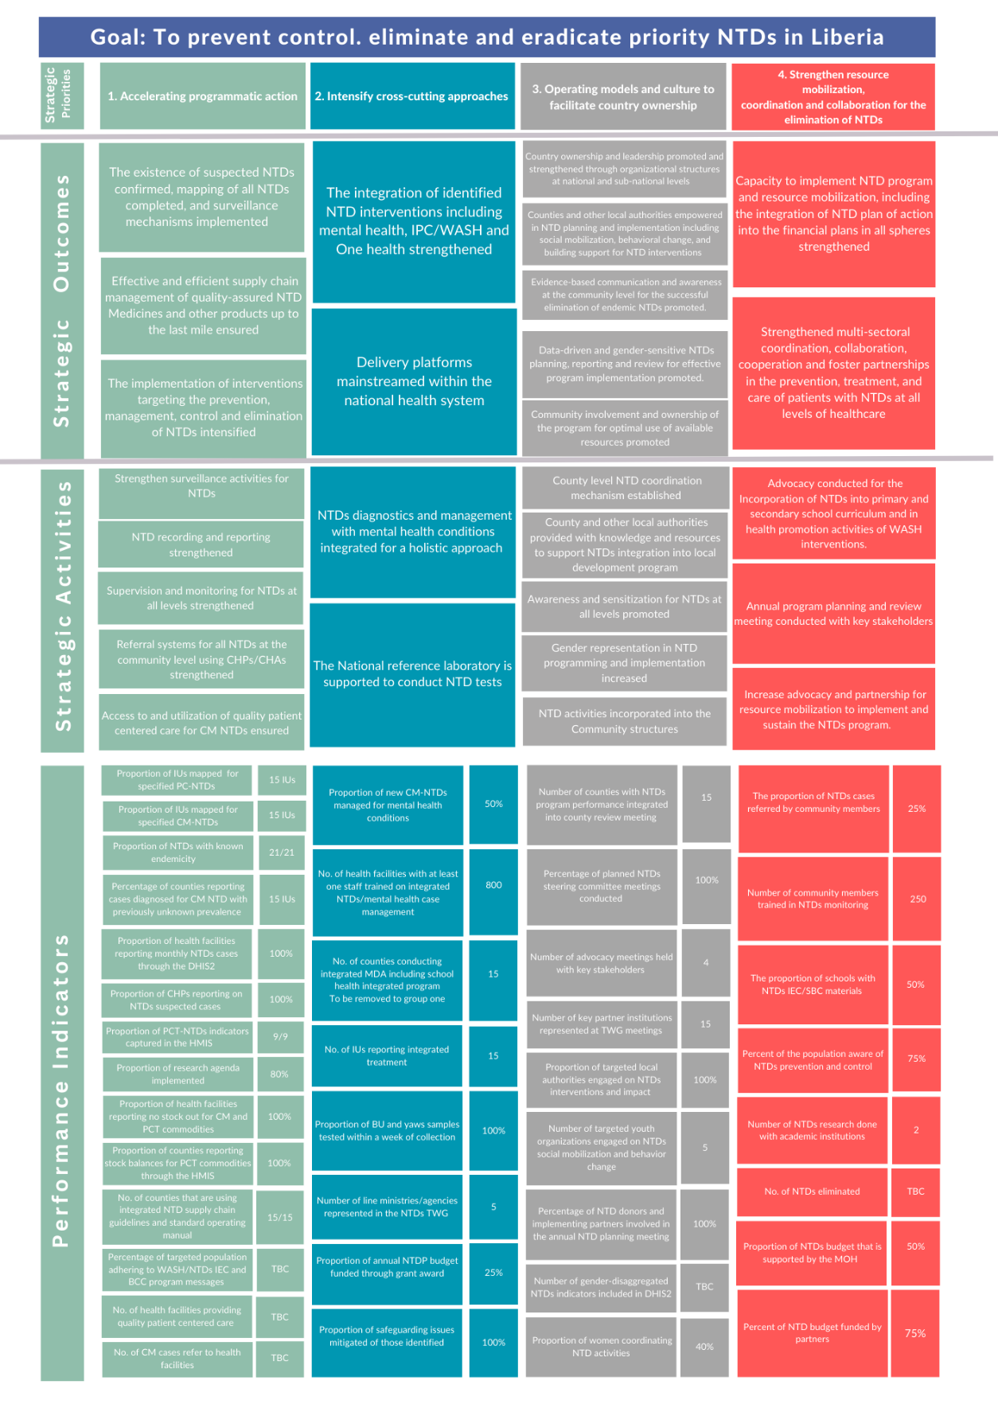

Figure 32 Logic map summary diagram

### 2.4.2. Strategic Objectives

**Strategic Objectives for the Elimination of Neglected Tropical Diseases**

|  |  |
| --- | --- |
| **Strategic Priority or Pillar** | **Strategic Objectives** |
| I Accelerating programmatic action | Confirm the existence of suspected NTDs and complete mapping of all NTDs |
| Prioritize and strengthen monitoring and evaluation and operational research to track progress and informed decision-making toward the 2030 NTDs roadmap goals |
| Ensure effective and efficient supply chain management of quality assured NTD Medicines and other products up to the last mile |
| Intensify the implementation of interventions targeting the prevention, management, control and elimination of NTDs |
| II Intensify cross-cutting approaches  II Intensify cross-cutting approaches | Strengthen the integration of identified NTD interventions including mental health, IPC/WASH, Vector Control and One health |
| Mainstream delivery platforms within the national health system |
| Strengthen multi-sectoral coordination, collaboration, cooperation and foster partnerships in the prevention, treatment, and care of patients with NTDs at all levels of healthcare |
| Integrate safety across NTD planning, implementation, and monitoring |
| III Operating Models and culture to facilitate country ownership | Promote and strengthen country ownership and leadership through organizational structures at national and sub-national levels |
| Empower Counties and other local authorities in NTD planning and implementation including social mobilization, behavioral change, and building support for NTD interventions |
| Promote youth engagement to influence positive change and norms for the reduction of NTDs in favor of the national NTD program |
| Promote evidence-based communication and awareness at the community level for the successful elimination of endemic NTDs. |
| Promote data-driven and gender-sensitive NTDs planning, reporting and review for effective program implementation. |
| Promote community involvement and ownership of the program for optimal use of available resources |
| Pillar 4. Strengthen Resource  Mobilization,  Coordination and collaboration for the elimination of NTDs | Strengthen advocacy and visibility of NTDs for the management, prevention, control or elimination interventions at all levels |
| Strengthen capacity to implement NTD program and resource mobilization, including the integration of NTD plan of action into the financial plans in all spheres |
| Ensure donors, implementing partners and disease experts align their strategies and plans with the National NTD Plans |
| Increase advocacy and partnership for resource mobilization to implement and sustain the NTDs program. |

Table 33 Strategic Objectives for the Elimination of Neglected Tropical Diseases

# 

# PART 3 Implementing the Strategy: NTD Operational Framework

In line with the 2021- 2030 NTD Global Roadmap, this strategic plan is geared towards ensuring three fundamental shifts in the approach to tackling NTDs: **first**, increase accountability for impact by using impact indicators instead of process indicators, as reflected by the targets and milestones in Part II and accelerate programmatic action; **secondly**, move away from siloed, disease-specific programs by mainstreaming programs into national health systems and intensifying cross-cutting approaches centered on the needs of people and communities: and **thirdly**, change operating models and culture to facilitate greater ownership of programs by countries.

## Section 3.1: Strategic priorities and Key Activities

|  |  |  |  |  |  |  |
| --- | --- | --- | --- | --- | --- | --- |
| **Impact** | **Priority NTDs in Liberia controlled, eliminated and eradicated** | | | | | |
| **SP** | **Outcome** | **Outputs** | **Major Activities** | **Sub-Activities** | **QTY/Frequency** | **Resources Needed** |
| **1** | 1.1 The existence of suspected NTDs confirmed, mapping of all NTDs completed, and surveillance mechanisms implemented. | Country-wide mapping of NTDs completed | Review current PCT-NTD prevalence maps in Liberia and identify gaps/ priority areas for mapping. | Conduct reassessment mapping for LF in Bomi and Gbarpolu | 1/once | Funds, Filiria Test Strips (FTS) and positive control, Non Consumable, human resources, logistics |
| Conduct Reassessment mapping for Schistosomiasis in 15 counties | 1/once | Laboratory equipments, funds, non- consumable, logistics human resources |
| Conduct mapping for suspected and confirmed CM NTDs and associated morbidities | Hire a consultant to develop CM-NTDs digital maps | 1/once | funds to support consultant services at $250 per day for 30 days |
| Develop ToR for a consultant | 1/once | 0 |
| Conduct a meeting to review and organize DHIS2 data for confirmed CM-NTDs | once/year | Funds for 8 persons (consultant, 2 HMIS, 3 NTDs, 2 NTDs focal persons)/ 2 days/once |
| Strengthen surveillance activities for NTDs | Train district surveillance officers (93) on surveillance systems for pharmacovigilance assessments / surveillance of MDA SAEs | Conduct training for 93 surveillance officers for 4 days | 1/Once  1/Once  monthly | Funds  No cost  Fund to support CHSS to supervise CHAs doing contact tracing |
|  |
| Conduct contact tracing and referrals for Leprosy and Yaws |
| Conduct training of CHAs and CHPs  Conduct contact tracing for Leprosy and Yaws |
| Introduce and conduct post-MDT surveillance | IntegratePost-MDT surveillance into pharmacovilance training | once in year one | No cost |
|  |  |  |
| Integrate and strengthen NTD surveillance systems for pharmacovigilance assessments and surveillance of MDA severe adverse effects (SAEs) | Procure drugs and medical supplies for SAE during MDA | Annually | Funds |
|  |  |  |
|  |  |  |
| Develop surveillance mechanism to determine the endemicity of non-targeted NTDs (trachoma, Noma) | IntegrateNon-targeted NTDs (Tachoma, Noma, Snake bite, etc ) into integrated training manual for surveillance officers and health workers | Once | No cost |
|  |  |  |
| Train CHAs/CHPs to conduct active case search in all counties (est. 13,000-check #s) | Integrate ONCHO and Mental Health into active case search training and contact tracing for CHAs and CHPs | Every two year | Fund for DSA, transportation refund, meal, hall rental, fuel, stationery, printing of training manual, |
|  |  |  |
| Establish cross border mechanisms with Mano River members | Conduct MRU cross boarder meetings  Map up cross boarder communities within adjacent MRU countries  Conduct MDA and cross boarder surveillance  Host and participate in rotational MRU meetings | Annually | Fund to host meetings.  Fund to update map to generate accurate data.  No Cost  No cost |
|  |  |  |
| Conduct coverage surveys for MDA | Train coverage survey staff  Hire independent monitor to conduct coverage survey | Annually | Funds to provide Fuel, DSA, communication cards, vehicle parts, printing of tools, |
|  |  |  |
| Provide support to districts to integrate NTDs peer support groups into county structure | Identified the peer support groups  Adopt REDRESS Project Peer Advocate Training Manual    Training of peer support groups  To collaborate with Mental Health and Community Health Programs to include NTDs Peer Advocates into existing cultivation for user hope at county level | Annually | No cost  No cost  Fund to provide meal for participants, transportation, DSA,  Fund to support groups monthly meetings |
|  |  |  |
| Procure logistics to support conduct active case searchfor CHAs/CHPs (check #s) | Procure CHAs/CHVs resource kits(back packs, raincoats, boots etc.) in coordination with CHA Program | Every two years | Funds to procure CHAs resource kits |
|  |  |  |
| Orientate traditional and faith healers to suspect and refer NTDs cases and look, listen and link | Host one day Orientation meeting with traditional healers  Host one day orientation meeting with faith healers | Annually | Funds to provide feeding, transportation refund for participants and CHSS |
|  |  |  |
| Provide performance-based incentives for CHAs/CHPs to conduct active case search and referral through the national PBF Program | Work with PBF to establish the mechanism to include NTDs Program in the PBF scheme. | 1/once | Refreshment |
|  |  |  |
| 1.2 Research, monitoring and evaluation evidenced established that tracked progress and informed decision-making toward the 2030 NTDs Road Map Goals | NTD recording and reporting strengthened | Integrate MDA data into DHIS2 | Work with HMIS to include NTDs data into the DHIS2 | 1/Once | Funds to provide communication cards, and support to HMIS to development process |
|  |
|  |  |  |
| Support health facilities to record and report through the HMIS | Update the HF CM integrated ledgers to include indicators for oncho, mental, and non-targeted NTDs  Update HF Summary Form to include Oncho, Mental Health, and Non-targeted (surveillance) NTDs  Print 850 copies of the CM integrated ledgers | Once/year one | Funds to provide communication cards, and support to HMIS to development process  No cost  Funds to print ledgers |
|  |  |  |
| Pilot study into the feasibility of implementing Post-Exposure Prophylaxis for leprosy in Liberia | Support CHSS to conduct intensive contact tracing to line list leprosy cases and contacts in Nimba County for two years | Monthly | Funds to procure communication cards and gasoline for 45 CHSS |
| Print 52,000 integrated contact tracing forms  Increase MDT supply to the Pilot County to reach out to suspects and contacts | Quarterly  Quarterly | Funds to print forms  WHO donated MDTs |
| Include rabies and snake bite into the DHIS2 | NTDs team to work with the HMIS team to include snake bite and human rabies into the DHIS2 | 1/once | No cost |
|  |  |  |
| Review, update and implement SOP/manual for routine data quality assessment, data analysis and dissemination | Develop Data Quality control tool to enable county data officer to enter harmonized data flow to the HMIS for analysis | Once | No cost |
|  |  |  |
| Support the HMIS division to conduct quarterly data reliability check at county level | Conduct data quality check | Quarterly | Funds to procure fuel, provide DSA for overnight intra county movement, communication cards for 5 NTDs staff, 4 HMIS staff, 15 NTD FPs, 15 County data mangers, |
| Engage with donors’ agencies to fund identified priority operational research areas. |  |  | No cost |
| Create a repository for operational research conducted within the country | Work with HMIS and partners to establish repository for NTDs | 1/Once | No cost |
| Coordinate with research institutes in Liberia to conduct more research and trainings | Conduct meetings with local research institutions.  Provide support to research institutions to develop protocol  Facilitatetraining for 10 national key staff and 15 FPs | Annually | Funds to provide refreshment for participants attending the meetings,  Fund for facilitators fees for five days at $100.00 per day |
|  | Data analysis training for 336 county Health Team Members forNTD intervention at all level | Conduct data analysis training for (CHOs, DHOs, NTDs FP, County Data Managers, County M&E, county supply chain coordinators and district data officers- (**336**) NTD intervention at all level | Every two years | Funds to provide meal, DSA, transportation refund, fuel and vehicle maintenance |
| Operational research for NTDs strengthened | Collaborate with training/research institutions to conduct NTDs research | Develop a NTD research agenda | 1/once | No cost |
| Develop protocol for research | Once Annually | Fund for ethical Review Board fee ($500) |
| Train 10 national key program staff and 15 NTDs FP for 5 days in Monrovia to conduct research. | Once in 2024 | Funds to provide meal for participants, Facilitators fees, transportation for participants, |
| Conduct KAP survey in 12 counties for health workers in assessing their capacity to diagnose NTDs cases. | Year one and Year four | Funds to support survey team (DSA, Fuel, printing of surveys forms,) |
| Ascertain factors contributing to diagnostic delay in BU and Leprosy at reference lab | Once in year one | No cost |
| Conduct entomological (Breeding Sites) surveys for Onchocerciasis in 15 counties | Phase 1 in year one and Phase 2 in year two | Fund for DSA, printing of survey materials, fuel for field work, feeding for participant during TOT for national staff, cards |
| Conduct operational research for Female Genital Schistosomiasis (FGS) prevalence. | 1/Once | Funds |
| Conduct LF operational research to ascertain the prevalence in urban Montserrado | 1/Once | Funds |
| Conduct Lymphatic Filariasis Pre Transmission Assessment Survey in 6 (Pre TAS) and Transmission Assessment Survey in 7 counties (TAS)  Conduct LF TAS- 2 and 3 in seven counties that passed TAS one | Year two | Funds to provide DSA, Fuel, meal, print materials, communication cards for survey teams |
| Conduct impact survey for Schistosomiasis, Soil Transmitted Helminthiases | In year two | Funds |
| Conduct coverage surveys for Onchocerciasis, Lymphatic Filariasis, Schistosomiasis, Soil Transmitted Helminthiases | After every MDA | Funds |
| 1.3.1 All NTDs commodities integrated into the overall MOH Supply Chain System | Mainstream NTD commodities into the paper based and electronic Logistics Management Information Systems (eLMIS) platform | Develop NTD Supply Chain Guidelines, and SOPs | 1/once | Funds |
| Print (850 copies) and distribute NTDs supply chain guideline and SOPs to health facilities  Monitor the usage of NTD Supply chain Guidelines, and SOPs through monitoring and supervision | 1/Once  1/Once  Monthly | No cost  Same as above |
| Develop quality control guidelines for NTD medicines  Integrate the NTDs quality control guideline with the national quality control guideline | 1/Once | Fund to print 850 copies of finalized version of the Quality Control Guideline |
| Include NTD supplies on CMS platform | Advocate with county depots (medicine stores) to increase storage capacity for NTD medicines at county level | 1/once | No cost |
|  |
| Integrate pharmacovigilance guideline training into the NTDs training for health workers | Work with LMHRA (10) to develop NTDs pharmacovigilance guideline for health workers in Monrovia for 3 days | 1/Once | Fund for transporration refund for participant, meal for participants, |
| Procure CM-NTDs and MDA medicines (including anti-venom, vaccines) and commodities for CM-NTDs | Procure BU medicines | Annually | Funds |
| 1.3 effective and efficient supply chain management of quality-assured NTD Medicines and other products up to the last mile ensured | Procure BU wound dressing materials | Annually | Funds |
| Procure leprosy reaction medicine (prednisolone) in 15 couties | Annually | Funds |
| ProcureRDT & DPP for yaws testing. | Annually | Funds |
| Procure home-based self-care kits for lymphedema clients | Annually | Funds to provide HBSC kits for existing and new cases |
| Preposition NTDs medicines for MDA and CM activities within the counties | Provide support to CMS to preposition MDA and CM medicines  Provide support to counties to preposition MDA and CM medicines | Quarterly | Fuel support to CMS |
| supervision and monitoring for NTDs at all levels strengthened | HMIS to produce monthly dashboard for NTDs cases reported through the DHIS2  Use the dashboard as guide to conduct integrated supervision with the CM monthly supervision. | Monitor DHIS2 to verify the number of CM NTDs cases diagnosed  Conduct routine data quality verification on CM NTDs data within the counties | Monthly  Monthly at county level & quarterly at national level | No cost  DSA for team members, printing of DHIS2, fuel, communication cards for internet connectivity, vehicle servicing, |
|  |  |  |  |
| Conduct CM quarterly supervision at the national level | Provide logistical and material support to National staff to conduct supportive supervision | Quarterly | Fund for fuel support, DSA for both national staff & NTD FP, communication cards |
| Conduct CM monthly supervision at the county level | Provide logistical and materials support to the NTDs Focal Persons to conduct routine supervision | Monthly | Fund for fuel support to CHTs, DSA for NTD FP, communication cards |
| Conduct supportive supervision and mentorship through the joint integrated supportive supervision mechanism | Provide support for County Health Teams to conduct supervision and mentorship at health facility level through the joint integrated supportive supervision mechanism | Quarterly | Fund for fuel support to CHTs, DSA for NTD FP, communication cards |
| Support for national to conduct supervision and mentorship | Bi-annual | Fund for fuel support to electronic Joint Integrated Supportive Supervision (eJISS), DSA for NTD national supervisors, vehicle maintenance, communication cards |
|  | Conduct yearly supervision for PCT campaigns | Provide support logistsical, materials, and human resources to carry out Mass Drug Adminiration implementation in selected counties | Annually | Fund to provide DSA for supervisors, fuel for supervision, communication cards for team members, assorted vehicle parts, print supervision tools, |
| 1.4 the implementation of interventions targeting the prevention, management, control and elimination of NTDs intensified | 1.4.1 Integrated MDA including twice-per- year treatments as appropriate conducted | Conduct integrated MDA (Schisto) including school health integrated program (SHIP) | Develop integrated treatment SOPs for PCT NTDs (Oncho, LF, SCH & STH) |  | Print the integrated PCT SOPs |
| Develop specific budgets and timelines for MDA implementation | Annually | Laptops |
| Conduct MDA in urban communities (Monrovia and adjacent communities) | Annually | Funds |
| Develop integrated IEC/SBC materials for MDA that are quality assured and in line with the SBC strategy, NTDs communication strategy and the national collaboration framework | Every two years | Funds |
| Conduct training for 5000 social mobilizers during MDA | Annually | Funds |
| Train Community Health workers (13,000) and teachers on mass drug administration procedures | Annually | Funds |
| Review and revise reporting and recording tools to integrate MDA data into the HIS | Develop and adapt digital platform for MDA treatment report and survey | Annually | Funds |
| Adopt ESPEN (expanded special project on the elimination of NTDs) reporting tools | Once | No cost |
| Counter data verification of NTDs records | Routine | No cost |
| Develop action plan to address all gaps reported on treatment under coverage | Once | Fund and human resource |
| Set up data quality assurance system for MDA | Once | Fund and human resource |
| Conduct community census before MDA | Train health workers (800) and CHAs/CHPs (13,000) to conduct community census | Annually | Funds |
| Conduct community mapping and census  Print training materials for CHAs/CHPs  Train CHSS to train CHAs/CHPs to conduct MDA household census and carry on Mass Drug Administration in their assigned communities |  |  |
| referral systems for all NTDs at the community level using CHPs/CHAs strengthened | Conduct training to strengthen CM referral system between community health and NTDs program | Conduct training for 13, 000 CHPs/CHAs to utilize the referral pathways at community level to health facility level | Annually | Funds and human resource |
| Print and distribute the two-way referral forms from community to health facilities | Print 13,000 two-way referral forms for CHPs/CHAs | Annually | Funds |
| Conduct routine post-operative follow up assessment to evaluate quality of life | Provide logistical and materials supports to county health teams and selected hospital catchments | Quarterly | Funds |
| access to and utilization of quality patient centered care for CM NTDs ensured | Train surgical staff and orthopedic technicians on CM intervention techniques | Conduct joint training for surgeons and orthopedics to management complications of NTDs | Every two years | Funds and human resource |
| Train laboratory technicians per county to conduct diagnostic tests for investigation and confirmation of CM NTDs | To conduct training for 300 lab technicians in 15 counties to be able to diagnose and confirm CM NTDs (BU, Leprosy, Yaws, FGS, etc) | Annually | Funds |
| Refresher training for national, county, district and health facility levels CM NTDs | Conduct refresher training for 2,400 Mid-level health workers on the CM NTDs | Every two years | Funds to train 2,400 HWs 3 per HF |
| Train national, county, district and health facility levels on CM NTDs | Conduct training for 2,400 mid-level health workers on the management of CM NTDs | Once/year one | Funds to train 2,400 HWs 3 per HF |
| Include FGS training intervention manual into the existing CM training manual for health workers | Revise and update the existing CM training manual to include FGS intervention for health workers and community health Assistants/promotors | Annually | Funds to print 850 copies for HFs |
|  |  |  |  |
| Support district peer support group to conduct regular meetings and activities | Provide financial and logistical support for peer groups to host regular meeting on positive behavior change and initiate positive lifestyle activities for peers | Annually | No cost |
| **2** | 2.1 The integration of NTDs interventions associated with mental health, IPC/WASH and One health approach | IPC/WASH/SBC integrated into PC NTDs interventions | Conduct training for mid-level health workers (1600) and community health workers (4420) on the use of tools and SBC/IEC materials development and use | Develop integrated IPC/WASH and SBC protocols, tools and IEC including tools to collect beneficiary feedback | Once | Fund to conduct training |
| Validate and disseminate the tools |  | Printing of IPC/WASH/One Health tool |
| NTDs diagnostics and management with mental health conditions integrated for a holistic approach | Conduct integrated NTDs and mental health refresher training for mid-level health workers (1,600) every two years | Revise the integrated NTDs and mental health training manual | Every two years | No cost |
| Update the integrated CM-NTDs reporting and recording tools to include Mental health | Once | No cost |
| Print and distribute integrated NTDs and mental health training manuals | Once | No cost |
| Revise exiting CM NTDs IEC materials to include Onchocerciasis and mental health | Update and print existing CM IEC tool to 15 counties.  Workshop to include Oncho and Mental health in IEC tool | Once in year one | Fund to print and distribute updated version, facilitate development workshop, fuel for pilot testing, DSA for Health promotion personnel and communication cards. |
| 2.2 Delivery platforms mainstreamed within the national health system | The National reference laboratory is supported to conduct NTD tests | Collaborate with the National Reference Laboratory (NRL) to designate lab technicians for NTDs testing | Host regular meeting with the management of the NRL on how to improve staff capacity in conducting NTDs tests | Monthly | Lab reagents and human resource |
| Procure reagents for NTDs tests | Conduct anti-microbial resistance tracking | Monthly | Funds |
| Procure an additional PCR machine | Seek partners supports | Once | Funds |
| 2.3 multi-sectoral coordination, collaboration, cooperation and foster partnerships in the prevention, treatment, and care of patients with NTDs at all levels of healthcare strengthened | intersectoral collaboration at all levels strengthened | Support implementation of integrated NTD IPC/WASH/SBC interventions | Adapt WASH/NTDs and mental health toolkit for Liberian context | Once | Provide funds for HP department development process and print finalized copies |
| Print revised IEC/SBC NTDs materials that include WASH and mental health components | Once | Funds to print 2600 for communities (laminated visual aid & posters) and 1800 for health facilities and 200 for Traditional and Faith healers |
| Provide support for the airing of jingles  Provide support to translate jingles into Liberian local languages | Monthly | Funds |
| Conduct KAP survey on WASH to guide integrated interventions | Once every two years | Funds |
| Finalize, Disseminate and Monitor the implementation of NTD /IPC/WASH and SBC collaboration framework | Host Validation Meeting to adapt the NTD/IPC/WASH Framework  Conduct dissemination meetings with relevant stakeholders | Once  once | Funds  Funds |
|  |  |  |  |  |
|  | Conduct assessment on feasible study/strategy for vector control of SCH & STH | Conduct operational (ecological study) research in schistosomiasis endemic counties | Once | Funds and human resource |
|  | 2.4.1 NTD safety guidelines incorporated into all implementation | Integrate existing NTD safety guide for all activities. (Guide should include ethical consideration and safety measures.) | Develop an integrated Safety Guide (DO NO HARM GUIDE) for the NTD Program | Once | Funds and human resource |
|  | 2.4 safety integrated across NTD planning, implementation, and monitoring | Print and disseminate the validated NTD safety guide for all activities | Distribute printed copies to all concerned | Once | Logistics |
|  |
|  |
| **3.1** | country ownership and leadership promoted and strengthened through organizational structures at national and sub-national levels | The NTD structure at national level strengthened | Revamp the Technical working group (TWG) by including new members | Support quarterly TWG meetings | Quarterly | Funds |
|  | Expand the national TWG members based on stakeholder mapping | Monthly | Funds |
| Establish the National NTDs Steering Committee | Conduct Steering Committee meetings | Twice a year | Funds and human resource |
| county level NTD coordination mechanism established | Integrate NTDs activities into existing counties coordination mechanism | Integrate NTDs into regular review meetings at the county level | Monthly | No cost |
|  | Develop NTDs activity plan at the county level | Monthly | No cost |
|  | Provide support for the health facility development committee (HFDC) meetings | Monthly | Funds for refreshment |
| Counties and other local authorities empowered in NTD planning and implementation including social mobilization, behavioral change, and building support for NTD interventions | county and other local authorities provided with knowledge and resources to support NTDs integration into local development program | Engage county authorities (superintendent, district commissioners, paramount chief, faith healers, religious leaders etc.) and other local authorities on NTD interventions | Conduct meetings with county authorities on the importance of the local government involvement in achieving the various elimination targets of each NTD condition in Liberia | Annually | Funds, logistics and human resources |
| youth engagement promoted to influence positive change and norms for the reduction of NTDs in favor of the national NTD program | collaboration with youth organizations and NGOs working with youths strengthened | Map Youth Organizations and NGOs, CBOs working with youths | Provide materials for mapped youth organizations to intensify awareness on NTDs in their catchments | Quarterly | Funds and human resource |
| Hold sensitization meetings with Youth Organizations and NGOs working with youths | Host youth friendly min-forum to explain the elimination, prevention and control goals of NTDs in Liberia | Once/year | Funds and human resource |
| sustainable initiatives for youth in NTD programming established | Identify opportunities for NTD activities to be led by local youth | To provide support to youth organizations involved with community services to carry out awareness on the prevention and control of NTDs in their locals | Annually | No cost |
| Promote evidence-based communication and awareness at the community level for the successful elimination of endemic NTDs. | awareness and sensitization for NTDs at all levels promoted | Organize social mobilization events (moving stage, drama, testimonies, etc) to promote NTDs prevention, control, and eradication  Integrate REDRESS Project Community Advisory Board (CAB) in existing Community Health Committee (CHC) structure | Organize activities ( sports, community services, media engagement) commemorate the WORLD NTD Day | Annually  Monthly | Funds  Funds to provide transportation and refreshment. |
| Engage GSM companies and media houses to disseminate NTDs messages | Host source mobilization meetings with GSM companies to support NTDs services at community levels | Quarterly | logistics |
| Document and disseminate success stories (including successful collaboration) of the NTD programs as well as publish a quarterly bulletin on NTDs. | Create and design a simple and flexible social media platform to disseminate NTD Program performances | Quarterly | Human resource |
|  | Leverage social media and digital technologies to promote awareness and sensitization for NTDs | Provide for radio and telecommunication companies to create awareness on NTDs | Quarterly | Funds |
| Promote data-driven and gender-sensitive NTDs planning, reporting and review for effective program implementation. | gender representation in NTD programming and implementation increased | Collaborate with gender specialists to make NTDs interventions gender sensitive NTDs | Hold meeting with Gender Ministry and other agencies involve with gender issues on NTDs | Annually | Funds |
| Work with the Gender Ministry and MOH to ensure that NTDs are included in the national Gender Strategy | Hold meeting with Gender unit to include NTDs in the national gender strategy  Include representatives from the Ministry of Gender, children, and social protection in the planning and implementation of NTDs interventions | Annually | Funds |
|  |  |  |  |
| Promote community involvement and ownership of the program for optimal use of available resources | NTD activities incorporated into the Community structures | Engage CHPs/CHAs to raise awareness to enhance community engagement during training | CHPs/CHAs to conduct pre and post meetings with community leaders following all training and interventions to raise awareness | Annually | Funds |
| Integrate NTDs awareness into community Town Hall Meetings | Hold meeting with community leaders through the CHPs/CHAs at community level | Quarterly | Feeding |
| Involve the community leadership in the NTDs review meetings | Provide support for CHPs/CHAs to attend NTDs review meetings | Annually | Funds |
| **4** | Advocacy and visibility of NTDs for the management, prevention, control or elimination interventions at all levels strengthened | Advocacy conducted for the Incorporation of NTDs into primary and secondary school curriculum and in health promotion activities of WASH interventions. | Establish a group for incorporation of NTDs into primary and secondary school curriculum and in Social Behavior Change Communication (SBCC) activities including WASH, | Hold meeting with Ministry of Education to include NTDs into schools curriculum  Organize program involving students to participate in NTDs Days  Coordinate with the Health Promotion and WASH commission to create awareness on SBCC and WASH | 1/Once  Annually | Funds |
| Integrate NTDs into pre-service curriculum for medical and para-medical training institutions including WASH, vector control, mental health and One Health | Hold meetings with para-medical and training institutions to include NTDs into their curriculum.  Conduct curriculum review meeting with medical institutions to review NTDs materials | 1/once | Funds |
| capacity to implement NTD program and resource mobilization, including the integration of NTD plan of action into the financial plans in all spheres strengthened | NTD plans incorporated into National MOH annual plan | Conduct annual joint multi sectoral planning for implementation and collaboration (Education, IPC/WASH, Agriculture, Youth, etc.) | Map all relevant stakeholders for collaboration.  Establish coordination meetings with stakeholders | Annually | Funds |
| Engage Planning and Policy Department of MOH to include NTD Master Plan | Involve planning and policy department to review and include NTDs plan into the MOH annual plan | Annually | Funds |
|  |  |  |  |  |
| Ensure donors, implementing partners and disease experts align their strategies and plans with the National NTD Master Plan | Partners engaged in the design, planning, and implementation of NTDs interventions | Engage all relevant NTDs partners and stakeholders at national level to align their plan with the NTDs Master Plan | Share the NTDs Master Plan with all NTDs partners  Map up all potential NTDs Partners (National and International) and share NTDs Master Plan  Conduct joint planning meeting with all relevant NTD partners and stakeholders at national level | 1/Once  Annually | Funds |
| communication and coordination improved at all levels | Advocacy, sensitization, and information sharing on the NTDs with key partners | Create a platform to share information on NTDs | 1/Once |  |
| Develop and distribute advocacy kits to key stakeholders | Map up stakeholders to receive advocacy kits | Annually | Funds |
|  | annual program planning and review meeting conducted with key stakeholders | Engage partners to participate in NTD review meetings | Hold a joint planning review meeting at national level | Annually | Funds |
|  | Involve the counties in planning and review meetings | Provide support for county health team to form part of the planning and review meetings | Annually | Funds |
|  | Conduct midterm review of the NTDs masterplan | Map up 100 stakeholders to be involve in the midterm review meeting | After two years | Funds |
|  | Conduct an end-term evaluation of the NTDs masterplan | Provide support for external firm to evaluate the NTDs Master Plan | Year Five | Funds |
| Increase advocacy and partnership for resource mobilization to implement and sustain the NTDs program. | resources for NTDs interventions increased | Conduct advocacy meetings with policymakers, political leaders and private sectors to mobilize resources for NTDs | Hold meeting with lawmakers and other key political actors to present on NTDs for resource mobilization  Develop and submit proposals for Resource mobilization for NTDs program implementation  Engage MFDP and the National Legislature to create a budget line for NTDs program | Annually | Funds |
| Include NTDs as a priority of the National Health Financing Strategy | Engage Health Financing Unit to include NTDS into the financing strategy  Conduct a review meeting to look at the National Health Financing strategy to include NTDS | Annually | Funds |
|  |  |  |  |
| Engage stakeholders (national legislature, donors, partner,s etc) to commemorate NTDs day | To work with National Legislature, donors, partners, students and other stakeholders to celebrate NTDs Day | Annually | Funds |

Table 34 Strategic pillars with activities

## Section 3.2: Toward Program Sustainability: Intensifying Coordination and Partnerships

**3.2.1 NTD Program Management Structure**

The National NTD Program of Liberia is under the Department of Health Services on the Ministry of Health. The Program is integrated, covering Preventive Chemotherapy NTDs (PC-NTDs) and Case Management NTDs (CM-NTDs) under one leadership. The Program is headed by a Director with a Deputy. There is a national coordinator for each of the disease-specific PC-NTDs, whereas the CM-NTDs activities are coordinated by one person. At the decentralized level, the County Health Teams are responsible for both PC-NTD and CM-NTD interventions. Community health workers are involved in NTD service delivery and are linked to the primary healthcare facilities in their catchment areas.

Figure 33: MOH NTDs Program Organogram

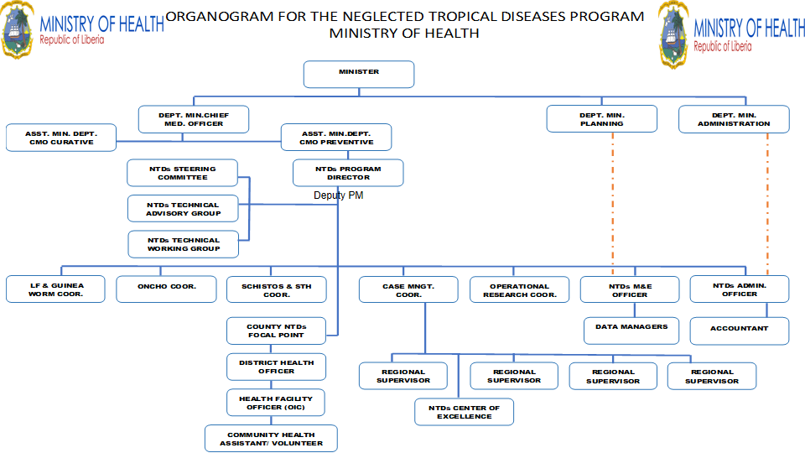

There is an NTD Steering Committee headed by the Chief Medical Officer, which takes high level program decisions and guides program sustainability, resource mobilization, inter-sectoral collaboration and coordination, and integration of NTD interventions in the health system. The Steering Committee also plays high level advisory roles to improve NTD program implementation in the country.

The Technical Working Group is composed of technical staff from the NTD Program, other MOH Programs, key stakeholders, and partners. It provides technical guidance on program direction, program evaluation, and priority setting in line with the national priorities.

At the county level, the County NTD Coordination Committee, headed by the County Health Officer, is composed of NTD partners and stakeholders. The committee is responsible for the coordination of NTD response, partner collaboration, and stakeholder engagement at the county and community levels.

**Membership and Terms of Reference – Program Coordination Mechanism**

|  |  |  |
| --- | --- | --- |
| **Entity/Institution/Agency** | **Membership** | **Terms of Reference** |
| **National NTD Steering Committee – Headed by the Chief Medical Officer** | | |
| NTD Program  Other MOH Programs  NPHIL  WHO  University of Liberia  Partners | CMO  NTD Program Director and Deputy  Heads of other MOH Programs  DG/NPHIL  WR  VP-AA/UL  Partners | TOR to be developed to include technical advisory and steering functions. |
| **National NTD Technical Working Group – Headed by the NTD Program Director** | | |
| NTD Program  Other MOH Programs  NPHIL  One Health Platform  WHO  Partners | NTD Coordinators  Technical staff from other  DG-Tech/NPHIL  One Health Focal Point  WHO NTD Focal Point  Partners | TOR available, to be revised. |
| **County NTD Coordination Committee – Headed by the County Health Officer** | | |
| County Health Teams  NTD Partners | County Health Officers  NTD focal persons  Representative of Community Health workers | TOR to be developed |

Table 35 Membership and Terms of Reference - Program Coordination Mechanism

**Partnership Matrix**

|  |  |  |  |  |  |  |  |  |  |  |
| --- | --- | --- | --- | --- | --- | --- | --- | --- | --- | --- |
| County | NTDs (List) | Mental Health | Disability / Physio therapy. | Veterinary  (List) | WASH (List) | IVM (List) | One-Health (List) | Education (List) | Malaria  (List) | Research |
| Bomi | Plan Intl  Village Reach  Chemonics |  | Break Through Action |  |  | MOA | Break Through Action  AFENET |  |  |  |
| Bong | Chemonics |  | AIFO Liberia |  |  |  |  |  |  |  |
| Gbarpolu | Chemonics |  |  |  |  |  |  |  |  |  |
| Grand Bassa | Chemonics |  |  |  |  |  |  |  |  |  |
| Cape Mount | Chemonics |  |  |  |  |  |  |  |  |  |
| Grand Gedeh | Last Mile Health  Chemonics | Carter Center | AIFO Liberia |  | WHH  UNICEF |  |  | Save the Children | Global Fund |  |
| Grand Kru | Chemonics |  |  |  |  |  |  |  |  |  |
| Lofa | Chemonics  Voice of Lofa Radio  Tamba Taikor Radio |  |  | MOA | IRC  CSI | MOA | Break Through Action | - | - | - |
| Margibi | Plan Intl  Village Reach  Break Through Action |  |  |  |  |  |  |  | STIP |  |
| Maryland | Chemonics |  |  |  |  |  |  |  |  |  |
| Montserrado | Plan Intl  Break Through Action  UNICEF | MSF  St. Benedict Mennie  Carter Center  AHA  LAPS |  | MOA | AAH  Water Aid  UNICEF  WHO |  | Global Health |  | USAID (STAH)  BreakThrough Action |  |
| Nimba | Chemonics  GLRA  National Catholic Health Council | The Carter Center | AIFO | MOA | Living Water Intl  AAH | MOA | MOA  Break Through Action  AFENET | MOE | Plan Intl |  |
| River Gee | Chemonics |  |  |  |  |  |  |  |  |  |
| Rivercess | Chemonics |  |  |  |  |  |  |  |  |  |
| Sinoe | Chemonics Plan Intl  WHO |  | xxx | MOA | WHH |  |  |  | Plan Int’l |  |
| National | Chemonics Sight Savers  ACTS  Americares  WHO  Last Mile health  SCIF  LSTM  EH  GSK  Merck Co  ALM  Americares  PIH | Cater Center  Mental Health Service Users | NUOD | MOA | WASH Commission |  | MOA  NPHIL | MOE  Save the Children  Sight Savers |  | UL-PIRE  UL Health /Research Dept  REDRESS |

Table 36 Partnership Matrix

## Section 3.3: Assumptions, Risks and Mitigations

Risk is the process of examining how likely risk will arise in the implementation of NTD programme. It also involves examining how the programme outcome and objectives might change due to the impact of the risk. The impact could be in terms of schedule, quality and cost.

Risk mitigation is the process of developing options and actions to enhance opportunities and reduce threats to the programme objectives. Risk mitigation progress monitoring includes tracking identifiable risks, identifying new risks, and evaluation risk process effectiveness throughout the programme period.

**. Risk Criteria and Assessment**

|  |  |  |  |  |  |  |  |  |  |  |  |
| --- | --- | --- | --- | --- | --- | --- | --- | --- | --- | --- | --- |
| **Potential Risk** | **Before risk mitigation** | | | | **Risk Mitigation** | | **After risk mitigation** | | | | |
| **Likelihood of occurrence** | **Impact** | | **Score** |  | | | **Likelihood of occurrence** | **Impact** | **Score** |
|  | Certain = 5  Likely = 4  Possible = 3  Unlikely = 2  Rare = 1 | Severe = 5  Major = 4  Moderate = 3  Minor = 2  Insignificant = 1 | | Likelihood x Impact |  | | | Certain = 5  Likely = 4  Possible = 3  Unlikely = 2  Rare = 1 | Severe = 5  Major = 4  Moderate = 3  Minor = 2  Insignificant = 1 | Likelihood x Impact |
| *Risk Type =* ***Operational Risks*** | | | | | | | | | | | | |
| Security challenges | 3 | 3 | | 9 | Promote and maintain peace and good governance | | | 3 | 3 | 9 |
| Flooding | 3 | 2 | | 6 | Distribute relief supplies and create awareness | | | 3 | 2 | 6 |
| Famine | 1 | 1 | | 1 | Improve and sustain food security | | | 1 | 1 | 1 |
| *Risk Type =* ***Financial Risks*** | | | | | | | | | | | | |
| Donor fatigue | 4 | 4 | | 16 | Improve resource mobilization and domestic financing | | | 4 | 4 | 16 |
| Pull out of partners | 3 | 4 | | 12 | Improve resource mobilization and domestic financing | | | 3 | 4 | 12 |
| Risk Rating (Likelihood x Impact) | | | | | |
| 19 – 25 | | | Severe | | |
| 13 – 18 | | | Major | | |
| 7 – 12 | | | Moderate | | |
| 0 – 6 | | | Minor | | |

**Risk Mitigation**

Managing risk means mitigating the threats or capitalizing on the opportunities that uncertainty presents to expected results. Failure to identify risks and failures to come up with risk mitigation strategies can and do kill projects. If no mitigation strategy can help, then *change* your strategy and project approach.

|  |  |
| --- | --- |
| Table 23: Steps to mitigate risk | |
| Avoid | Change plans to circumvent the problem |
| Control | Reduce threat impact or likelihood (or both) through intermediate steps |
| Share | Outsource risk (or a portion of the risk) to a third party or parties that can manage the outcome. |
| Accept | Assume the chance of the negative impact |
| Monitor | Monitor and review process in which risk management is in place |

## Section 3.4. Performance and Accountability Framework

.

|  |  |  |  |
| --- | --- | --- | --- |
| **Performance Indicators for Pillar 1: Accelerating programmatic action** | | | |
| **Strategic Priority** | **Performance Indicators** | **Target** | **Year** |
| Strategic objective 1:  Confirm the existence of suspected NTDs and complete mapping of all NTDs | Proportion of Counties mapped for specified PC-NTDs | 15 Counties | 2023 |
| Proportion of Counties mapped for specified CM-NTDs | 15 Counties | 2024 |
| Proportion of NTDs with known endemicity | 21/21 | 2025 |
| Percentage of counties reporting cases diagnosed for CM NTD with previously unknown prevalence | 015 counties | 2025 |
| Proportion of health facilities reporting monthly NTDs cases through the DHIS2 | 100% | 2024 |
| Proportion of CHPs reporting on NTDs suspected cases (including 0 reports) | 100% | 2024 |
| Strategic objective 2:  Prioritize and strengthen monitoring and evaluation and operational research to track progress and informed decision-making toward the 2030 NTDs roadmap goals | Proportion of PCT-NTDs indicators captured in the HMIS | 9/9 | 2023 |
| proportion of research agenda implemented | 80% 10/10 | 2026 |
| Proportion of health facilities reporting NTD cases | 90% | monthly |
| Strategic objective 3: Ensure effective and efficient supply chain management of quality assured NTD Medicines and other products up to the last mile | proportion of health facilities reporting no-stock out for CM commodities | 880 | 2023-2025 |
| proportion of counties reporting stock balances for PCT commodities through the HMIS | 15/15 | 2024 |
| No. of counties that are using integrated NTD supply chain guidelines and standard operating manual | 15 | 2023-2027 |
| Strategic objective 4: Strengthen advocacy and visibility of NTDs for the management, prevention, control or elimination interventions at all levels | Percentage of targeted population adhering to WASH/NTDs IEC and BCC program messages No of Counties that held sensitization meetings | 50%15 IUs | 2022, 2025, 2027 KAP survey  Quarterly |
| Proportion of primary schools that have integrated NTDs |  | 2024 |
| Proportion of secondary schools that have integrated NTDs |  | 2024 |
| Proportion of training institutions that have integrated NTDs into their training curriculum |  | 2024 |
| Proportion of counties airing NTDs messages |  |  |
| Proportion of NTDs annual budget supported by partners Number of edition editions of newsletter on NTDs produced annually | 502 | Annually  Annually |
| Strategic objective 5: Intensify the implementation of interventions targeting the prevention, management, control and elimination of NTDs | No of NTDs tools develop, revise and adopted |  | 2024 |
| No. of health facilities providing quality patient centered care |  | 2024 |
| No. of CM cases refer to health facilities |  | 2024 |
| No. of supervision conducted quarterly for NTDs |  | 2023-2027 |

Table 37 Performance Indicators for Pillar 1

|  |  |  |  |
| --- | --- | --- | --- |
| **Performance Indicators for Pillar 2: Intensify cross-cutting approaches** | | | |
| **Strategic Objective** | **Performance Indicators** | **Target** | **Frequency** |
| Strategic objective 1:  Strengthen the integration of identified NTD interventions including mental health and IPC/WASH | Proportion of new CM-NTDs managed for mental health conditions | 50% | Annually |
| Proportion of health facilities with at least one staff trained on integrated NTDs/mental health case management | 800 | Annually |
| Number of counties conducting integrated MDA including school health integrated program  To be removed to group one | 15 | annually |
| Number of IUs reporting integrated treatment | 15 counties | Annually/Bi-annually |
| Strategic objective 2: Mainstream delivery platforms within the national health system | Proportion of BU and yaws samples tested within a week of collection | 100% | Monthly |
| Strategic objective 3:  Strengthen multi-sectoral coordination, collaboration, cooperation and foster partnerships in the prevention, treatment, and care of patients with NTDs at all levels of healthcare | Number of line ministries/agencies represented in the NTDs TWG  Proportion of planned TWG meetings conducted | 5  4 | annually |
| Strategic objective 4:  Strengthen capacity to implement NTD program and resource mobilization, including the integration of NTD plan of action into the financial plans in all spheres | Proportion of annual NTDP budget funded through grant award | 25% | Annually |
| Strategic Objective 5 Integrate safety across NTD planning, implementation, and monitoring and evaluation | Proportion of safeguarding issues mitigated of those identified | 100% | annually |

Table 38 Performance Indicators for Pillar 2

|  |  |  |  |
| --- | --- | --- | --- |
| **Performance Indicators for Pillar 3: Operating Models and culture to facilitate country ownersh**ip | | | |
| **Strategic Objective** | **Performance Indicators** | **Target** | **Date** |
| Strategic objective 1: Promote and strengthen country ownership and leadership through organizational structures at national and sub-national levels | Number of counties with NTDs program performance integrated into county review meeting | 15 | Annually |
| Percentage of planned NTDs steering committee meetings conducted | 100% | Annually |
| Number of advocacy meetings held with key stakeholders | 4 | Annually |
| Number of key partner institutions represented at TWG meetings ( WASH, Education, gender, agriculture, mental health, disabled persons organizations, Ministry of Internal Affairs etc) | 15 | Quarterly |
| Strategic objective 2: Empower Counties and other local authorities in NTD planning and implementation including social mobilization, behavioral change, and building support for NTD interventions | Proportion of targeted local authorities (100/county) engaged on NTDs interventions and impact | (100%) | Annually |
| Strategic objective 3: Promote youth engagement to influence positive change and norms in favor of the national NTD programs | Number of targeted youth organizations engaged on NTDs social mobilization and behavior change | 5 | Annually |
| Strategic objective 4: Ensure donors, implementing partners align their strategies and plans with the National NTD Plans | Percentage of NTD donors and implementing partners involved in the annual NTD planning meeting | 100% | Annually |
| Strategic objective 5: Promote data-driven and gender-sensitive NTDs planning, reporting and review for effective program implementation | Number of gender disaggregated NTDs indicators included in DHIS2    Number of gender specific NTDs interventions being implemented. | 100% | Annually |
| Percentage of women coordinating NTD activities at national, county and district levels | 40% | Annually |

Table 39 Performance Indicators for Pillar 3

|  |  |  |  |
| --- | --- | --- | --- |
| **Performance Indicators for Pillar 4: Strengthen Resource Mobilization, Coordination and collaboration for the elimination of NTDs** | | | |
| **Strategic Objective** | **Performance Indicators** | **Target** | **Date** |
| Strategic objective 1:Promote community involvement and ownership of the program for optimal use of available resources | The proportion of NTDs cases referred by community members  Number of community members trained in NTDs monitoring | 25%  250 | Annually |
| Strategic objective 2: Promote evidence-based communication and awareness at the community level for the successful elimination of endemic NTDs. | The proportion of schools with NTDs IEC/SBC materials  Percent of the population aware of NTDs prevention and control | 50%  75% | Annually |
| Strategic objective 3: Expand and strengthen inter-sectoral collaboration and Partnership for the prevention, control, elimination, and eradication of priority NTDs | Number of NTDs research done with academic institutions    Number of NTDs elimination | 2    3 | Once |
| Strategic objective 4: Increase resource mobilization for NTDs program implementation and sustainability | Proportion of NTDs budget that is supported by the MOH  Percent of NTD budget funded by partners  Number of mapping exercises conducted | 50%    75% | Annually |

Table 40 Performance Indicators for Pillar 4

|  |  |  |  |  |  |  |
| --- | --- | --- | --- | --- | --- | --- |
| **NTD MP Budget Summary** |  |  |  |  |  |  |
|  | **FY2023** | **FY2024** | **FY2025** | **FY2026** | **FY2027** | **Total** |
| **Strategic Pillar 1: Accelerating programmatic action** |  |  |  |  |  |  |
| **Objective 1.1** |  |  |  |  |  |  |
| Activity 1.1.1 Review current PCT-NTD prevalence maps in Liberia and identify gaps/ priority areas for mapping. | - | 27,553.58 | - | - | - | 27,553.58 |
| Activity 1.1.2 Conduct mapping for suspected and confirmed CM NTDs and associated morbidities | - | 59,351.25 | - | - | - | 59,351.25 |
| Activity 1.1.3 Train district surveillance officers (93) on surveillance systems for pharmacovigilance assessments / surveillance of MDA SAEs | - | 30,418.50 | - | - | - | 30,418.50 |
| Activity 1.1.4 Conduct contact tracing and referrals for Leprosy and Yaws for 14 counties excluding Nimba for the first two years | 160,590.00 | 207,900.00 | 217,800.00 | 227,700.00 | 237,600.00 | 1,051,590.00 |
| Activity 1.1.5 Introduce and conduct post-MDT surveillance | - | - | - | - | - | - |
| Activity 1.1.6 Integrate and strengthen NTD surveillance systems for pharmacovigilance assessments and surveillance of MDA severe adverse effects (SAEs) | - | - | - | - | - | - |
| Activity 1.1.7 Develop surveillance mechanism to determine the endemicity of non-targeted NTDs (trachoma, Noma) | - | - | - | - | - | - |
| Activity 1.1.8 Train CHAs/CHPs to conduct active case search in all counties (est. 13,000-check #s) | - | 442,680.00 | - | 484,840.00 | - | 927,520.00 |
| Activity 1.1.9 Establish cross border mechanisms with Mano River members | 44,705.00 | 33,752.25 | 35,359.50 | 36,966.75 | 38,574.00 | 189,357.50 |
| Activity 1.1.10 Conduct coverage surveys for MDA | - | - | - | - | - | - |
| Activity 1.1.11 Provide support to districts to integrate NTDs peer support groups into county structure | - | 3,150.00 | - | - | - | 3,150.00 |
| Activity 1.1.12 Procure logistics to support conduct active case search for CHAs/CHPs (check #s) | - | 450,450.00 | - | - | - | 450,450.00 |
| Activity 1.1.13 Orientate traditional and faith healers to suspect and refer NTDs cases and look, listen and link | - | 65,310.00 | - | - | - | 65,310.00 |
| Activity 1.1.14 Provide performance-based incentives for CHAs/CHPs to conduct active case search and referral through the national PBF Program | 2,250.00 | 4,935.00 | 4,950.00 | 5,175.00 | 5,400.00 | 22,710.00 |
| Activity 1.1.15 Integrate MDA data into DHIS2 | - | - | - | - | - | - |
| Total for Objective 1.1 | 207,545.00 | 1,325,500.58 | 258,109.50 | 754,681.75 | 281,574.00 | 2,827,410.83 |
| **Objective 1.2** |  |  |  |  |  |  |
| Activity 1.2.1 Support health facilities to record and report through the HMIS | - | 28,906.50 | - | - | - | 28,906.50 |
| Activity 1.2.2 Pilot study into the feasibility of implementing Post-Exposure Prophylaxis for leprosy in Liberia | - | 56,784.00 | 59,488.00 | - | - | 116,272.00 |
| Activity 1.2.3 Include rabies and snake bite into the DHIS2 | - | - | - | - | - | - |
| Activity 1.2.4 Review, update SOP/manual for routine data quality assessments, data analysis and dissemination | - | 493.50 | - | - | - | 493.50 |
| Activity 1.2.5 Support the HMIS division to conduct quarterly data reliability check at county level | 26,840.00 | 56,364.00 | 59,048.00 | 61,732.00 | 64,416.00 | 268,400.00 |
| Activity 1.2.6 Engage with donors’ agencies to fund identified priority operational research areas. | 1,250.00 | 1,312.50 | 1,375.00 | 1,437.50 | 1,500.00 | 6,875.00 |
| Activity 1.2.7 Create a repository for operational research conducted within the country | 850.00 | 892.50 | 935.00 | 977.50 | 1,020.00 | 4,675.00 |
| Activity 1.2.8 Coordinate with research institutes in Liberia to conduct more research and trainings | 2,500.00 | 19,834.50 | 2,750.00 | 2,875.00 | 3,000.00 | 30,959.50 |
| Activity 1.2.9 Data analysis training for 336 county Health Team Members forNTD intervention at all level | - | 58,201.50 | - | - | - | 58,201.50 |
| Activity 1.2.10 Collaborate with training/research institutions to conduct NTDs research | 122,987.00 | 454,949.25 | 135,285.70 | 176,038.55 | 127,227.60 | 1,016,488.10 |
| Total for Objective 1.2 | 154,427.00 | 677,738.25 | 258,881.70 | 243,060.55 | 197,163.60 | 1,531,271.10 |
| **Objective 1.3** |  |  |  |  |  |  |
| Activity 1.3.1 Mainstream NTD commodities into the paper based and electronic Logistics Management Information Systems (eLMIS) platform | 28,235.00 | - | - | - | - | 28,235.00 |
| Activity 1.3.2 Include NTD supplies on CMS platform | 370.00 | - | - | - | - | 370.00 |
| Activity 1.3.3 Integrate pharmacovigilance guideline training into the NTDs training for health workers | 2,015.00 | - | - | - | - | 2,015.00 |
| Activity 1.3.4 Procure CM-NTDs and MDA medicines (including anti-venom, vaccines) and commodities for CM-NTDs | 73,010.00 | 153,321.00 | 160,622.00 | 167,923.00 | 175,224.00 | 730,100.00 |
| Activity 1.3.5 Preposition NTDs medicines for MDA and CM activities within the counties | 2,900.00 | 6,090.00 | 6,380.00 | 6,670.00 | 6,960.00 | 29,000.00 |
| Activity 1.3.6 HMIS to produce monthly dashboard for NTDs cases reported through the DHIS2 | 300.00 | 630.00 | 660.00 | 690.00 | 720.00 | 3,000.00 |
| Activity 1.3.7 Use the dashboard as guide to conduct integrated supervision with the CM monthly supervision. | 100,782.00 | 211,642.20 | 221,720.40 | 231,798.60 | 241,876.80 | 1,007,820.00 |
| Activity 1.3.8 Conduct CM quarterly supervision at the national level | 37,780.00 | 79,338.00 | 83,116.00 | 86,894.00 | 90,672.00 | 377,800.00 |
| Activity 1.3.10 Conduct supportive supervision and mentorship through the joint integrated supportive supervision mechanism | 45,000.00 | 94,500.00 | 99,000.00 | 103,500.00 | 108,000.00 | 450,000.00 |
| Activity 1.3.11 Conduct yearly supervision for PCT campaigns | - | - | - | - | - | - |
| Total for Objective 1.3 | 290,392.00 | 545,521.20 | 571,498.40 | 597,475.60 | 623,452.80 | 2,628,340.00 |
| **Objective 1.4** |  |  |  |  |  |  |
| Activity 1.4.1 Conduct integrated MDA (Schisto) including school health integrated program (SHIP) | 863,070.00 | 904,176.00 | 947,232.00 | 990,288.00 | 1,033,344.00 | 4,738,110.00 |
| Activity 1.4.2 Review and revise reporting and recording tools to integrate MDA data into the HIS | - | 420.00 | - | - | - | 420.00 |
| Activity 1.4.3 Conduct community census before MDA | - | - | - | - | - | - |
| Activity 1.4.4 Conduct training to strengthen CM referral system between community health and NTDs program | - | - | - | - | - | - |
| Activity 1.4.5 Print and distribute the two-way referral forms from community to health facilities | 13,000.00 | 27,300.00 | 28,600.00 | 29,900.00 | 31,200.00 | 130,000.00 |
| Activity 1.4.6 Conduct routine post-operative follow up assessment to evaluate quality of life | 47,010.00 | 95,509.00 | 96,998.00 | 98,487.00 | 102,856.00 | 440,860.00 |
| Activity 1.4.7 Train surgical staff and orthopedic technicians on CM intervention techniques | 54,120.00 | 55,513.50 | - | - | - | 109,633.50 |
| Activity 1.4.8 Train laboratory technicians per county to conduct diagnostic tests for investigation and confirmation of CM NTDs | 55,975.00 | 57,533.75 | - | - | - | 113,508.75 |
| Activity 1.4.9 Refresher training for national, county, district and health facility levels CM NTDs | 748,515.00 | - | 786,601.50 | - | - | 1,535,116.50 |
| Activity 1.4.10 Train national, county, district and health facility levels on CM NTDs (Initial CM-NTDs training roll-out) | 249,190.00 | - | - | - | - | 249,190.00 |
| Activity 1.4.11 Include FGS training intervention manual into the existing CM training manual for health workers | - | 425.25 | - | - | - | 425.25 |
| Activity 1.4.12 Support district peer support group to conduct regular meetings and activities | - | 13,387.50 | 14,025.00 | - | - | 27,412.50 |
| Total for Objective 1.4 | 2,030,880.00 | 1,154,265.00 | 1,873,456.50 | 1,118,675.00 | 1,167,400.00 | 7,344,676.50 |
| **Total for Strategic Priority 1** | **2,683,244.00** | **3,703,025.03** | **2,961,946.10** | **2,713,892.90** | **2,269,590.40** | **14,331,698.43** |
| **Strategic Pillar 2: Intensive cross cutting approach** |  |  |  |  |  |  |
| Objective 2.1 |  |  |  |  |  |  |
| Activity 2.1.1 Conduct training for mid-level health workers (830) and community health workers (13000) on the use of tools and SBC/IEC materials development and use | - | 203,857.50 | - | - | - | 203,857.50 |
| Activity 2.1.2 Conduct integrated NTDs and mental health refresher training for mid-level health workers (1,600) every two years (included in the integrated initial and refresher trainings) | 80.00 | - | - | - | - | 80.00 |
| Activity 2.1.3 Revise exiting CM NTDs IEC materials to include Onchocerciasis and mental health | - | - | - | - | - | - |
| Activity 2.1.4 Advocate with the medical and nursing boards to include comprehensive NTDs training into pre-service curriculum | 3,850.00 | 4,042.50 | - | - | - | 7,892.50 |
| Total for Objective 2.1 | 3,930.00 | 207,900.00 | - | - | - | 211,830.00 |
| Objective 2.2 |  |  |  |  |  |  |
| Activity 2.2.1 Collaborate with the National Reference Laboratory (NRL) to designate lab technicians for NTDs testing | - | - | - | - | - | - |
| Activity 2.2.2 Procure reagents for NTDs tests | - | 128,488.50 | 128,161.00 | 133,986.50 | 139,812.00 | 530,448.00 |
| Activity 2.2.3 Procure an additional PCR machine | - | - | 144,100.00 | - | - | 144,100.00 |
| Total for Objective 2.2 | - | 128,488.50 | 272,261.00 | 133,986.50 | 139,812.00 | 674,548.00 |
| Objective 2.3 |  |  |  |  |  |  |
| Activity 2.3.1 Support implementation of integrated NTD IPC/WASH/SBC interventions | 113,287.00 | 945.00 | - | - | - | 114,232.00 |
| Activity 2.3.2 Finalize, Disseminate and Monitor the implementation of NTD /IPC/WASH and SBC collaboration framework | 1,250.00 | - | - | - | - | 1,250.00 |
| Activity 2.3.3 Conduct assessment on feasible study/strategy for vector control of SCH & STH | - | - | - | - | - | - |
| Total for Objective 2.3 | 114,537.00 | 945.00 | - | - | - | 115,482.00 |
| Objective 2.4 Integrate existing NTD safety guide for all activities. (Guide should include ethical consideration and safety measures.) |  |  |  |  |  |  |
| Activity 2.4.1 Integrate existing NTD safety guide for all activities. (Guide should include ethical consideration and safety measures.) | - | - | - | - | - | - |
| Activity 2.4.2 Print and disseminate the validated NTD safety guide for all activities | - | - | - | - | - | - |
| Total for Objective 2.4 | - | - | - | - | - | - |
| **Total for Strategic Priority 2** | **118,467.00** | **337,333.50** | **272,261.00** | **133,986.50** | **139,812.00** | **1,001,860.00** |
| **Strategic Pillar 3: Operating Models and culture to facilitate country ownership** |  |  |  |  |  |  |
| Objective 3.1 |  |  |  |  |  |  |
| Activity 3.1.1 Revamp the Technical working group (TWG) by including new members | 500.00 | 1,050.00 | 1,100.00 | 1,150.00 | 1,200.00 | 5,000.00 |
| Activity 3.1.2 Establish the National NTDs Steering Committee | 500.00 | 1,050.00 | 1,100.00 | 1,150.00 | 1,200.00 | 5,000.00 |
| Activity 3.1.3 Integrate NTDs activities into existing counties coordination mechanism | 6,900.00 | 14,490.00 | 15,180.00 | 15,870.00 | 16,560.00 | 69,000.00 |
| Total for Objective 3.1 | 7,900.00 | 16,590.00 | 17,380.00 | 18,170.00 | 18,960.00 | 79,000.00 |
| Objective 3.2 |  |  |  |  |  |  |
| Activity 3.2.1 Engage county authorities (superintendent, district commissioners, paramount chief, faith healers, religious leaders etc.) and other local authorities on NTD interventions | - | 12,390.00 | 12,980.00 | 6,785.00 | 7,080.00 | 39,235.00 |
| Total for Objective 3.2 | - | 12,390.00 | 12,980.00 | 6,785.00 | 7,080.00 | 39,235.00 |
| Objective 3.3 |  |  |  |  |  |  |
| Activity 3.3.1 Map Youth Organizations and NGOs, CBOs working with youths | - | 5,040.00 | 5,280.00 | 2,760.00 | 2,880.00 | 15,960.00 |
| Activity 3.3.2 Hold sensitization meetings with Youth Organizations and NGOs working with youths | - | 945.00 | 990.00 | 517.50 | 540.00 | 2,992.50 |
| Activity 3.3.3 Identify opportunities for NTD activities to be led by local youth | - | 1,260.00 | 1,320.00 | 1,035.00 | 1,080.00 | 4,695.00 |
| Total for Objective 3.3 | - | 7,245.00 | 7,590.00 | 4,312.50 | 4,500.00 | 23,647.50 |
| Objective 3.4 |  |  |  |  |  |  |
| Activity 3.4.1 Organize social mobilization events (moving stage, drama, testimonies, etc) to promote NTDs prevention, control, and eradication | - | 2,336.25 | 2,447.50 | 2,558.75 | 2,670.00 | 10,012.50 |
| Activity 3.4.2 Integrate REDRESS Project Community Advisory Board (CAB) in existing Community Health Committee (CHC) structure | - | - | - | - | - | - |
| Activity 3.4.3 Engage GSM companies and media houses to disseminate NTDs messages | 100.00 | 210.00 | 220.00 | 230.00 | 240.00 | 1,000.00 |
| Activity 3.4.4 Document and disseminate success stories (including successful collaboration) of the NTD programs as well as publish a quarterly bulletin on NTDs. | 9,200.00 | 20,370.00 | 20,240.00 | 11,960.00 | 12,480.00 | 74,250.00 |
| Activity 3.4.5 Leverage social media and digital technologies to promote awareness and sensitization for NTDs | 3,000.00 | 6,300.00 | 6,600.00 | 6,900.00 | 7,200.00 | 30,000.00 |
| Total for Objective 3.4 | 12,300.00 | 29,216.25 | 29,507.50 | 21,648.75 | 22,590.00 | 115,262.50 |
| Objective 3.5 |  |  |  |  |  |  |
| Activity 3.5.1 Collaborate with gender specialists to make NTDs interventions gender sensitive NTDs | 600.00 | 1,260.00 | 1,320.00 | - | - | 3,180.00 |
| Activity 3.5.2 Work with the Gender Ministry and MOH to ensure that NTDs are included in the national Gender Strategy | 600.00 | 1,260.00 | 1,320.00 | 690.00 | 720.00 | 4,590.00 |
| Activity 3.5.3 Include representatives from the Ministry of Gender, children, and social protection in the planning and implementation of NTDs interventions | 120.00 | 252.00 | 264.00 | 138.00 | 144.00 | 918.00 |
| Total for Objective 3.5 | 1,320.00 | 2,772.00 | 2,904.00 | 828.00 | 864.00 | 8,688.00 |
| Objective 3.6 |  |  |  |  |  |  |
| Activity 3.6.1 Engage CHPs/CHAs to raise awareness to enhance community engagement during training | - | - | - | - | - | - |
| Activity 3.6.2 Integrate NTDs awareness into community Town Hall Meetings | - | - | - | - | - | - |
| Activity 3.6.3 Involve the community leadership in the NTDs review meetings | - | - | - | - | - | - |
| Total for Objective 3.6 | - | - | - | - | - | - |
| **Total for Strategic Priority 3** | **21,520.00** | **68,213.25** | **70,361.50** | **51,744.25** | **53,994.00** | **265,833.00** |
| **Strategic Pillar 4: Strengthening the resource mobilization, inter-sectoral collaboration for the elimination of NTDs** |  |  |  |  |  |  |
| **Objective 4.1** |  |  |  |  |  |  |
| Activity 4.1.1 Establish a group for incorporation of NTDs into primary and secondary school curriculum and in Social Behavior Change Communication (SBCC) activities including WASH, | 300.00 | 630.00 | 660.00 | 690.00 | 720.00 | 3,000.00 |
| Activity 4.1.2 Integrate NTDs into pre-service curriculum for medical and para-medical training institutions including WASH, vector control, mental health and One Health | - | - | - | - | - | - |
| Total for Objective 4.1 | 300.00 | 630.00 | 660.00 | 690.00 | 720.00 | 3,000.00 |
| Objective 4.2 |  |  |  |  |  |  |
| Activity 4.2.1 Conduct annual joint multi sectoral planning for implementation and collaboration (Education, IPC/WASH, Agriculture, Youth, etc.) | 25,745.00 | 27,032.25 | 28,319.50 | 29,606.75 | 30,894.00 | 141,597.50 |
| Activity 4.2.2 Engage Planning and Policy Department of MOH to include NTD Master Plan | 225.00 | 236.25 | - | - | - | 461.25 |
| Total for Objective 4.2 | 25,970.00 | 27,268.50 | 28,319.50 | 29,606.75 | 30,894.00 | 142,058.75 |
| Objective 4.3 |  |  |  |  |  |  |
| Activity 4.3.1 Engage all relevant NTDs partners and stakeholders at national level to align their plan with the NTDs Master Plan | 15,660.00 | 236.25 | 247.50 | 258.75 | 270.00 | 16,672.50 |
| Activity 4.3.2 Advocacy, sensitization, and information sharing on the NTDs with key partners | 300.00 | 630.00 | 660.00 | 690.00 | 2,880.00 | 5,160.00 |
| Activity 4.3.3 Develop and distribute advocacy kits to key stakeholders | 600.00 | 1,260.00 | 1,320.00 | 1,380.00 | 5,760.00 | 10,320.00 |
| Total for Objective 4.3 | 16,560.00 | 2,126.25 | 2,227.50 | 2,328.75 | 8,910.00 | 32,152.50 |
| Objective 4.4 |  |  |  |  |  |  |
| Activity 4.4.1 Engage partners to participate in NTD review meetings | - | - | - | - | - | - |
| Activity 4.4.1.1 Hold a joint planning review meeting at national level | - | - | - | - | - | - |
| Activity 4.4.2 Involve the counties in planning and review meetings | - | - | - | - | - | - |
| Activity 4.4.3 Conduct midterm review of the NTDs masterplan | - | - | 69,855.50 | - | - | 69,855.50 |
| Activity 4.4.4 Conduct an end-term evaluation of the NTDs masterplan | - | - | - | - | 68,508.00 | 68,508.00 |
| Activity 4.4.5 Conduct advocacy meetings with policymakers, political leaders and private sectors to mobilize resources for NTDs | 3,150.00 | 3,307.50 | 3,465.00 | 3,622.50 | 3,780.00 | 17,325.00 |
| Activity 4.4.6 Include NTDs as a priority of the National Health Financing Strategy | - | - | - | - | - | - |
| Activity 4.4.7 Engage stakeholders (national legislature, donors, partner,s etc) to commemorate NTDs day | - | - | - | - | - | - |
| Total for Objective 4.4 | 3,150.00 | 3,307.50 | 73,320.50 | 3,622.50 | 72,288.00 | 155,688.50 |
| **Total for Strategic Priority 4** | **45,980.00** | **33,332.25** | **104,527.50** | **36,248.00** | **112,812.00** | **332,899.75** |
|  |  |  |  |  |  |  |
| **GRAND TOTAL** | **2,869,211.00** | **4,141,904.03** | **3,409,096.10** | **2,935,871.65** | **2,576,208.40** | **15,932,291.18** |

References

K. Hampson, L. Coudeville, T. Lembo, M. Sambo, A. Kieffer, M. Attlan, J. Barrat, J.D. Blanton, D.J. Briggs, S. Cleaveland, P. Costa, C.M. Freuling, E. Hiby, L. Knopf, F. Leanes, F.- X. Meslin, A. Metlin, M.E. Miranda, T. Müller, L.H. Nel, S. Recuenco, C.E. Rupprecht, C. Schumacher, L. Taylor, M.A.N. Vigilato, J. Zinsstag, J. Dushoff

**Global alliance for rabies control partners for rabies prevention.** Estimating the global burden of endemic canine rabies. PLoS Negl. Trop. Dis., 9 (2015), Article e0003709, [10.1371/journal.pntd.0003709](https://doi.org/10.1371/journal.pntd.0003709)

1. Ministry of internal affairs, Government of Liberia; directorate of localities. Accessed on September 14, 2018 from <http://www.mia.gov.lr/2content.php?sub=210&related=40&third=210&pg=sp>
2. Pro-poor Agenda for Prosperity and Development, Government of Liberia, 2018
3. Human Development Report, 2019
4. National Health Accounts (NHA) Reports, 2015/16, 2016/17 and 2017/18, MOH
5. Resource mapping, Health Financing Unit, MOH, 2020
6. Ministry of Finance and Development Planning, 2019
7. High Level, Task Force (HLTF) for innovative financing of comprehensive services
8. MOH 2015 Annual Report, Ministry of Health, 2016
9. Pro-poor Agenda for Prosperity and Development, Government of Liberia, 2018
10. <https://www.cia.gov/library/publications/the-world-factbook/rankorder/2223rank.html>, 2015 estimates.
11. LISGIS, MOH, ICF, LDHS, KIR, 2019-20
12. Overview of Health Financing Landscape & Progress toward UHC in Liberia, HF conference 2017
13. GOL, MOH & USAID Capacity Assessment of 15 CHTs, March 2020.
14. Nimba County Capacity Assessment Report, March 2020
15. Benefit Incidence Analysis, NHA, 2010
16. Ten Year Health Policy and Plan (2011-2021) MOH, 2011
17. Process Evaluation, Plan International, Liberia 2018
18. UNDP Discussion Paper on Gender and NTDs
19. Universal sustainable development goals: understanding the transformational challenge for developed countries. Report by the stakeholder Forum, May 2015.
20. Note that STH was excluded from the FU3 protocol as the timing of the impact survey coincided with the LF MDA during which ivermectin and albendazole were distributed nationally (including in Bong, Lofa & Nimba).
21. Mitja O. et al. Global epidemiology of yaws: a systematic review. Lancet Glob. Health 2015, 3:e324-31
22. Asiedu K. et al. Yaws eradication: past efforts and future perspectives. Bulletin of the WHO. 2011, 86(7). <http://www.who.int/bulletin/volumes/86/7/08-055608/en>
23. Accelerating work to overcome the global impact of Neglected Tropical Diseases: a roadmap for implementation. World Health Organization 2012.
24. K. Hampson, L. Coudeville, T. Lembo, M. Sambo, A. Kieffer, M. Attlan, J. Barrat, J.D. Blanton, D.J. Briggs, S. Cleaveland, P. Costa, C.M. Freuling, E. Hiby, L. Knopf, F. Leanes, F.- X. Meslin, A. Metlin, M.E. Miranda, T. Müller, L.H. Nel, S. Recuenco, C.E. Rupprecht, C. Schumacher, L. Taylor, M.A.N. Vigilato, J. Zinsstag, J. Dushoff

    **Global alliance for rabies control partners for rabies prevention.** Estimating the global burden of endemic canine rabies. PLoS Negl. Trop. Dis., 9 (2015), Article e0003709, [10.1371/journal.pntd.0003709](https://doi.org/10.1371/journal.pntd.0003709)

    WHO, 2018 WHO Expert Consultation on Rabies, third report. Geneva: World Health Organization; 2018 (WHO Technical Report Series, No. 1012). Licence: CC BY-NC-SA 3.0 IGO., 2018.